Objective
Learn how to scan images and objects and do minimal image manipulation and save for the Web.

What is Photoshop?

Image Editor

Full Featured Design Tool

Painting Program

Getting Started

Quit all open applications.

Select Photoshop from the Apple menu to open Photoshop.

Scanning

Put a picture or item to be scanned in the flatbed scanner face down.

Select File > Import > Umax Vistascan 3.5.1.

Select the Advanced tab at the top of the window.

Set Mode to True Color, RGB or B/W Photo.

Set resolution (100-150dpi works well for the Web).

Check the box next to Auto Adjust.

Select Preview.

Move the 'marching ants' to define the area you want to scan.

Select Scan to complete the scan and bring it into Photoshop.

Adjusting the Image

Select Image > Image Size to check the size of the file in pixels. Be sure units is set to pixels and remember most images should not be bigger than 640 x 480 pixels for the Web.

Select Image > Adjust > Auto Levels and/or Image > Adjust >Auto Contrast to fix color and contrast.

Select Filter > Sharpen > Unsharp Mask… to compensate for loss in detail from scanning.

Cropping

Use the crop tool (found by holding down the marquee tool) to define the area to crop.

Move the 'handles' to modify the crop area.

Double-click inside cropped area to complete cropping. (Press Escape if you decide not to crop.)

Saving

Select File > Save for Web.
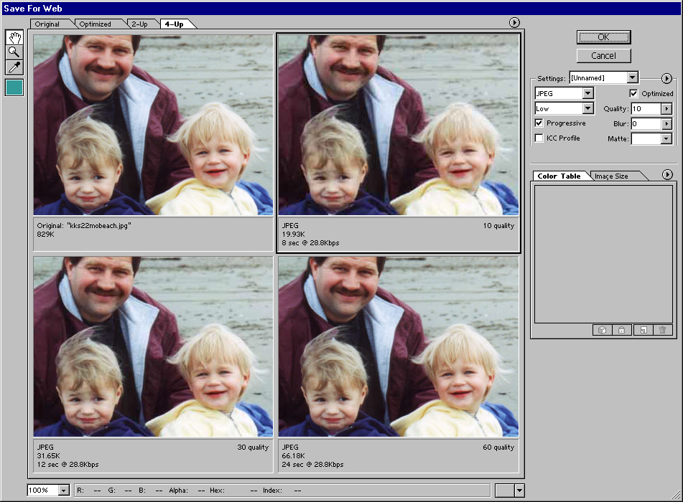

Select the 4-Up Tab along the top so you can compare different options.

Note: Most photos look best saved as a JPEG. (Be sure to name the file with the extension .jpg.)For line drawings and scans with little color depth, saving as a GIF is usually best. (Name the file with a .gif extension.)

The photo in the top left square is your uncompressed scanned image.

Click on the photo at the top right and modify the settings for that picture.

Click on the photo at the bottom left and try other options.

Do the same for the photo on the bottom right.

Once you've decided on the best option for your image, select that 'version' in the window and click OK.

Name the file and click Save. This creates a separate file from your Photoshop file.

