COMETS: PAST and PRESENT
May 26, 2004

By

Carlos A.Aviles
and
Abigail L. Brown

Research project for Astronomy and Cosmologies
The Evergreen State College

Introduction_____________________________________________________________
The arrival of the two comets C/2001/ Q4 NEAT and C/2002/T7 LINEAR in 2004 motivated us to study comets in modern science and in their historical context. We will attempt, in this paper, to give an overview of the historical, cultural, physical, and modern significance of comets. We will review cometary origins, and give a brief overview of comet science through history and in modern science. We will discuss the basic physical parameters of comets and the orbital details of comet trajectories. We will describe our observations and conclusions. We will investigate the probability of the Sun changing a comet’s path. In closing, we review the importance of Near Earth Object tracking and its relationship to comets.

The Birth of an Interstellar Comet__________________________________________
Imagine a time around four billion years ago when the sun began to blaze forth, heating the entire solar system in the blink of an eye. The solar system consisted of the planets we know today, but there were also many small “planetismals” orbiting the sun. The universe was filled with many asteroids and comets during these early times. If a person were sitting on the molten earth looking into the sky, it was constantly filled with dozens of comets, at all times. These young comets formed with the stellar birth of the universe. Dust particles and other organic grains slowly combined in the large swirling mass of the universe. Thus, comets literally contain the building blocks of life: carbon, hydrogen, oxygen, and nitrogen. As the molten Earth began to cool it was bombarded with comets, and this allowed for organic compounds to be delivered to our planet (Levy, 62). This may have helped to facilitate the beginning of life on Earth. The connection does seem probable, if you think about the composition of a person; we are made of the same things as comets! (See Figure 1)
Many of the early comets disappeared when they collided with objects in the galaxy. Others were eventually diverted to their homes in the outer solar system where they came to rest. One of these comet locales is called the Kuiper Belt, an area at the edge of the planetary system that holds many asteroids, comets, and the planet Pluto. It has a relatively close location to the sun, around 500 AU away. Some comets captured in the belt are affected by the gravitational pull of Jupiter and Saturn. These comets are often called Jupiter family comets, most with a short orbital period of less than 20 years. Famous comets from the Kuiper Belt include comet Encke.
There are other comets that orbit only once in a million years. They reside in an area far from the observable view of earthlings called the Oort cloud. It lies at the far, far distance of 50 thousand AU away. The Oort cloud comprises a spherical area that is at the edge of the solar system. Some of the comets in the Oort cloud can have intermediate orbits from 20-200 years, like Halley’s comet or they can have long orbits from 1-30 million years (Freedman, Chapter 17). The Oort cloud is home to famous comets like Swift-Tuttle, Hyakutake and Hale-Bopp. The comets in this region are periodically thrown into the inner solar system when the gravitational affects of passing stars or the bending and compressing of the cloud can change the trajectory of a comet. It is thought that there are a possible 6 trillion comets in the Oort cloud region (Freedman, Chapter 17).
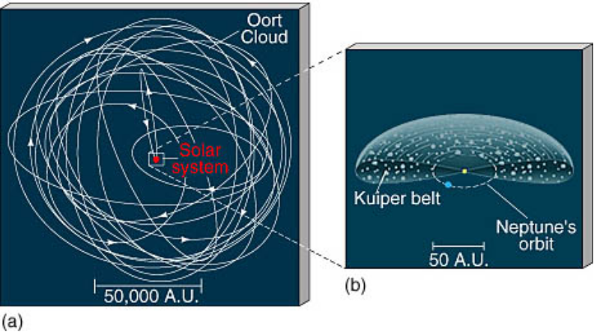
Figure 1: (<http://astro.nmsu.edu/~aklypin/ast110/WebSite/images/oort-cloud.jpg>)

An Abbreviated History of Comet Science____________________________________
The arrival of two comets, C/2002/T7 LINEAR and C/2001/Q4 NEAT, mark a momentous occasion in the year of 2004. Comet LINEAR arrived at perihelion during April, and comet NEAT arrived at its perihelion during the month of May. This helped to make viewing a relatively simple task. It has been the first time in our time on this planet, that we have observed a visitor from the furthest reaches of our solar system. This visitor’s lifetime far exceeds our own, and if it could speak, the comet would explain the amazing sight of a young universe in formation. As the sky slowly darkened, one by one, the stars began to twinkle out of oblivion. We noticed peaking out from behind a small mountain was a star unlike the others. Looking through binoculars revealed the true identity of this hazy interloper. It was comet NEAT. Amazement and excitement prevailed as this celestial sight crossed the night sky. We were able to first view the comet NEAT in Olympia, WA on May 8, 2004.
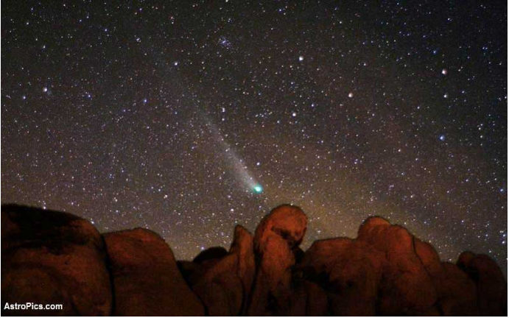
Figure 2: (<http://cometography.com/lcomets/2001q4.html>)

The mythology of comets has survived for many thousands of years into the lineage of civilization. The rarity and beauty of their transit must be a reason for the continued sense of wonder a comet provides. The earliest recorded comet sightings were in 1059 BC. A Chinese king recorded a comet transit in the midst of a battle with a neighboring kingdom (Yeomans). Detailed charts signifying the different shapes of comets were found in the tomb of an ancient Chinese from 168 BC (Yeomans, 43). We owe much of the accurate documentation recorded by ancient civilization due to their fear of comets.
Many European civilizations often connected comets with a bad omen. The most famous of this evidence lies in Shakespeare’s work documenting the reign of Julius Caesar in 44 BC. Calpurnia cries out to her husband to keep him from traveling:

When beggars die there are no comets seen,
The heavens blaze forth the death of the princes. (Julius Caesar, 2.2. 29-30)
(Levy)

Accurately, a comet did arrive just after the reign of Caesar, a couple of months after his death (Levy, 130). Roman emperor, Nero, had an advisor who kept close tabs on comets. He employed long-time friend and scholar, Lucius Annaeus Seneca, to scan the sky for comets. Seneca wrote a science-based text called the Naturales Quaestiones, in which he included a section “De Cometis.” This writing included his Aristotelian views that comets were created from the winds in the atmosphere (Levy, 127). An increasing erratic and emotionally unstable Nero eventually put Seneca to death in 65 AD (Yeomans). During the medieval period, most cometary views were related to that of Aristotle. These views were widely accepted by the European Church, because they did not contradict biblical scripture. It could even coincide with the bible as comets could be sent to Earth as signs from God (Yeomans, 49).
The telescope was introduced in the seventeenth century. This achievement aided the advancement of cometary knowledge. Tycho Brahe noted that a comets movement suggested they formed far from our atmosphere, and he also hinted at the possibility of a comets elliptical orbit (Yeomans). The next great advancement in comet science was to be had by Edmond Halley. He concluded that a comet seen in 1531, 1607, and 1682 was the same comet (Yeomans). This comet was later named Halley’s comet, after a prediction of its return came true in 1758 (Yeomans). Cometary motion and orbit were to be one of the main focuses in the eighteenth century, and by the end of the nineteenth century meteor showers were found to be related to comets. Before a couple of hundred years ago “…astronomers concentrated most their cometary research on the dynamics, rather than the physics, of comets (Yeomans, 201).” If alive today, we are sure that many ancient scientists would look in awe and wonder at modern astronomy.
Who would have thought it possible to send a spacecraft out to intercept a comet in mid-space? It sounds like a something in a sci-fi novel, and it is also a feat that was accomplished by the European Space Agency in 1986. The ESA’s Giotto spacecraft detected hydrogen, cyanide, water, and formaldehyde in the tail of Halley’s comet (Levy). The improvement in modern technology has certainly aided in comet exploration. In 1999, NASA launched Stardust spacecraft. Stardust mission is to fly through the tail of Comet Wild 2 and collect samples of particles. It is scheduled to return home to Earth in 2006 with the sample (<http://stardust.jpl.nasa.gov/>). There are many other missions currently being planned and implemented.

Comets: The Particles of Life_______________________________________________
The composition of a comet is not surprisingly familiar to the makeup of a star or a human being for that matter. We all originated from the same source.
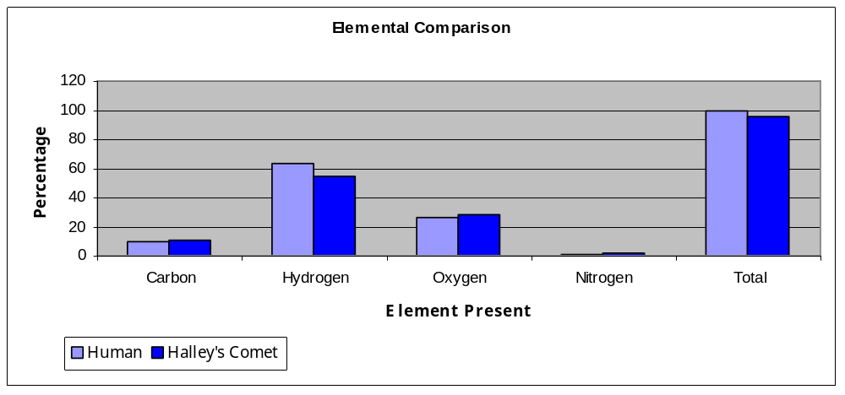 Figure 3: (Data retrieved from Levy, David H. “Comets: Creators and Destroyers”)
URL? http://…

Comets have long been described as “dirty snowballs (Levy).” This is because comet nuclei are made of ice, dust particles, and organic compounds: like water, methane, ammonia, and carbon dioxide (Levy). These nuclei were formed along with the birth of the universe, and thrown to the freezer at the edge of the solar system. While trapped in these distant orbits, a comet encounters no difficulty remaining frozen until they are thrown towards the heat of the Sun. The International Astronomical Union (IAU) does not classify a comet until it has a visible tail, and this happens on the approach to the interior of the solar system (Levy). The radiation from the Sun warms the icy nucleus, which in return releases gases through a process called sublimation. The nucleus grows in size to form a coma of gases above the ice ball, up to one million kilometer in diameter (Freedman, Chapter 17). Hovering above the coma is an invisible area called the hydrogen envelope, much like a star. This hydrogen gas can be millions of kilometer thick around the coma (Freedman, Chapter 17).
A shooting star, a beautiful ribbon in the sky, a flying beam of light, all of these images could be invoked by seeing a comet with its tail in full glory. Actually, comets have two tails (Freedman, Chapter 17). The most well known to the observer on the Earth is the dust tail. The heat of the sun causes melting to expel many materials from the icy core. Dust falls in the wake of a comet, just as if one was running with a kite in their hand. It flows behind the comet in its path through the sky. The reflection of sunlight off of the dust particles allow for it to be seen from the earth. Surprisingly, comets also have another type of tail. This tail is called an Ion tail. Ionized materials and molecules are expelled with the heat. This carbon bearing material is often tinted a deep blue. The magnetic field of the sun causes this ion tail to always be pointed away from the sun. Thus a comet can have two tails at once, and sometimes the ion tail will form in front of the coma! What an interesting sight!
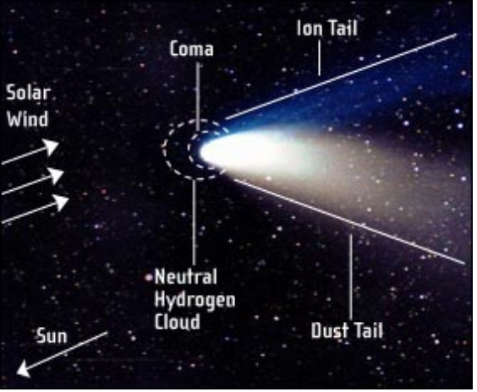
Figure 4: (<http://www.celestron.com/astrowatch/comets/>)

Orbital Elements_________________________________________________________
There are six essential elements to describing a comet’s orbital movement. (Schaff, pg.346) The perihelion date (T) gives us the date and time at which the comet is closest to the Sun. This is a comet’s starting point. Perihelion distance (q) and eccentricity (e) give us the shape and size of a comet’s orbit. (q) is the distance between the Sun and the comet at perihelion measured in AU. (e) is a measure of the extent to which an orbit is elongated or open in comparison to a circle, ellipse, parabola, or hyperbola. Finally, the inclination (i), the longitude of ascending node (Ω), and the argument of perihelion (μ) are the three elements that describe a comet’s orientation in space. (i) describes the angle in degrees that an orbit is tilted from the ecliptic plane. (Ω) describes the angle in degrees from the vernal equinox to the comet’s ascending node. The ascending node is the point where the comet’s plane of orbit passes northward of the earth’s plane of orbit. (μ) describes the angle in degrees between the comet’s ascending node and the comet’s perihelion. (Schaff, pg.346)
Orbits of comets consist of very long ellipses. In terms of eccentricity (e), an ellipse has an eccentricity between 0 and 1. As (e) approaches 1, the orbit will appear more like a straight line than an ellipse. As (e) approaches 0, the orbit will appear more like a circle. Those comets with an (e) greater than 1 are described as having a hyperbolic orbit and will not ever return to our solar system. Comet’s paths can vary quite drastically from the Earth’s orbital plain with the Sun as determined by (i). (Schaff, pg.346) The force of gravity is imposed on a comet’s body from the different members in the solar system. The force imposed on this body can come from neighboring asteroids, meteoroids, or other comets in the Kuiper Belt as well as planets like Jupiter and Earth. In addition to the Kuiper Belt, a comet’s orbit can be determined by its interaction with other comets in the Oort Cloud. The gravity from other planets or celestial bodies can grab on to comets and drastically alter their original orbits.

Observations
In our observations, we were able to see C/2001 Q4 NEAT, but were unable to see C/2002 T7 LINEAR even though it is now visible in the northern hemisphere. In the past month including our field trip to Goldendale Observatory in Eastern Washington, we observed the comet a total of seven times. Most observations could only be made when conditions for viewing were optimal. We had a difficult time finding a location to make our observations because of our proximity to the neighboring city light pollution. We decided to observe off a road out by Delphi Valley. We were able to observe the comet with our own eyes on at least one occasion; the rest of the observations made were done with our 10X50 binoculars and use of the Orion and Goldendale Observatory telescopes.
If we were to trace the route that Comet NEAT took in the sky it appeared at the beginning of May below Canis Minor. As the days and nights passed, NEAT continued to rise above Canis Minor, Hydra, through Cancer and Lynx at about one degree of declination a night. NEAT is now in Ursa Major and can currently be seen in the fore arm of the "Great Bear". If this path continues we think that the comet will pass through the "cup" of the big dipper. As the days continue now, NEAT will dim more, making observation much more difficult until finally it is no longer visible.
We estimate that NEAT's angular size is much less than a quarter of a degree. While the comet does appear angularly larger than a star, it is still difficult to determine its actual size. We think it has the angular size of 3-4 stars clumped together or a couple of arc seconds in diameter. Tails were only faintly visible in early may and grew to a length of about 2-3 degrees before fading away. We were able to observe a distinct dust tail and ion tail at least one of the nights.
We learned a lot about observing comets and what to bring when we observe. We were surprised to see how dim and cloudy NEAT appeared to us and concluded that we were still not far away enough from the nearby light pollution to observe NEAT well enough. The tails were easier to observe with our binoculars than with the use of the Orion telescope or the Observatory telescope, which surprised us as well. Since we were unable to make calculations, it is difficult to make any further conclusions from our observations. We will continue to track NEAT and possibly LINEAR for as long as we can and hopefully, we will be able to make some calculations with further observations.

Research _______________________________________________________________
What would it take for a comet to change orbit when nearing the Sun and give it a trajectory headed directly towards the Earth? To guide our investigations of this research question, we postulated three hypotheses. The first: when approaching perihelion, a comet is influenced by the Sun’s radiation to form a large enough thrust, deviating the comet from its original path and giving the comet a new trajectory towards Earth. The second: when approaching perihelion, a comet is influenced by the Sun’s radiation and accelerates along its orbit but does not deviate from that orbit. The third: when a comet approaches perihelion, the Sun’s radiation does not influence that comet’s speed and the comet does not deviate from its orbit.
We have learned that the sublimation of a comet’s icy nucleus contributes to a comet’s movement. As solar radiation interacts with the comet, the sublimation of the nucleus reveals pockets of gas that expel rapidly forming jets. These jets contribute to a comet’s rotation, its velocity, and its acceleration. Therefore, a substantial amount of thrust might be created from the comet’s jets, enough to push a comet out of its present orbit and into a new one; we have not investigated the probability of this happening.
A comet’s movement through space can be very complicated because their orbit is influenced greatly by the gravity from planets in the solar system and the Sun. It is possible for a comet to impact a planet as long as the comet's orbit brings it close enough to the planet’s gravity to be captured by it. A comet’s jets could also motion the comet to impact the surface. We do not need to speculate or theorize such an event. Evidence of this phenomenon exists if we look at the different members of our solar system including the moon and Earth.

Substantial Evidence of Planetary Impact____________________________________
Our own planet is showered on a daily basis by meteoroids and comet dust. (Freedman/Kaufmann, pg.375) One of the major meteor showers, the Leonid meteor stream, comes from Comet Tempel-Tuttle. This comet orbits the Sun approximately every 33 years on its passage away from the Sun it leaves a long stream of debris. The Earth’s atmosphere intersects this trail of debris in mid-November creating a very brilliant meteor shower. The dust from a comets tail is really of no danger to our planet, but there is a far graver threat than the normal occurrence of meteor showers. The probability of a comet impacting the Earth! The occurrence of this, while rare, has been recorded in the Earth’s geology. These records support historical observations of comets impacting the earth. One particular event, had it occurred in a more inhabited area of the planet, would have become a catastrophic event in the history of our world.
On June 30 1908, a ball of fire was observed by many natives in the forests of Siberia known as the Taiga. (Brandt/Chapman, pg.185) This ball of fire was observed to have plunged into the Earth’s atmosphere and explode in mid-air, producing a massive shockwave that leveled an area more than 2000 sq km over the basin of the Podkamennaya Tunguska River (Grego, pg.100). Trees were found charred, lying away from the explosion, and an entire population of reindeer were reported missing after the incident. Several eyewitnesses were hurt from the shockwave and two indirect deaths were reported. These eyewitnesses report seeing the ball of fire setting the nearby forest on fire and just as quickly putting the fire out from the massive blast of a mid-air explosion. An earthquake was registered at a seismic station in Irkutsk, almost 900 km from the site of the explosion (Brandt/Chapman, pg.185). The Tunguska body’s mid-air explosion was sensed by microbarographs in Britain, calculating a speed for the change in the atmospheric pressure of 308-323 m/s (Grego, pg.77). It is estimated that the impact’s explosion was similar to 12.5 megatons of TNT or 2000 times more powerful than the atomic bomb that devastated Hiroshima at the close of World War II (Grego, pg.76).
Fortunately, the Earth’s atmosphere protects us from most of the cosmic dust, small meteors, or comets that we encounter everyday. This is why it is believed that there was no evidence discovered after the Tunguska event. In an expedition in 1962, several scientists discovered a narrow area almost 250 km in length containing an unusually high amount of cosmic dust (Brandt/Chapman, pg.186). Calculations performed by Czech astronomer Lubor Kresak conclude that the Tunguska event probably originated from Comet Encke, where a small chunk of the comet broke off and headed for Earth (Schaff, pg.100). The small chunk’s low density is what allowed it to break up in the Earth’s atmosphere and explode 6 km in the air (Grego, pg.75). It is estimated that an event like this only happens once every few hundred years and efforts are currently underway to avert another event like this from happening again.

The Race to Protect the Earth from Destruction_______________________________
Organizations like Near-Earth Asteroid Discovery Statistics, Lincoln Near-Earth Asteroid Research (LINEAR), Near-Earth Asteroid Tracking (NEAT), and many others are all part of the Near Earth Object (NEO). Program, one of the many sub-divisions of NASA. (http://neo.jpl.nasa.gov/) These teams dedicate their time to finding asteroids, celestial objects, and comets that come within a certain proximity to our planet. This proximity is measured in fractions of AU or in Lunar Distance (LD) with one LD equal to approximately 384,000 km, the distance from the Earth to the Moon. (http://neo.jpl.nasa.gov/) Risk of impact on Earth is rated using the Torino Scale from 0-10: 0 being no risk and 10 being an imminent impact. (Steel, pg.137) Most of the NEO’s found in our neighboring space today rate mostly “0” with a few “1” ratings every now and then. (http://neo.nasa.gov/risk/) An example of a rating "10" on the Torino scale would be the K/T boundary event responsible for ending the reign of the dinosaurs on Earth. (Verschuur) Finding NEO’s is only half the battle, however. What should happen when we find a NEO that has a high risk of impacting our surface? What can we do to avoid a catastrophe from occurring hear on Earth?
There isn’t a lot that we can do about diverting a NEO’s path, but scientists in space agencies all around the world like the International Spaceguard Foundation are brainstorming methods to do so. (Steel, pg.125) The most popular of ideas already have been glorified by Hollywood. The development of nuclear weapons has allowed humanity a chance, albeit a very slim one, to overt the catastrophe of cometary or asteroidal impact on Earth. Contrary to what you may have seen in the movies, it is actually more productive if the nuclear device is detonated outside of the NEO. If detonated inside, it would blow up into several smaller pieces and the blast will not have changed the path of the comet. That’s like turning a cannon ball into a shotgun blast (Steel, pg.128). The idea with detonating outside of the NEO, is to push the NEO away from Earth so that we can avoid the danger all together. The problem with this is that there would have to be a series of successive detonations to push the object far away enough to eliminate the danger. (Grego)
Other ideas include attaching engines to the object to help change the objects trajectory or shooting a super hot laser that would sublimate a comets surface, pushing it out into a different trajectory. (Steel) A lot of these solutions are still riddled with problems making them difficult to carry out. There are still a large number of objects that we have failed to see because of the difficulty to view them and because there are just so many objects to view in space. If our society is serious about protecting our planet from the threat of an impact, we must place more effort into watching the night sky. Even with the current network of NEO organizations and agencies, it’s not enough,
“At our current level of effort in looking for these lethal projectiles, the chances are that we would not see it prior to impact. Unless you count eight or ten seconds’ warning as constituting an adequate time to prepare.” (Steel)
For the moment, we can marvel at the assembly of an active network of NEO tracking. As technology advances, these problems will be confronted and preventative solutions will become feasible, but until that is the case, it’s probably best to just hope we don’t come across an NEO’s path anytime soon.

Conclusion______________________________________________________________
In order for a comet to gain a trajectory headed towards Earth, the comet’s orbit has to be within the proximity of the Earth. Once sublimation begins, jets can form on the side of the comet facing the solar radiation. These jets contribute a thrust perpendicular to body of the comet affecting its rotation, velocity, and acceleration. If the rotation of the comets body is not too variable, then the thrust produced from the jets could accelerate the comet into Earth, another planet, the Sun, an asteroid, etc. Should the comet enter our atmosphere, its materials will dissipate substantially and depending on the size of the comet, may or may not actually impact the Earth. If impact were to occur, the level of catastrophe will range from something as small as the Tunguska event to something as large as the K/T boundary event again depending on the size of the comet. As a comet approaches perihelion, the solar radiation could accelerate the comet into another object, like Earth. Cometary impact on Earth is possible, but based on the myriad of factors from gravity, the comet’s position, Earth’s position, and the complexity of cometary motions, the likelihood of this event occurring is very slim. Though the window of impact on Earth is small, we cannot ignore the threat it poses to us.
Bibliography

•Brandt, John C. and and Robert D. Chapman. “Rendezvous in Space: The Science of Comets” 1992; WH Freeman and Company, New York.

•Freedman, Roger A. and William J. Kaufman 3rd. “Universe, 6th ed.” 2002: WH Freeman and Company, New York.

•Grego, Peter. “Collision Earth: The Threat from Outer Space” 1998: Blandford, London.

•Levy, David H. “Comets : Creators and Destroyers” 1998: Touchstone, New York.

•Levy, David H. “The Quest for Comets” 1994: Plenum Press, New York.

•Schaaf, Fred. “Comet of the Century: From Halley to Hale Bopp” 1997: Springer-Verlag, New York.

•Verschuur, Gerrit L. “Impact: The Threat of Comets and Asteroids” 1996:Oxford University Press, New York.

•Yeomans, Donald K. “Comets: A Chronological History of Observation, Science Myth, and Folklore” 1991: John Wiley and Sons, New York.

- Steel, Duncan. "Target Earth: The Search for Rogue Asteroids and Doomsday Comets that Threaten Our Planet" 2000: The Readers Digest Association, Inc., Pleasnatville, New York

•<http://cometography.com/>
•<http://www.heavens-above.com/>
•<http://www.space.com/>
•<http://www.spaceweather.com/>
•<http://antwrp.gsfc.nasa.gov/>
- <http://neo.jpl.nasa.gov/>

