Seminar Assignment for week 7
Chemistry for the Health Professions

The seminar on Friday 5-13-05 will focus around nutrition and human health. During week seven we will watch a video called, “Diet Wars”. Starting on Saturday of week seven you will begin keeping a food diary. (See the web or your day one packet for the food diary assignment description.) During week eight you will participate in a nutritional analysis workshop.

Read through this handout; print out four PDF files (calories.pdf, explanation.pdf, intake.pdf, pyramid.pdf) and look-up, print-out, and read the following three articles.
Type a one-page reaction statement to turn in at the beginning of seminar.

- Alana Semuels, “Nations new food pyramid baffles critics”, Pittsburgh Post-Gazette, 4-20-2005
- Harvard School of Public Health, “Food Pyramids” (This will be an online only 8 page article.)
- McCullough ML, Feskanich D, Stampfer MJ, et al. “Diet quality and major chronic disease risk in men and women: moving toward improved dietary guidance” Am J Clin Nutr 2002; 76: 1261-71

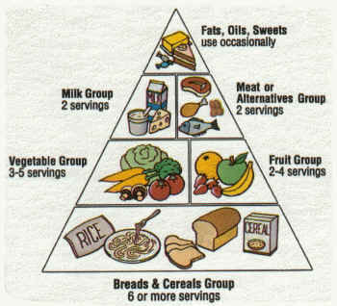

The Original Food Pyramid

