10/10-11 Laboratory: Water Quality and Microbiology Techniques

Today we will analyze the results from last week’s experiments and continue learning new techniques in microbiology. The first part of the lab will be dedicated to data analysis and water quality testing. The second part will focus on microscopy and gram staining – one of the most common bacteriology tests performed in determinative bacteriology.

PART I. Data Analysis
Take this time to analyze your serial dilution plates and your quadrant streak plate. Share the information with others in the class. Evaluate the results from your group experiment and be sure to that everyone in the four groups has the data from the individual group experiment. Also report the data to the instructors so that the entire class has access to it.

PART II. Water Quality Testing
Today you will perform a determinative bacteriology test to identify members of the Enterobacteriaceae family. Members of this family are defined as gram negative, non-spore-forming rods which ferment the sugar lactose with the evolution of gas and acids. General coliforms produce the enzyme galactosidase in lactose fermentation and E. coli produces the enzyme glucuronidase in addition to galactosidase. The Coliscan Gel method is a medium that allows for the differentiation of coliforms and E. coli from other bacteria in water and other types of samples. This method incorporates two chromogenic substrates which are acted upon by the enzymes galactosidase and glucuronidase to produce pigments of different colors. General coliforms will produce galactosidase and will grow as pink colonies. E. coli will produce galactosidase and glucuronidase, and will grow as blue/purple colonies. The sum of the E. coli and the other coliforms is the total coliform number. Non-colored colonies that grow in/on the medium are not coliforms, but may be members of the family Enterobacteriaceae such as Salmonella, Shigella, Proteus, etc. Unrelated bacteria that produce that produce glucuronidase only will turn teal green. Coliscan Gel contains inhibitors, thus most other bacteria will not grow on it.

Protocol
1. You may select any two water samples that you wish to test. However, a discussion at the beginning of class will provide you with more details to guide you in your selections.

2. Prepare your sample for mixing with the Coliscan Gel. You may use up to 5mls water per plate but it is best if you use less.

3. Mix your water sample with the sterile Easygel medium and swirl gently to mix. Be sure to mix well.

4. Pour the gel into the plate provided. Place the unsolidified plate in the incubator until solid. After it solidifies, invert the plate.

Interpretation of Coliscan Gel results:
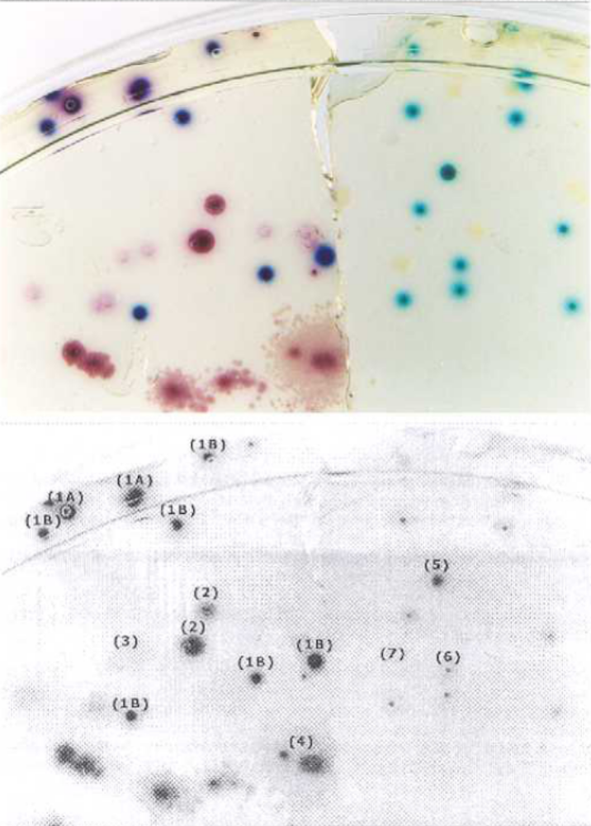
Specific colonies are numbered in the picture to the left and their interpretation is described below. Refer to the color photo for the actual color reference.

The left half of the photo (#1-4) consists of colonies of E. coli (#1A and 1B) and Enterobacter aerogenes (#2, 3, 4) growing in/on Coliscan Easygel medium. The right half of the photo (#5, 6, 7) represents the appearance of organisms other than E. coli or coliforms.

1A – Two E. coli CFUs showing purple color with obvious pink diffused halos. Fecal coliform. (Glucuronidase +, Galactosidase +)

1B – E. coli CFUs blue/purple color with obvious pink diffused halos. Fecal coliform. (Glucuronidase +, Galactosidase +)

2 – Enterobacter aerogenes CFUs as dark, solid pink color. Non-fecal coliform (Glucuronidase -, Galactosidase +)

3 - Enterobacter aerogenes CFUs as light pink color. Non-fecal coliform (Glucuronidase -, Galactosidase +)

4 - Enterobacter aerogenes CFUs spread on surface of medium (2 original colonies) Non-fecal coliform (Glucuronidase -, Galactosidase +)

5 – Teal green CFU growing on surface of medium. (Glucuronidase +) This colony type should not be counted as E. coli or coliform.*

6 – Teal green CFU growing in the medium (Glucoronidase +). This colony type should not be counted as E. coli or coliform.*

7 – Colorless CFU (indicates no Glucoronidase or Galactosidase activity) This colony type should not be counted as E. coli or coliform.*

These teal or colorless types of colonies may be significant other types of bacteria (such as Salmonella or Shigella) or even rarely found atypical E.coli or coliforms, but should never be counted as E. coli or coliforms without further biochemical testing.

PART III. Using the microscope

The microscope is one of the most valuable tools of the scientist. They use it to study and identify a large variety of organisms. It is believed that engravers used glass globes filled with water as magnifying glasses at least 3,000 years ago. The simplest microscope is called a magnifying glass. Optical microscopes magnify because light rays reflected from an object bend (refract) as they pass through one or more lenses.

How big you can make the object depends on the refractive index (bend power) of the glass in the lens. Hand lenses are 3 to 10x. Since the light rays are spread out when an object is magnified, the magnified object is not as bright as the original. To make it as bright as it was originally additional light must be used. This is the purpose of having a mirror under the lens of the microscope. It collects sunlight or light from an auxiliary lamp. The condenser focuses the light collected by the mirror onto the sample.

Suppose that you took a small section of a magnified object and placed a second lens over it. This magnified section could then be further magnified and we would have a compound microscope. The Dutch spectacle maker, Zacharias Janssen, is credited with discovering this principle and making the first compound microscope in 1590. Since then, there have been many improvements although the basic concept has remained essentially unchanged. Magnification up to about 400x is possible with ordinary illumination. With a substage condenser to focus more light on the object and with better lenses, it is possible to go to 1000x magnification. About the highest magnification that can be obtained with a compound microscope is 2500x.

The quality of a microscope resides in the lenses. Slight imperfections can cause large distortions in the object that is viewed. In addition, various colors refract at different angles, so correcting lenses must be added. Expensive microscopes have excellent correcting lenses, while less expensive microscopes may not even have correcting lenses.

In working with a compound microscope, you will find the following terms useful:

Working distance - the distance between the specimen and the tip of the objective lens. In general, the higher the magnification, the shorter the working distance.

Depth of field - the thickness of the object that is simultaneously in focus. The higher the power of magnification, the less is the depth of field.

Field of view - the area or diameter of the specimen that is in view. The higher the power of magnification, the less is the field of view.

Magnification - to determine the magnification of a microscope multiply the magnification of the eyepiece by the magnification of the nosepiece.

PART A: THE COMPOUND MICROSCOPE

Obtain an assigned compound microscope from the cabinet, and carry it back to your seat at the lab table.

With a piece of lens paper and lens cleaner, lightly wipe any dust and grease from all the exposed glass surfaces. Never use anything else to do this job.

Spend the next few minutes becoming familiar with the names and locations of the various important parts of the instrument; Figure 4-1 will help.

Several important rules are to be noted concerning the foregoing procedures:

- To find an object, always start your examination with the low-power objective, never with the high. The low-power objective reveals an area of the slide some 20 times greater than the high-power, making it 20 times easier to locate the desired object.

- To bring the object into focus, always focus upward, with the coarse adjustment. (NOTE: Some microscopes focus by moving the stage up and down rather than the body tube. In such cases, the focusing is downward-away from the nonmovable parts.) You want to focus upward because when your eye is at the ocular (eyepiece), it is impossible to determine how far down or up the tip of the objective has traveled. In focusing down, carelessness might result in crushing the specimens.

- When the high-power objective is being used, never use the coarse adjustment.

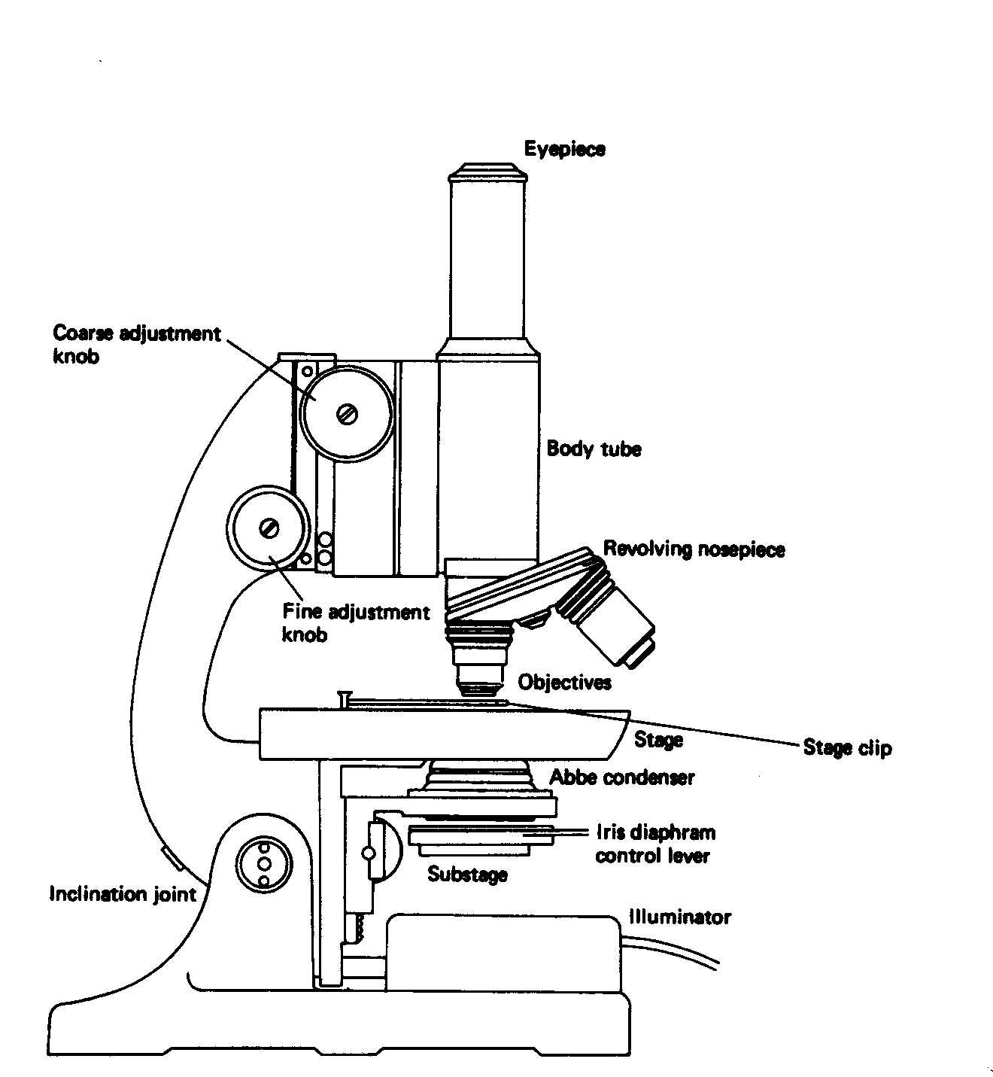

FIGURE 4-1: General structure of a compound microscope.

Köhler Illumination

Anyone can eventually adjust a microscope to view an object placed on a slide. However, if you want to do it the best way possible to get the brightest image with the best focus possible then you should use Köhler illumination. This is a method to align the optics and focus all of the components to minimize distortion and to obtain uniform brightness. It should be done with every sample and particularly so if a photomicrograph is to be made. It can be done in less than five minutes once you know how to do it. An uncentered lamp filament will usually not show up until a photomicrograph is taken and then the photo will be unevenly exposed. It has been estimated that 90% of the people who use a microscope do not use Köhler illumination, either because they do not know what it is or do not know how to make the adjustments. Since a microscope is a major component of a criminalistics laboratory and because many photomicrographs are taken, it is desirable that you should know the basics of how to establish Köhler illumination. A comparison can be made between a finely tuned engine and one that needs a tune up. Both will run and both will do the job, but to get the best performance and have the greatest piece of mind, you use the one that is properly tuned.

The components that need to be adjusted are: (a) the light source, (b) the field diaphragm, (c) the condenser, (d) the objective lens, and (e) the iris diaphragm. While all of these can be adjusted on a high quality microscope, usually only the condenser and the iris diaphragm can be adjusted on student type microscopes. The directions given below are for use with a high quality microscope. Your instructor will tell you how many you can do with your microscope.

- Place the fixed objective lens in place. This is usually a 10x objective lens. Adjust its height to be about 2-3 mm above the stage with the coarse focusing adjustment.
- Turn on the lamp. If it has an adjustable intensity control, adjust the intensity to be bright, but not cause you to squint. Feel comfortable.
- If the microscope is binocular, (two eyepieces) adjust their separation to fit your eyes.
- Place a slide, with a specimen on it, on the stage and center it.
- Open both the field and iris diaphragms completely so the specimen can be viewed. You should have a full field of view with an unfocused specimen close to the center. See Figure 4-2 (A).
- Bring the specimen into focus by focusing up, first with the coarse adjusting knob, then with the fine adjusting knob. See Figure 4-2 (B).
- Completely close the field diaphragm (the one just in front of the lamp) or until about all you can see is a fuzzy circle around your specimen. Almost the entire field will be black except for a small white circle of light around your specimen and the separation between the black and white will usually be fuzzy and multi colored. Keep your specimen inside of the light area, or at least so you can see part of it. See Figure 4-2 (C).
- Move the condenser up or down to focus the edge of the diaphragm. You should now be able to see that the circle is actually a polygon. See Figure 4-2 (D).
- Your specimen should be in the center of the lighted area. If it is not, and you have condenser controls (usually two adjusting screws with handles on them just under the stage), adjust the condenser so your specimen is in the center of the bright area. See Figure 4-2 (E).
- You should be able to move any other higher power objective in place and the specimen should still be in the center. If it is not, then there are inset adjusting screws at the base of each objective lens where it fastens onto the turret. These can be adjusted to center the specimen. Only the instructor should do this if it is necessary.
- Open the field iris until the lighted area just fills the circular field. You should be able to see a polygon perfectly inscribed and just touching the outer rim of the field of view.
- Remove one of the eyepiece oculars so you can look down the body tube. If you have a high quality microscope with a lamp adjustment then do step 13. If not, go to step 14. Refer to Figure 4-3.
- Focus an image of the lamp filament on the objective back focal plane by moving the lamp with its adjusting screws.
- Open or close the iris diaphragm (right under the stage) until the polygon fills about 70-80% of the field of view (Figure 4-4). This provides for good image contrast, a flatter field and better depth of field.
- Replace the eyepiece ocular. You now have Köhler illumination. See Figure 4-2 (F). Unless you did step 10, you should repeat this each time the objective is changed.

FIGURE 4-2 Selected views for establishing Köhler Illumination.

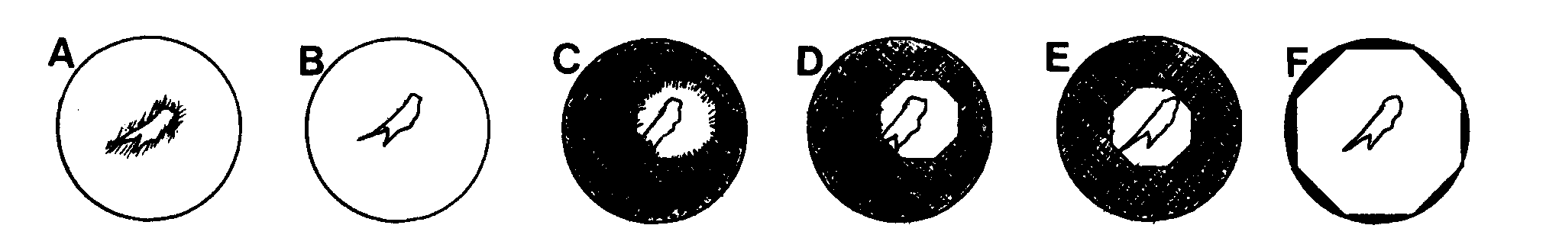

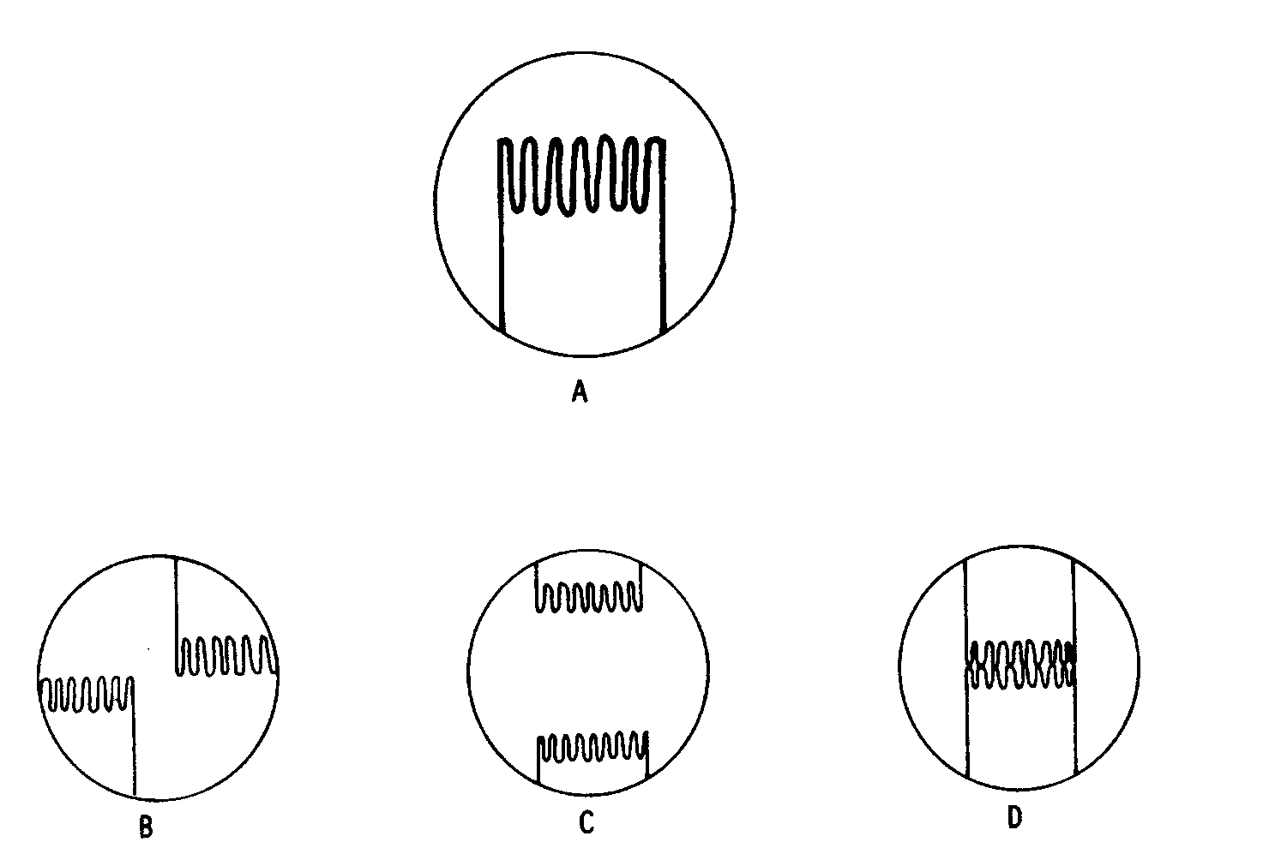

FIGURE 4-3 m (A) A diagram of the image of the filament of a quartz-iodine bulb as seen in the plane of the aperture diaphragm of the condenser. (B) One possible appearance when the lamp system is out of adjustment. Two images of the filament (one inverted and produced by the mirror behind the lamp) are not coincident. (C) The filament images have not been aligned. (D) The final correct adjustment when the images are both aligned and made contiguous. Courtesy of S. Bradbury, "An Introduction to the Optical Microscope," Oxford University Press, (1984).

- Turn on the substage illuminator of your microscope if it has one or the auxiliary lamp if the lighting is separate.

- Now, looking through the ocular, slowly raise the tube with the coarse adjustment knob until the letter "h" is in focus. If you cannot see the object, center the slide more carefully and repeat the whole procedure. The focus may be made sharper by a slight turn on the fine adjustment knob.

- Open and close the iris diaphragm by turning the diaphragm handle, which projects laterally from the lower portion of the condenser. The iris diaphragm controls the amount of light reaching the specimen. Adjust it to make the image as sharp as possible (maximum definition).

- The image is in focus 3 to 4 mm above the eyepiece. Thus, there is no reason to press one's eye to the ocular. Some students who wear glasses find it advisable to remove them, others to keep them on, as determined by experience.
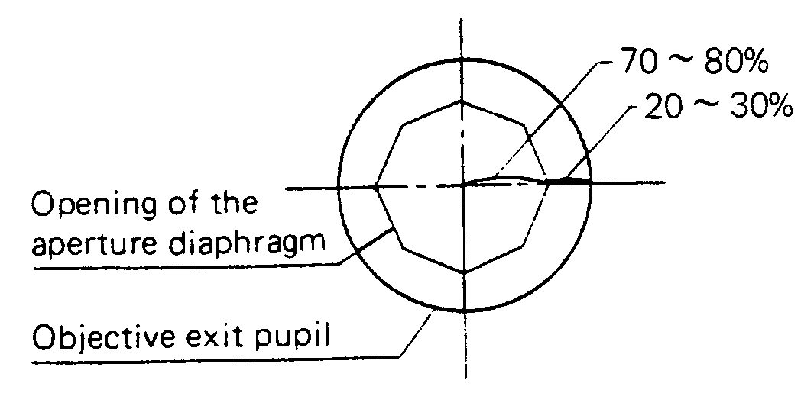

FIGURE 4-4 The final adjustment with the iris diaphragm. Courtesy of Olympus Optical Co., Ltd., Tokyo, Japan.

- To change to high power, make sure that you have focused sharply under low power on the object and centered it in the field. Then, carefully swing the high-power objective into place. The microscopes are parfocal. This means that once the image is brought into sharp focus under low power, it will remain in focus when the high-power objective is turned into position. The high-power objective should not strike the slide, though it will come very close. A few turns of the fine adjustment knob, either up or down, should suffice to bring the "h" into sharp focus. If it does not, go back to step 3 and begin again. Once the image has been brought into sharp focus, it may be necessary to readjust the diaphragm opening, as discussed in step 8 in the Köhler Illumination section.

PART IV. Gram Staining
This exercise is to show you how microbiologists use cell structure to identify different kinds of bacteria. The Gram’s stain allows us to discern between bacteria with thick peptidoglycan layers (Gram positive) and those with relatively thin peptidoglycan layers (Gram negative). The peptidoglycan layer in the bacterial cell wall is a structure formed from linear chains of two alternating amino sugars, namely N-acetyl glucosamine (GlcNAc or NAG) and N-acetyl muramic acid (MurNAc or NAM). Each MurNAc is attached to a short (4 to 5 residue) amino acid chain, normally containing D-alanine, D-glutamic acid and mesodiaminopimelic acid. These three amino acids do not occur in proteins and are thought to help protect against attacks by most peptidases.

Protocol
Equipment
Bunsen burner, alcohol-cleaned microscope slide, water, forceps

Reagents
Crystal violet, Gram's iodine solution, acetone/ethanol (50:50 v:v), 0.1% basic fuchsin solution, several bacterial strains

Procedures
1. Prepare a Slide Smear:
A. Transfer a drop of the suspended culture to be examined on a slide with an inoculation loop. If the culture is to be taken from a Petri dish or a slant culture tube, first add a drop or a few loopful of water on the slide and aseptically transfer a minute amount of a colony from the Petri dish. Note that only a very small amount of culture is needed; a visual detection of the culture on an inoculation loop already indicates that too much is taken. The smear should be thin enough to dry completely within a few seconds. Stain does not penetrate thickly applied specimens, making interpretation very difficult.
B. Spread the culture with an inoculation loop to an even thin film over a circle of 1.5 cm in diameter, approximately the size of a dime. Thus, a typical slide can simultaneously accommodate 3 to 4 small smears if more than one culture is to be examined.
C. Air-dry the culture and fix it or over a gentle flame, while moving the slide in a circular fashion to avoid localized overheating. The applied heat helps the cell adhesion on the glass slide to make possible the subsequent rinsing of the smear with water without a significant loss of the culture. Heat can also be applied to facilitate drying the the smear. However, ring patterns can form if heating is not uniform, e.g. taking the slide in and out of the flame.
2. Staining:
A. Add crystal violet stain over the fixed culture. Let stand for 10 to 60 seconds; for thinly prepared slides, it is usually acceptable to pour the stain on and off immediately. Pour off the stain and gently rinse the excess stain with a stream of water from a faucet or a plastic water bottle. Note that the objective of this step is to wash off the stain, not the fixed culture.
B. Add the iodine solution on the smear, enough to cover the fixed culture. Let stand for 10 to 60 seconds. Pour off the iodine solution and rinse the slide with running water. Shake off the excess water from the surface.
C. Add a few drops of decolorizer so the solution trickles down the slide. Rinse it off with water after 5 seconds. The exact time to stop is when the solvent is no longer colored as it flows over the slide. Further delay will cause excess decolorization in the gram-positive cells, and the purpose of staining will be defeated.
D. Counterstain with basic fuchsin solution for 40 to 60 seconds. Wash off the solution with water. Blot with bibulous paper to remove the excess water. Alternatively, the slide may shaken to remove most of the water and air-dried.
3. Quality control:
It is a simple matter to prepare a control slide by breaking a clean wooden applicator stick and picking a small amount of material from the interproximal space of one's teeth. This should be smeared into a drop of clean tap water on a clean glass slide. The slide may be stained as above. This material will consistently display a few neutrophils and a mixture of Gram (+) and (-) organisms. Neutrophil nuclei should be pink.
4. Examine the finished slide under a microscope.
A caveat in the examination of the Gram smears is the distortion in morphology that can be caused by antimicrobial therapy. This is especially likely to occur in urine speciments. Filamentous and pleomorphic forms may be observed among the Gram (-) rod species. Gram reaction of the organism may also change after antimicrobial therapy, Gram (+) bacterial may become gram variable. Look at areas that are one cell thick only; observation of thick areas will give variable and often incorrect results. White blood cells and macrophages should stain Gram-negative, whereas sqamous epithelial cells are Gram-positive.

