Foundations of Public Administration, Constitution Summary Sheet

References:
Greenberg, E. & Page, B., The Struggle for Democracy, 4th ed., Addison-Wesley Educational Publishers Inc., 1999

http://www.usconstitution.net

The Basics
The Constitution is the highest law in the United States. The Constitution also provides a framework for the government of the United States. It creates things like the President, the Congress, and the Supreme Court. It is a public record of how decisions are to be made in government.

Article I: Legislative Branch- House of Representatives and the Senate.
Article II: Executive Branch
Article III: Judicial Branch
Article IV: How states work together, Citizen’s rights, State’s rights.
Article V: Amending the Constitution
Article VI: Public Debt, Supreme Law of the Land
Article VII: Ratification of the Constitution

The Constitution sets up three main branches of government. These are called the Legislative, the Executive, and the Judiciary. Each one has its own role in how the law is made and used. The role of the Legislature is to make the law. The legislature is called the Congress, and is made up of the House of Representatives and the Senate.

Legislative Branch: Congress
House of Representatives: 435 members, based upon the population of each state, must be at least 25 years old, U.S. citizen for at least 7 years, 2 year term in office, can impeach officials.
Senate: 100 members, 2 members for each state, must be at least 30 years old, U.S. citizen for at least 9 years, six year term in office, holds impeachment trials.

The role of the Executive is mainly to make sure the law is carried out. Executive branch includes: President, Vice President, Department of Agriculture, Department of Commerce, Department of Defense, Homeland Security, Department of Education, Department of Energy, Department of Health and Human Services, Department of Housing and Urban Development, Department of the Interior, Department of Justice, Department of Labor, Department of State, Department of Transportation, Department of the Treasury, Department of Veterans Affairs.

The last branch is the Judiciary. This includes all the federal courts, all the way up to the Supreme Court. States have their own court systems that fall underneath the national court system. The role of the Judiciary is to interpret the law.

The Preamble to the Constitution has no force in law; instead, it establishes the “Why” of the Constitution. Why is this document in existence? It reflects the desires of the Framers to improve on the government they currently had (to be “more perfect” than the Articles of Confederation), to ensure that that government would be just, and would protect its citizens from internal strife and from attack from the outside. It would be of benefit to the people, rather than to its detriment. And, perhaps as importantly, it intended to do the same for the future generations of Americans.

A history lesson
The colonists were loyal subjects of the English King, George III. For a time. They fought with the British against the French in the French and Indian War.
1763. 1776. In thirteen years, the colonies went from loyal subjects, helping the war cause, to rebels, intent on expelling Britain from the world it had conquered, intent on independence.

There are many reasons given for the change, from the patriotic to the cynical. For some, the colonists were intent on freedom, on ridding themselves of a monarch that oppressed them. For others, the ruling elite of the colonies was done sharing the wealth of their holdings with the mother country, and had to sever all ties to keep it all for themselves.
The French and Indian War was a great victory for the United Kingdom, but it left a large hole in the nation’s wallet, doubling its debt. Taxes were increased everywhere, and the colonies were no exception. Indeed, the King felt that since his soldiers were in the colonies, there to protect the people (and the land and its riches) against foreign attack and Indian transgression, that the colonies should pay more than their fair share of the defense budget.

1763 through 1765, the British Parliament enacted several laws which the colonists sharply disagreed with. The Proclamation of 1763 prevented settlement of the area south of the Appalachians; the Currency Act prohibited the use of paper money for the payment of debt; the Sugar Act placed a tax on goods imported into the colonies, such as sugar, wine, and coffee and provided for tight control on its enforcement; the Quartering Act

On July 4, 1776, the Declaration of Independence was formally accepted. It was formally signed on August 2, 1776, with some members adding their names after that date. The Declaration was printed and sent out to the colonies and to the troops.

Shays’ Rebellion, 1786-1787
In the summer of 1786, a group of farmers formed under Revolutionary War veteran Daniel Shays. They were protesting the Constitution of Massachusetts and the seizure of farms for non-payment of debts. The group marched on Springfield with the intent of siezing a federal armory, but they were turned away by General Benjamin Lincoln, commanding a militia force paid for by Bostonian merchants. This event shocked much of the upper and ruling classes, as they realized how close the young United States came to a mass rebellion, and how ineffective the Articles of Confederation were in the quelling of such rebellion. The Rebellion was a motivating event that ultimately led to the Constitutional Convention.

Comparing the Articles and the Constitution
The United States has operated under two constitutions. The first, The Articles of
Confederation, was in effect from March 1, 1781, when Maryland ratified it. The second,
The Constitution, replaced the Articles when it was ratified by New Hampshire on June
21, 1788.

The two documents have much in common - but they differ more than they do resemble each other, when one looks at the details. Comparing them can give us insight into what the Framers found important in 1781, and what they changed their minds on by 1788.

Articles of Confederation:
Organizing Principle- a loose confederation of independent states, with a weak central government.
Central Government- no president or judiciary. Legislature has no power to levy taxes, to regulate commerce between states, or to enforce national policy.
State Governments- sovereign states have veto power over constitutional change, independent power over militia and over commerce between states.

U.S. Constitution:
Organizing Principle- a federation of states, with powers divided between states and a central government.
Central Government- powers are divided among executive, judicial, and legislative branches, each with certain powers over one another. Can levy taxes, regulate commerce and currency, enforce national laws, and raise a military.
State Governments- states are represented in Congress and through electoral votes. Approval of 3/4 of the states needed to amend the Constitution.

THE ELECTORAL COLLEGE
The Framers were wary of giving the people the power to directly elect the President - some felt the citizenry too beholden to local interests, too easily duped by promises or shenanigans, or simply because a national election, in the time of oil lamps and quill pens, was just impractical. Some proposals gave the power to the Congress, but this did not sit well with those who wanted to see true separation of the branches of the new government. Still others felt the state legislatures should decide, but this was thought to make the President too beholden to state interests. The Electoral College, proposed by James Wilson, was the compromise that the Constitutional Convention reached.

The electoral college are representatives of the states who formally elect the President. The number of electors in each state is equal to the total number of its senators and congressional representatives.

State Constitutions
Each state in the United States has its own constitution. Of course, all state constitutions are inferior (in a legal sense) to the United States Constitution, and when reading state constitutions, this must be kept in mind - a state constitution, for example, cannot validly authorize a state religion. However, many state constitutions guarantee civil rights that the United States Constitution does not. The Vermont Constitution, for example, abolished slavery long before the U.S. Constitution did so.
The following U.S. territories also have constitutions:
• American Samoa
• Guam
• Puerto Rico
• US Virgin Islands

Data on the Framers of the Constitution
Note: the “T’ column is an answer to the question, did this person sign the Constitution?
Religion key:
CO = Congregationalist
DE = Deist
DR Dutch Reformed
EP Episcopal
LU = Lutheran
ME Methodist
PB Presbyterian
QU = Quaker
RC = Roman Catholic

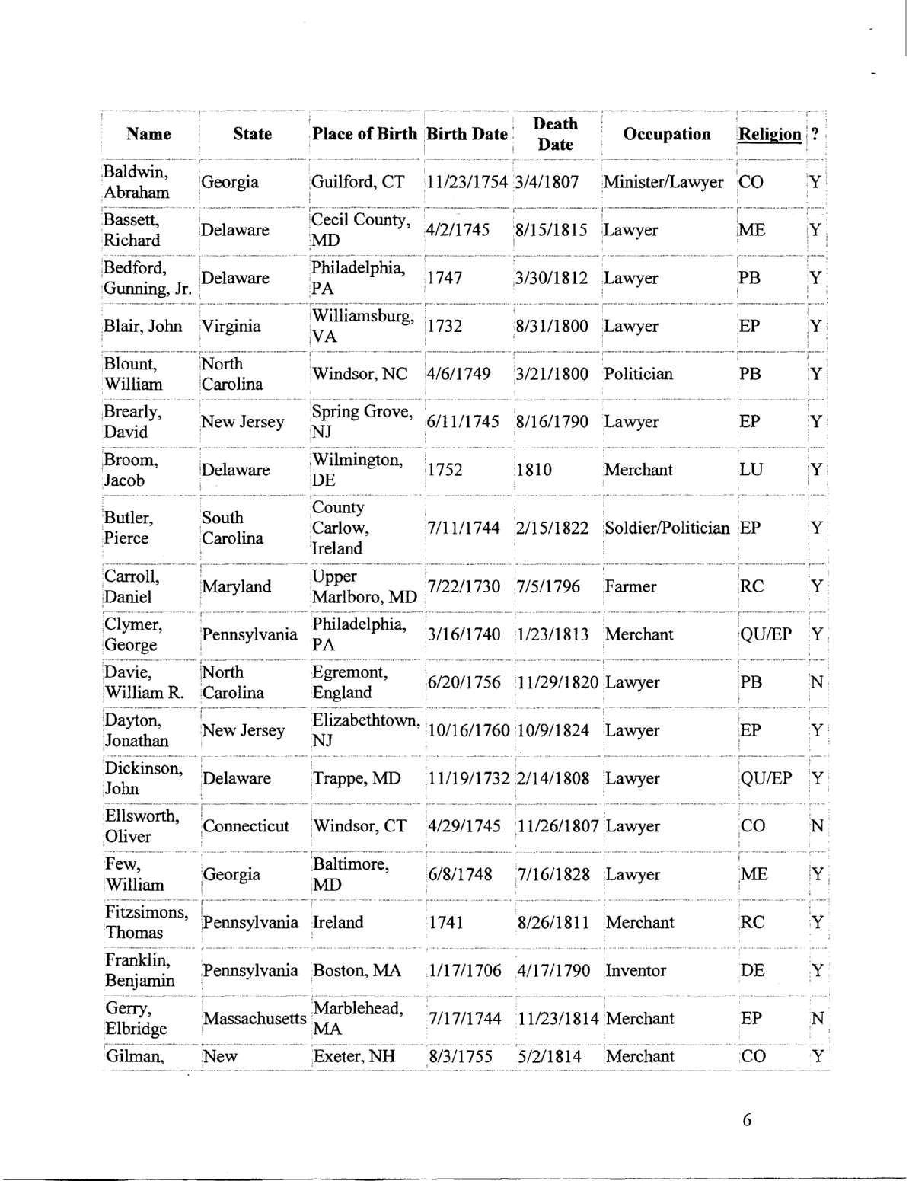

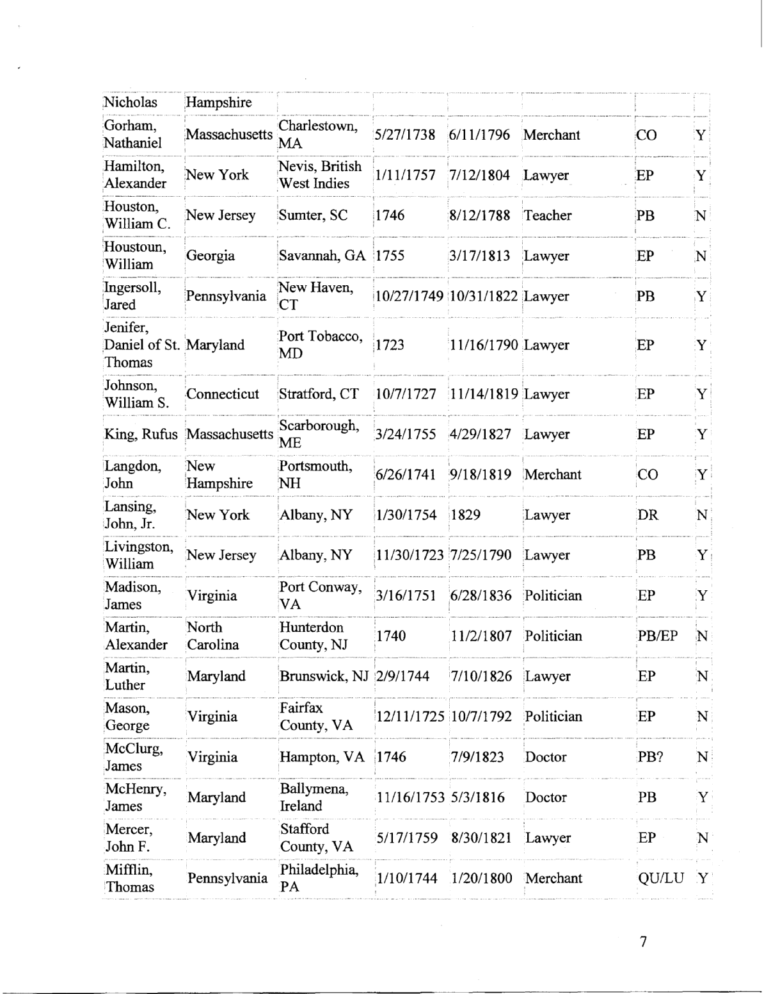

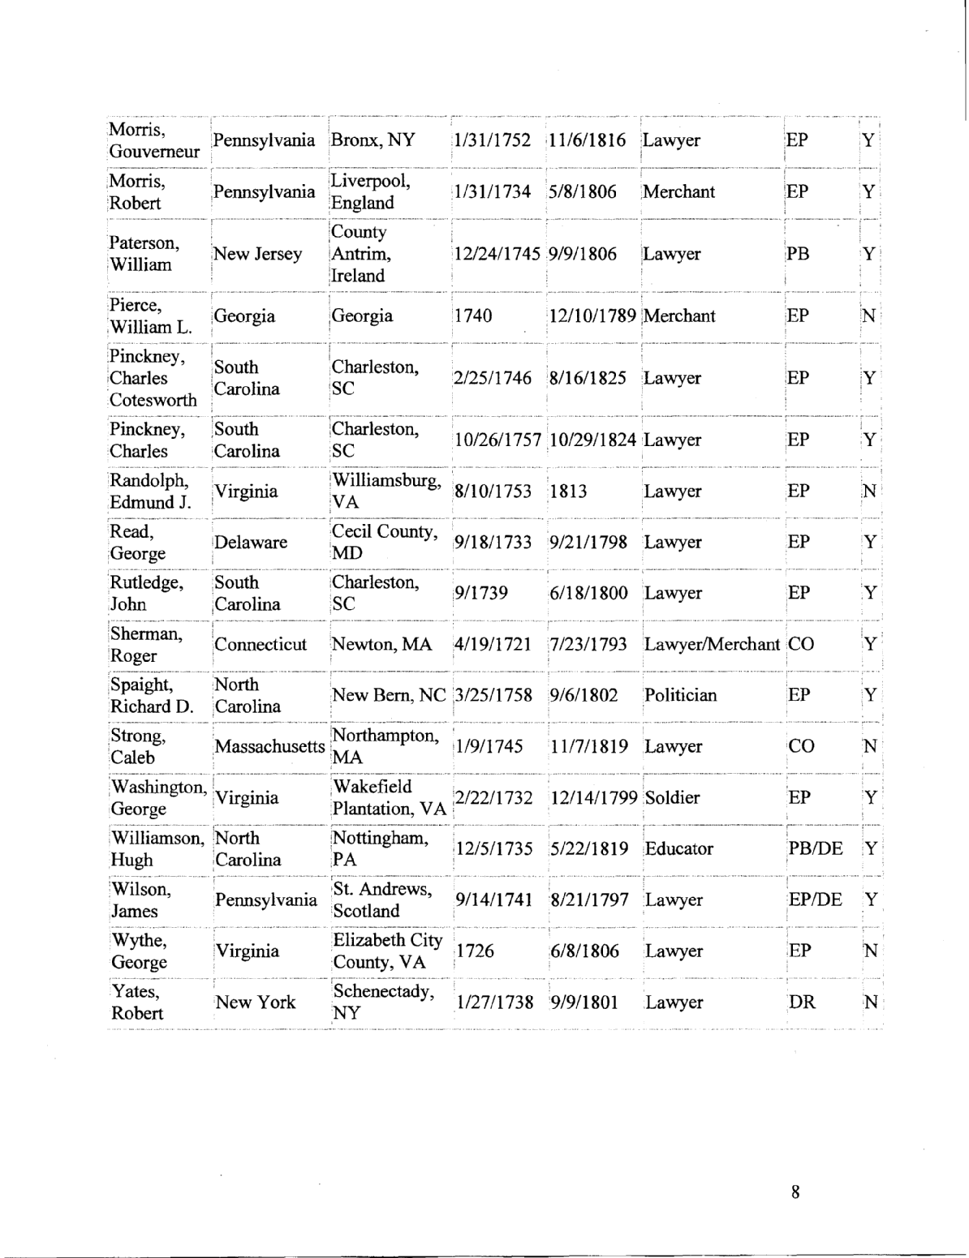

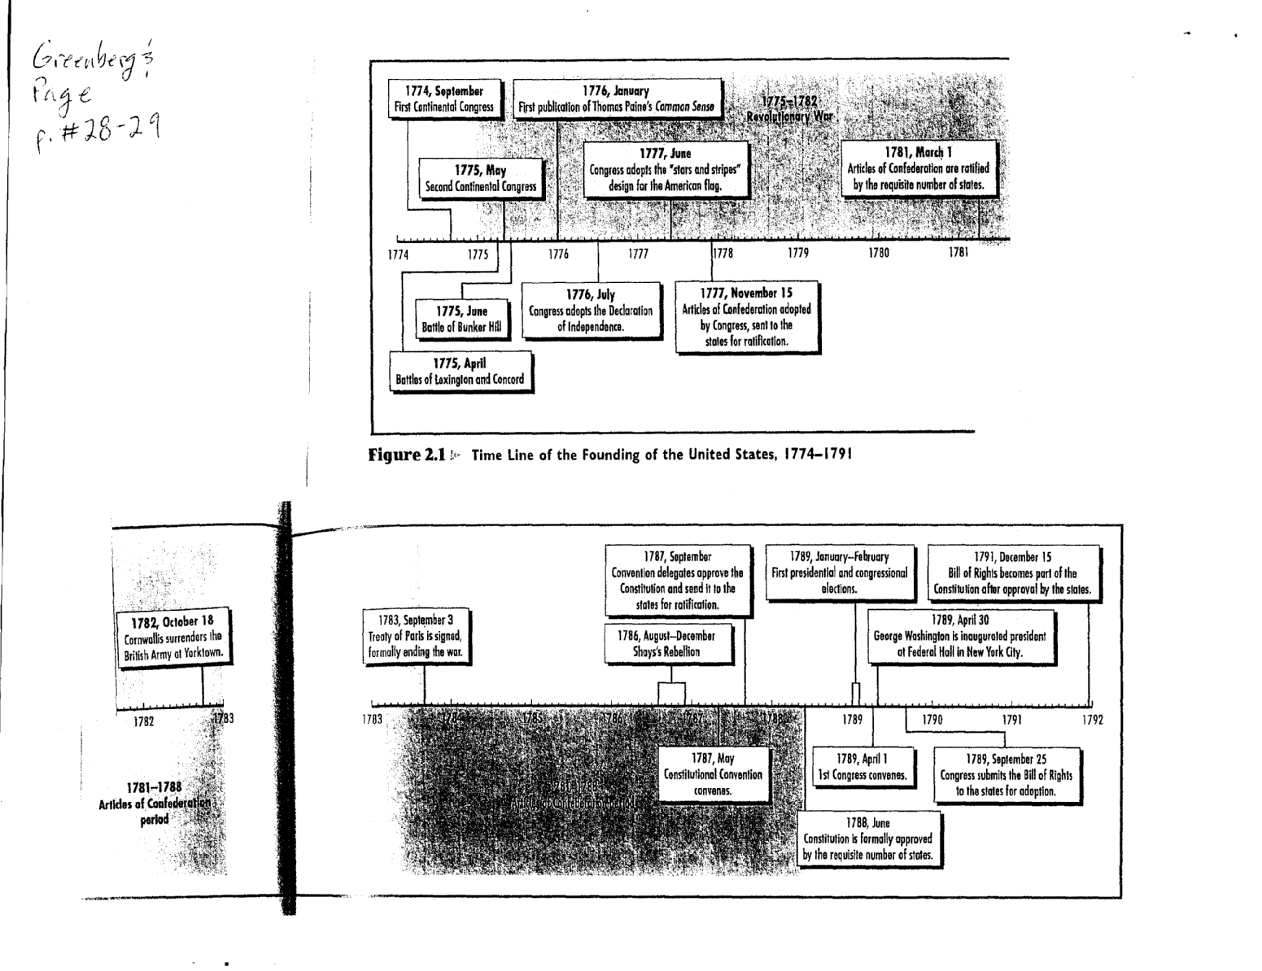
Historical Dates
The following is a key for the various abbreviations used below:
• AR: Date an Amendment was ratified
• AP: Date of the passage of a Constitutional Amendment
• NA: Notable American event
• NW: Notable World event
• PR: Presidential term begins
• SH: Statehood (for original 13 colonies, date Constitution was ratified)
• WR: An event in a U.S. war
Dates are of format YYYY/MMIDD (year, month, day).
1620/11/09 NA - Mayflower lands
1754/07/10 NA - The Albany Congress meets
1770/03/05 NA - Boston Massacre
1774/09/05 NA - First Continental Congress convenes
1775/04/18 WR - American Revolution begins
1775/05/10 NA - Second Continental Congress convenes
1776/07/04 NA - Declaration of Independence adopted
1776/12/20 NA - Third Continental Congress convenes
1777/11/15 NA - Articles of Confederation proposed
178 1/03/01 NA - Articles of Confederation ratified
1783/02/04 WR - English declare hostilities at an end
1783/04/11 WR - America declares hostilities at an end
1784/01/14 WR - Revolutionary War Ends (Treaty of Paris)
1787/05/25 NA - Constitutional Convention opens
1787/09/17 NA - Final draft of the Constitution sent to Congress
1788/06/2 1 NA - Constitution Ratified
1789/03/04 NA The Constitution goes into effect
1810/09/16 NW - Mexican independence
1846/04/25 WR - Mexican War begins
1848 NW - Communist Manifesto published
1848/02/02 WR - Mexican War ends (Treaty of Guadalupe Hidalgo)
1860/12/20 NA - South Carolina votes to secede
1861/01/09 NA - Mississippi votes to secede
1861/01/10 NA - Florida votes to secede
1861/01/11 NA - Alabama votes to secede
1861/01/19 NA - Georgia votes to secede
1861/01/26 NA - Louisianna votes to secede
186 1/02/01 NA - Texas votes to secede
1861/03/11 NA - Confederate Constitution ratified
1861/04/12 WR - Civil War begins (Fort Sumter)
1861/04/17 NA - Virginia votes to secede
186 1/05/06 NA - Arkansas votes to secede

1861/05/20 NA - North Carolina votes to secede
1861/06/08 NA - Tennessee votes to secede
1861/10/3 1 NA - Missouri votes to secede
1861/11/20 NA - Kentucky votes to secede
1865/04/08 WR - Civil War ends (Lee surrenders to Grant)
1866/07/24 NA - Tennessee readmitted to the Union
1868/02/24 NA - House impeaches President Johnson
1868/05/16 NA - Senate acquits President Johnson
1868/06/22 NA - Arkansas readmitted to the Union
1868/06/25 NA - Florida readmitted to the Union
1868/07/04 NA - North Carolina readmitted to the Union
1868/07/09 NA - South Carolina readmitted to the Union
1868/07/09 NA - Louisiana readmitted to the Union
1868/07/13 NA - Alabama readmitted to the Union
1870/01/26 NA - Viginia readmitted to the Union
1870/02/23 NA - Mississippi readmitted to the Union
1870/03/30 NA - Texas readmitted to the Union
1870/07/15 NA - Georgia readmitted to the Union
1898/04/21 WR - Spanish-American War begins
1898/12/10 WR - Spanish-American War ends (Treaty of Paris)
1912/01/06 SH - New Mexico
1912/02/14 SH - Arizona
1917/03/31 NA - U.S. purchases the Virgin Islands from Denmark
1918/04/02 WR - United States joins WWI
1919/06/28 WR - WWI officially ends (Treaty of Versailles)
1939/09/03 NW - WWII begins
1941/12/11 WR - United States joins WWII
1945/09/02 WR - WWII ends
1946/01/10 NW - First meeting of the UN
1950/06/25 WR - Korean War begins
1953/07/27 WR - Korean War ends
1959/01/03 SH - Alaska
1959/08/2 1 SR - Hawaii

