Imagine a Greener Future
An Arboretum Plan for The Evergreen State College

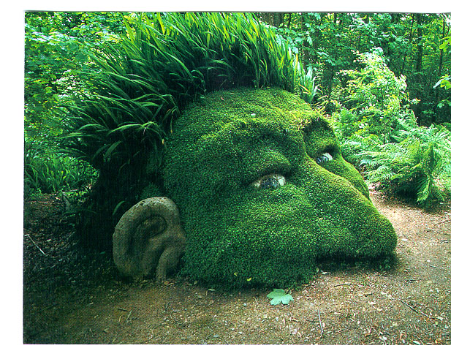

Updated for:
The Evergreen State College
Master Plan

Prepared by:
Frederica Bowcutt, Faculty Member
The Evergreen State College

September 2002
(December 2002: Approved by the Campus Land Use Committee and the Faculty)
(February 2008: Abbreviated Text, Updated Map and New Appendices)

“Americans have a deeply ingrained habit of seeing nature and culture as irreconcilably opposed; we automatically assume that whenever one gains, the other must lose. Forced to choose, we usually opt for nature (at least in our books). This choice, which I believe is a false one, is what led Thoreau and his descendants out of the garden. To be sure, there is much to be learned in the wilderness; our unsurpassed tradition of nature writing is sufficient proof of that. But my experience in the garden leads me to believe that there are many important things about our relationship to nature that cannot be learned in the wild. For one thing, we need, and now more than ever, to learn how to use nature without damaging it. That probably can’t be done as long as we continue to think of nature and culture simply as antagonists. So how do we begin to find some middle ground between the two? To provide for our needs and desires without diminishing nature? …the place to look for some of the answers to these questions may not be in the woods, but in the garden.”

Michael Pollan, Second Nature: A Gardener’s Education, p. 5

Table of Contents

Evergreen Arboretum 2008 Update
Introduction
Existing Conditions
Location
Climate
Soil
Geological Features
Teaching Gardens
Basket Garden
Deer Garden
Laurasian Landscape
Lawns
Longhouse Ethnobotanical Garden
Medicinal Herb Garden
Native Plant Demonstration Garden
Post Glacial Forest
Prairie Roof Garden
Primitive Plant Gardens
Rain Roof Gardens
Waterwise Pollinator Garden
Future Work
Acknowledgements
References

Appendix A: Plant Species by Garden including Suggested Additions
Appendix B: Baseline Map of Existing Plantings

Figure 1. Map of Teaching Gardens
Figure 2. Wattle Fence Made of Coppice Growth
Figure 3. Coppice Growth on Pollarded Trees

Evergreen Arboretum 2008 Update

In the summer of 2002 the former director of Facilities Michel George commissioned an arboretum plan. Since the plan’s approval in the fall of 2002 by the Campus Land Use Committee (CLUC) and the Faculty, nearly all of the proposed teaching gardens have been established.

The goals driving design of these new gardens are:
- Improve educational value of plantings
- Celebrate cultural diversity
- Foster social justice
As well as
- Promote environmentally sustainable garden design
- Create low maintenance designs
- Improve wildlife habitat
- Integrate existing mature trees and shrubs into proposed designs
- Work within existing irrigated beds
- Reduce water and energy usage
- Remove as much lawn as possible while meeting needs for inviting places to sit
- Improve aesthetics in the core of the campus
- Create opportunities for students to link theory with praxis and
- Integrate the arboretum with the forest trail system.

Since 2002, nine new teaching gardens have been added to the campus’ first teaching garden, the Longhouse Ethnobotanical Garden. Students created many of the new gardens. Students designed and installed the Waterwise Pollinator Garden and Basket Garden. Students installed the Medicinal Herb Garden at the Organic Farm. Other gardens were added with building renovation or new construction. When the Library roof was renovated in 2003, we added a Prairie Roof Garden. With the construction of the new Seminar II building, we installed four new types of teaching gardens: Native Plant Demonstration Gardens, Rain Roof Gardens, a Post Glacial Forest and a Primitive Plant Garden. By modifying the plantings around the lab buildings we created a Laurasian garden that educates visitors about the influence of continental drift and evolution of the world flora. Seven student designed interpretive panels have been installed. Hundreds of plant identification signs have been put in place. One memorial bench was donated. Alumna Deborah Mersky installed two public art pieces linked to the teaching gardens around SEM II. A directory for the teaching gardens in the core of campus was installed in front of the library building, and a directory was placed next to the Organic Farmhouse with descriptions of the various gardens on the Organic Farm. Both directories were student designed.

In the future we hope to:
- install phase II of the Waterwise Pollinator Garden,
- install the Deer Garden along with interpretive panel,
- augment the Primitive Plant Garden plantings,
- add interpretive panels for the Basket Garden, Longhouse Ethnobotanical Garden, Native Plant Demonstration Gardens, Primitive Plant Garden and Lawns.
- remove lawns designated for removal in the original arboretum plan,
- remove more English ivy and add edible landscaping in the core of campus,
- create a small medicinal herb garden in the core for the Student Health Center,
- create a low maintenance labyrinth,
- add more comfortable seating, and add more public art in the gardens.

A copy of the original plan, “Imagine a Greener Future,” is available in our library (Bowcutt 2002). The table below summarizes the progress made towards meeting the goals laid out in the 2002 arboretum plan.

Teaching Garden or Other Expense | Installed | Source of Funds | Left to be done
Basket Garden | √ | TESC Facilities paid for plants  Student design & installation | Interpretive panel  Deer protection  Summer irrigation
Deer Garden |  | Possibly local nurseries plus Dept. of Ecology or other govt. agency | Design and installation
Labyrinth |  | Design work done by student & proposed to CLUC | Resubmit plans that address maintenance concerns
Laurasian Landscape | in process | Possibly Local Nurseries (plants) | Increase species diversity
Longhouse Ethnobotanical Garden | in process | Donations from the Sierra Club, Elizabeth Wakeman Henderson Foundation and others. | Add memorial garden for Bruce Miller
Medicinal Herb Garden | √ | Small General Education Grant
Native Plant Demonstration Gardens | √ | SEM II budget
Post-Glacial Forest | √ | SEM II budget
Prairie Roof Garden | √ | Library Roof Remodel | Repair irrigation; restore failing areas
Primitive Plant Garden | √ | SEM II budget
Rain Roof Gardens | √ | SEM II budget
Waterwise Pollinator Garden | √ | City of Olympia &  Evergreen Foundation  Student design & installation | Phase II including wheelchair access trail/public art
Benches |  | Possibly private donations and/or created by students
Directory signs | √ | TESC Facilities paid for two
Interpretive panels | √ | TESC Facilities paid for seven | Add six more
Tool Storage space |  | Included in Longhouse remodel | Build
Sculptural Elements | √ | Public Arts Funds from SEM II | Student installations

Critical to the ongoing success of all these gardens is routine weeding and mulching.

Introduction

The original landscaping on the Evergreen State College campus was installed in the late 1960s. The design called for eastern deciduous forest trees, Japanese and other Asian species, and a number of common European ornamentals. A few native trees and shrubs were also intermixed. Now the mature plants provide shade and color. However, the full potential for using the landscaping to educate people about plants and their ecology was not realized. Until 2002 little changed in the landscape design with the notable addition of native plant and medicinal plant gardens around the Longhouse. The arboretum plan proposed modifying existing plantings and creating teaching gardens with interpretive panels and more public art (Bowcutt 2002). Installation of some of the gardens occurred during the construction of SEM II and when the library roof was renovated. Students installed the remaining gardens.

An arboretum creates a draw to our campus. Educators already use the labeled plants to help school children and college students learn about local plants and their ecology. Increasingly the campus is used by neighbors many from new, dense suburban subdivisions. They walk or jog the trails and the campus core. This increased visitation creates opportunities for environmental education including issues around sustainability. By integrating the arboretum with the existing trail system in the roughly thousand acres of native forest surrounding the core campus, we can introduce more people to our community and educate them about local ecology.

At the time landscape architects designed The Evergreen State College landscape, little awareness existed about the invasiveness of English ivy and a number of other common horticultural species. Now many in our community express concern about the use and ecological impact of such plants. Students have removed ivy to make room for native plants in several locations on campus. If fully implemented, this plan would significantly reduce the amount of English ivy and other aggressive non-natives in the core of the campus. Non-invasive species, both native and non-native, will be used to replace them. Along with many invasive species, turf dominates American horticulture and the Evergreen campus is no exception. Lawns, with their high demands for energy and water, do not reflect Evergreen values for sustainable relations with nature. By reducing the amount of turf and replacing it with drought tolerant species we can reduce our water use.

Existing Conditions

Creation of an arboretum on The Evergreen State College campus is based on the premise advocated by Ian McHarg to “design with nature”. Poet Gary Snyder says the same thing a little differently. Go with the grain of nature. To do so means less maintenance, less disease, more efficient water use. It means not imposing the will of people on the land without being sensitive to what is already there. To design with nature requires knowing the conditions of the site, including the physical, biological, and human community the gardens will live within. The following is a summary of those preexisting conditions.

Location

The Evergreen State College is located on a peninsula jutting into the south end of the Puget Sound. The campus occurs west of the Cascade Mountains, a volcanic range. It lies within the city limits of Olympia. Most of the 1,000 acre campus is forested with second growth coniferous forests. Douglas-fir (Pseudotsuga menziesii) dominates much of the forest along with red alder (Alnus rubra), western red cedar (Thuja plicata), and western hemlock (Tsuga heterophylla). For a plant species list and a more through description of the vegetation of the undeveloped portions of the campus see Lohmann 2006. The campus buildings are clustered together and surrounded by forest. Roughly 20 acres of the core of the campus are under irrigation. Irrigated lawns comprise the lion’s share. Rough-cut nonirrigated lawns are not included in this figure. Irrigated lawns require high maintenance, energy use and water use. English ivy and periwinkle cover the majority of the remaining grounds with an overstory of both native and exotic trees and shrubs.

Climate

Olympia, Washington enjoys a Mediterranean climate. This means that despite our high rainfall (55” on average), during the months of July, August and September drought conditions exist. For a good general description of the Puget Sound region’s climate and weather refer to Arthur Kruckeberg’s Natural History of Puget Sound Country. As many gardeners know, this region is ideal for growing northern temperate hemisphere plants including those from the Eurasian continent. A variety of arboreta in the Pacific Northwest demonstrate good plant selections for our region.

According to Sunset’s Western Garden Book, The Evergreen State College occurs in climate zone 5 (Brenzel, p. 36). It is under the marine influence of the Puget Sound with more moderate temperatures than nearby climate zone 4. These zone designations are used extensively by horticulturists and should inform any plant selections for our arboretum. This information enables us to select plants appropriate to the climate and thus to design with nature, not despite it. The danger of frosts as late as May and as early as October means that tropical and subtropical species are not hardy here. Desert species can’t tolerate the high rainfall. However, some Mediterranean species from Greece, Italy and southern France can survive on well-drained soils like many created by glacial deposits. Given one of the goals is to create low maintenance plantings, frost sensitive species and beds of annual plants are not appropriate choices.

Microclimatic conditions vary in relation to buildings and this must be taken into account when designing placement of plants. More frost tender plants can thrive against a concrete wall on the south side of a building. The thermal mass created by the building results in heat being radiated back out. Some plants adapted to forest understory conditions and with higher moisture-needs can be badly sun burnt in such a location and may prefer the north side of a building. Since stressed plants are more prone to disease and death, placement for optimal growth is important to meet the low maintenance goal. The Western Garden Book, and other garden reference books, can aid in identifying conditions favored by various plants. Consider also monographs on specific genera for more detailed cultivation information.

Soil

All of the soils on campus are derived from glacial deposits or volcanic ash and loess. The predominant soil type in the core of the campus is Alderwood gravelly sandy loam. The authoritative source on the subject of our soils is the Soil Survey of Thurston County (Soil Conservation District 1982). It has the following to say about the Alderwood series: “moderately deep, moderately well drained soils on glacial till plains.” Soils that drain well can accommodate drought resistant species from Mediterranean regions such as lavender, Cistus, and Santolina. It’s this kind of customizing we need to do when we design gardens on campus using the soil survey data. Skipopa silt loam occurs around the Campus Activities Building (CAB) and to the northeast and east of the Library building. According to the soil survey, it was derived from volcanic ash and wind blown sediments (loess) that was deposited on top of sediment from a glacier caused lake. The soils in the Skipopa series are moderately deep but “somewhat poorly drained.” Thus these will probably not be good sites for Mediterranean species as they would be prone to root rot. The soil survey should be field checked by digging holes in areas for different teaching gardens and observing how well water drains. By using the tables towards the back of the soil survey one can determine the capabilities of the various soil types in a very general sense.

Geological Features

In technical terms, Quaternary glacial drift and alluvium characterize the geology of the peninsula the college occurs on. Roughly 14,000 years ago ice hundreds of feet thick covered The Evergreen State College campus. When the Vashon Glacier, the last of several glaciers, receded it left behind a medley of rocky jumble, called till by geologists, and a variety of other deposits including huge rocks called erratics. Runoff from the melting glaciers also left behind sediment and rocks big and small. Large erratic boulders existing on the Seminar II site were used in the Post Glacial Forest.

Teaching Gardens

Our gardens educate about a variety of subjects including basket material access, evolution, geologic history, native plant ecology, water conservation, and wildlife enhancement. Reflected in the design of these gardens are the values of the institution: fostering communication across significant difference, multiculturalism, social justice and of course a dedication to excellence in teaching. Students have been involved in all aspects of the arboretum’s creation. Their involvement reflects one of our foci, linking theory and praxis. Refer to Figure 1 for a map of the teaching gardens.

Basket Garden

In addition to designing a variety of interpretive panels, Teaching Gardens students installed the Basket Garden in fall 2004. Contract student Ben Helmes designed it and supervised its installation including the willow structure, which resembles an upside

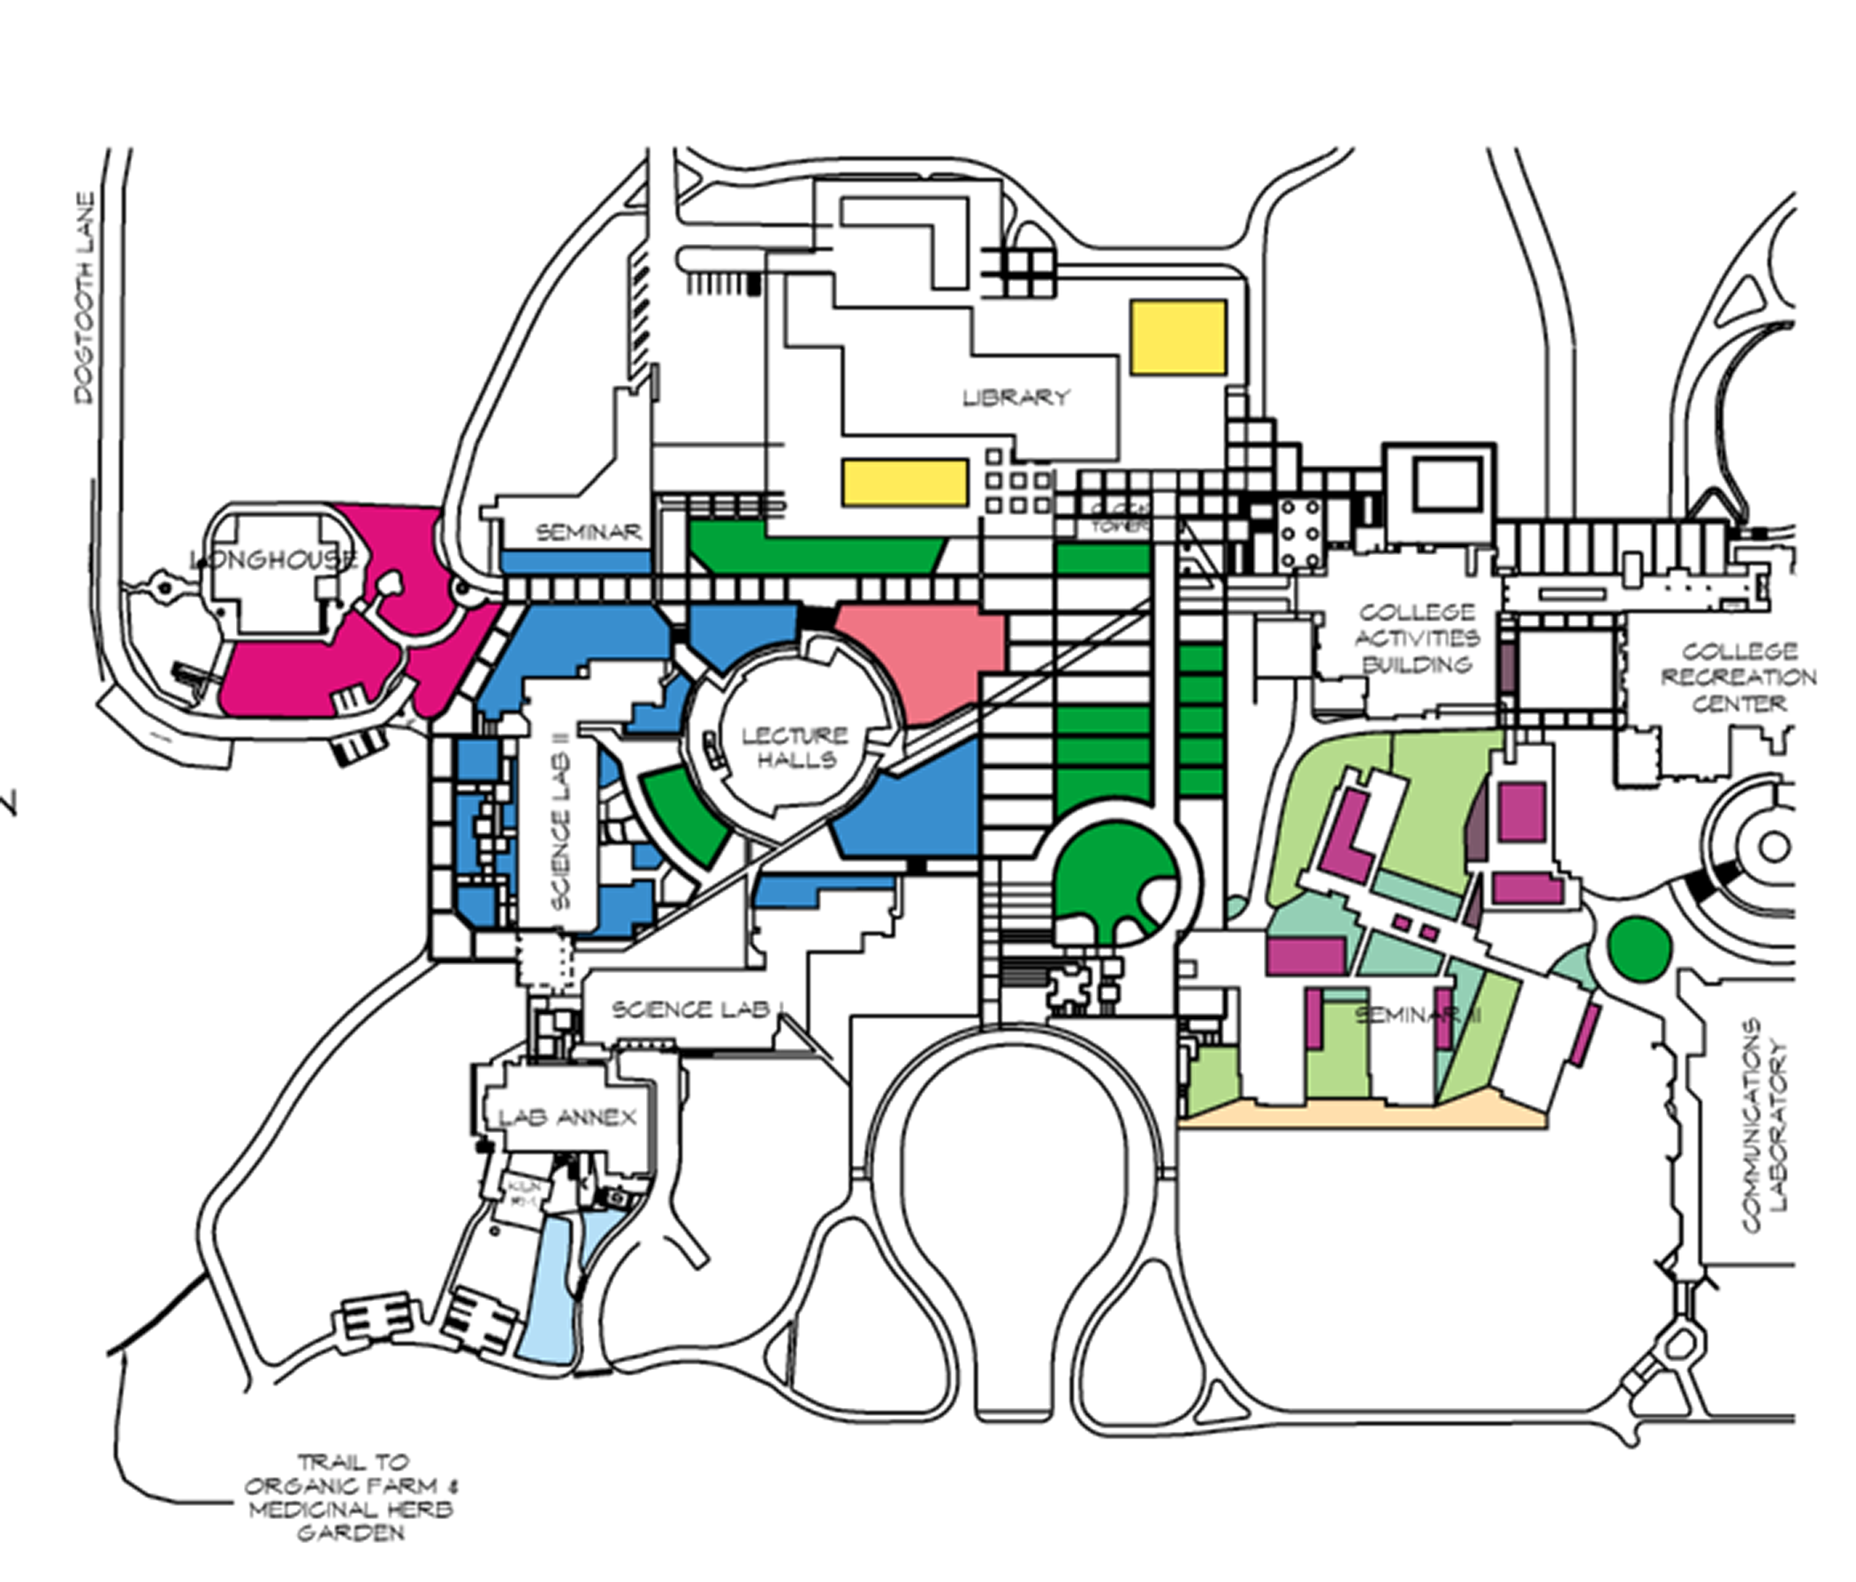

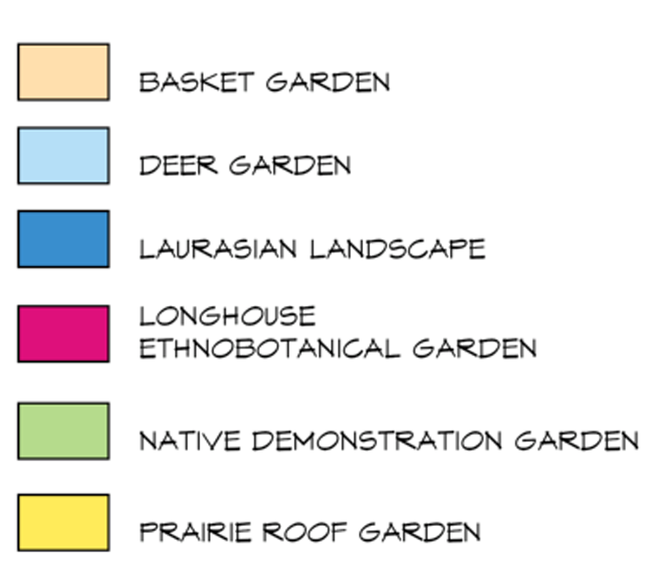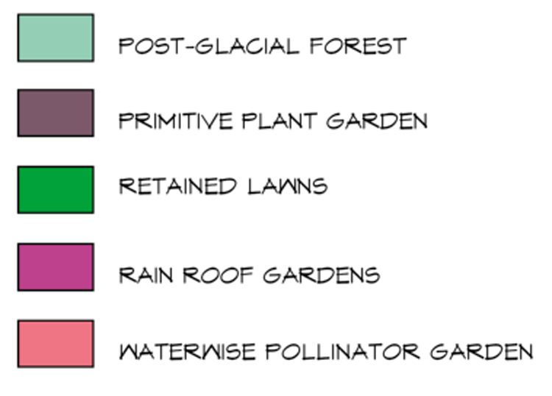

Figure 1. Map of Teaching Gardens

down basket. This garden includes plants used traditionally to make baskets by First Peoples from the Pacific Northwest as well as from other cultural traditions including western red cedar (Thuja plicata), red osier dogwood (Cornus stolonifera), sedge (Carex spp.), beargrass (Xerophyllum tenax), and willow (Salix spp.). Native activists advocate for botanic gardens to move away from their colonial and imperialist past and address social justice issues. Due to reduced land bases and access to gathering places, many basket makers find it difficult to gather the materials they need to keep traditional arts alive. This garden will eventually produce needed materials but also elevate awareness of the challenges faced by these artists.

Woven into this themed garden is the traditional use of coppice growth. Due to their annual pollarding treatment, the London plane trees in front of the library building produce copious amounts of coppice growth. As odd as it sounds, these poodle trees reflect an indigenous European management technique for making a useful product: straight pliable shoots. Medieval and Renaissance gardeners created wattle fences from the straight shoots (refer to Figures 2 and 3). By integrating the pollarded London Plane trees, the garden points out that European and Euroamerican peoples also have a cultural heritage that includes traditional, indigenous relations with plants.
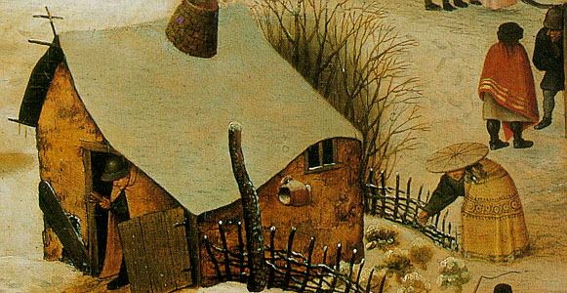
Figure 2. Wattle fence with a Rammed Earth House (16th century)

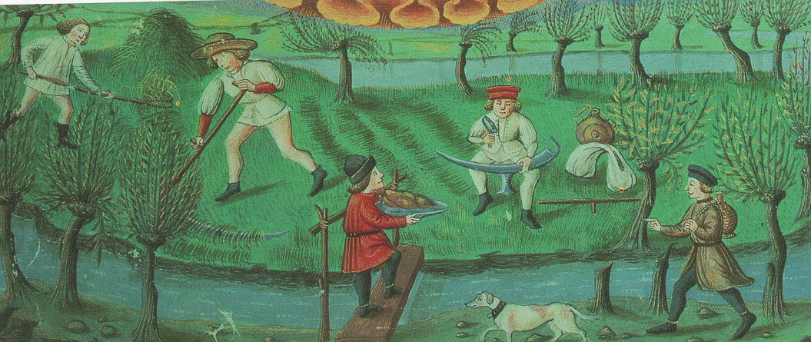
Figure 3. Coppice Growth on Pollarded Trees (Italian, 15th century)

Deer Garden

Once installed, this garden will demonstrate plants resistant to deer browse. For example many members of the mint family lack appeal to the deer palate. Plants in this family include sage (Salvia spp.), catmint (Nepeta spp.), mint (Mentha spp.), lemon balm (Melissa officinalis), lavender (Lavendula spp.). Note that some of these plants can be invasive and this needs to be considered in the design process. They might be contained with barriers. Members of the daisy family also tend to not taste good to deer, such as dahlias, aster, coreopsis, Rudbeckia, and Echinacea. Deer pass on a variety of poisonous plants such as foxglove, monkshood, and deadly nightshade.
deer garden. Thorny species, like barberry, Eryngium, and Oregon grape, prove formidable foe to a soft nuzzle. Deer turn their noses up to leathery rhododendron leaves and highly hairy plants like lamb’s ears. They dislike daffodils too. Ornamental sedges, grasses, and ferns can be good choices for the garden visited by deer (see Brenzel, pp. 104-105). Lawns not sprayed with broad-leaf herbicides can be planted with clover to provide a diversion for deer. Given the high number of new homes on the rural-urban interface in Olympia, educating people about coexisting with deer has high educational value. It could reduce the amount of enclosures created to protect plantings. Such enclosures reduce habitat for deer, increasing their impact elsewhere. Local nursery people often have good local knowledge about planting in deer zones. The designers of this garden should avail themselves of such placed-based expertise. Western Garden Book lists plants resistant to deer (Brenzel, pp. 152-160). However, note that it doesn’t mention that although deer don’t browse the leaves of day lilies they relish the flower buds and blossoms. Resist is the operative word. The plants listed are not deer proof, nothing is. Particularly in June when the fawns are newly exploring the world there’s a lot of testing going on. Also in winter when times are lean, deer will browse on plants they ordinarily avoid. It’s not a perfect system but it does radically reduce damage when plants are selected with deer in mind. This garden could include an interpretive sign about deer including their life cycle and local ecology.

Laurasian Landscape

This garden demonstrates that kinship exists among plants (and thus people) from the North American and Eurasian continents. The garden creates an opportunity to communicate across significant differences about relations between people and closely related plants. For example, indigenous peoples on both continents managed native hazelnuts for coppice growth and nut production. The theme of a Laurasian landscape emerged out of the original plant palette. In the late 1960s many Eurasian species were planted around The Evergreen State College lab buildings. A few natives such as vine maple were also planted. Through signage and additional plants, this garden is used to educate students and outside visitors of the impact of geologic history on plant life. Through geographic speciation, many new species evolved after the Laurasian continent broke apart. However, its two daughter continents, Eurasia and North America still share many genera, e.g. pines, maples, elderberries, hazelnuts, roses, oaks, birch, chestnut, dogwood, and sycamore. In this garden we pair species of the same genera from different continents. They may or may not be immediately adjacent, although proximity is helpful when doing plant walks. All of the plants are labeled with their scientific name along with their place of origin. Common names from their homeland will be provided where possible. A similar garden exists in the National Arboretum called the Friendship Garden. It does not emphasis the evolutionary links between the floras of North America and Eurasia. For linked academic materials see Kruckeberg 1983 and Wen 1999.

Lawns

Our intention through this plan is to reduce the amount of lawns on campus to lower our water and energy use and to create more sustainable and wildlife friendly landscaping. That said, we are not proposing elimination of all lawns. Lawns that are used frequently will be kept. Additional seating in the core will also create alternatives to sitting on lawn. Bench locations will be identified in the planting plans for specific teaching gardens. Where feasible, lawns will be converted to more environmentally sound alternatives (Brenzel 2001, pp. 100-103).

Although most American lawns receive large amounts of pesticides and chemical fertilizers, none of Evergreen’s lawns do. As a part of the arboretum we will educate visitors, staff, faculty, and students about our “green” lawns maintained through frequent mowing, leaving clippings, not cutting too short, and watering enough (not too much and not too infrequently). With an interpretive panel we will educate people about the risks pesticides pose. How their use endangers small children as well as pets, birds, frogs, snakes, salamanders, newts and other critters. We will also discuss the amount of labor required to maintain a lawn relative to other kinds of gardening options. For an American cultural history on lawns see Jenkins 1994.

Longhouse Ethnobotanical Garden

In 1995 work on the Longhouse Ethnobotanical Garden began. Faculty member Marja Eloheimo collaborated with students, tribal members, and campus facilities staff to prepare the site and install species representing various habitat areas (e.g., prairie, riparian, mixed forest, middle and high elevation). Many students in a variety of ethnobotany programs have contributed to the creation and maintenance of the native garden in front of the Longhouse. Students installed plant identification signs, including a local Indian language name whenever possible. In conjunction with the garden, students developed a relational database, a small ethnobotanical library and a baseline GIS map. The project was made possible by salvaging plants from development sites and funding from the Sierra Club, the Elizabeth Wakeman Henderson Foundation, and many other donations. Future plans include installation of a student-generated design for construction on the north side of the Longhouse of a medicinal garden organized by body systems. The Longhouse Ethnobotanical Garden was named "s'ulex" by Upper Skagit elder, Vi Hilbert. This word refers to gathering and creating possibilities from what nature offers. It reflects the fact that members of the Indigenous community who utilize and care about the Longhouse support this garden. It also reflects the idea that the garden represents a collaboration between people and plants, and between communities and cultures, especially if we have the means and support to gather and create the possibilities it offers.

Medicinal Herb Garden

Students in the program Christian Roots installed the Medicinal Herb Garden at the Organic Farm in winter 2004. This garden is based on the four square design of Persian origin and common in Europe during the Middle Ages and Renaissance. The Physick Garden at the University of British Columbia in Vancouver inspired the design. This garden is used to promote the medicinal use of easy to grow European plants like chamomile, oregano, lavender, lemon mint, and peppermint. This garden promotes increased self-reliance for treating common health problems like colds, indigestion, and stress. By integrating history into the design and associated interpretive panel, the garden elevates awareness of the significant influence of Christianity and Middle Eastern traditions on European herbology and styles of gardening.

Native Plant Demonstration Gardens

Native plants were used to revegetate a large percentage of the ground disturbed to construct Seminar II. Increasingly, environmental educators promote native plant gardens as a way to reduce water use, eliminate the need for pesticides, provide wildlife habitat, and avoid introducing noxious, invasive weeds. Reference texts on native plants include Link, Landscaping for Wildlife; Hitchcock and Cronquist, Flora of the Pacific Northwest; and Kruckeberg, Gardening with Native Plants in the Pacific Northwest. Native plants are integrated into most of the other teaching gardens, comingled with the non-natives.

Post Glacial Forest

The Post Glacial forest is a recreation of the vegetation that occurred in the region as the Vashon glacier receded from its Olympia terminus. The plant palette is based on palynology data from pollen core samples taken from wetlands in the Puget Sound area (Hansen 1947, Petersen et al. 1983, and Whitlock 1992). The late glacial period samples from which the plant palette was primarily derived range in age from 13,500 to 11,400 years old. We took some artistic license given design and availability limitations. Thus the result is to some degree a historical fiction. However, the Post Glacial Forest does contain species known from the pollen record by 8,000 years ago. During construction of Seminar Building II, the construction company saved erratic boulders left on site by the last retreating glacier. Additional erratics were brought in to complete the landscape as designed. Lodgepole pine dominate with a small grove of aspen. Sedges dominate the understory.

Prairie Roof Garden

Modeling after our native prairies in South Puget Sound, this garden teaches about these cultural landscapes as important oases of species diversity including many threatened species (Leopold and Boyd 1999). This garden was installed in 2003 when the library roof was renovated. In tandem with learning about this unique local ecosystem, students in the programs Natural History and Restoring Landscapes donated community service hours to this garden in 2006 and 2007. Rod Gilbert of the Washington Native Plant Society wrote the text for two interpretive panels. Contract student Randi Smith created original illustrations and did the graphic arts work for these panels. Greener grad Daeg Byrne of The Nature Conservancy has donated many hours, pounds of rare seed, and hundreds of native plants to this effort.

Primitive Plant Garden

This garden supports the study of plant evolution from spore bearing species that appear earliest in the fossil record to the more recently evolved flowering plants. Modeled after a similar garden in Strybing Arboretum in San Francisco’s Golden Gate Park, visitors can view spore bearing plants (moss, club moss, and ferns), gymnosperms (cycads and conifers), and primitive flowering plants (anemones and hellebores). Cycads are represented by a public art piece by Greener grad Deborah Mersky. Along with pollinators, the piece portrays the multiflagellate sperm of cycads, a primitive character. In the future we hope to establish a small grove of monkey puzzle trees to help students imagine the Jurrasic and Triassic landscapes with dinosaurs cohabitating. Refer to Raven et al. 2005 and Stewart and Rothwell (1993), for more information on plant evolution.

Rain Roof Gardens

On the top of the Seminar II building, roof top gardens reduce the impact of the buildings by mitigating the increase in impervious surface created by the new construction. They were planted with species designed to be low maintenance due to low water needs and, in some cases, the ability to self-propagate. Landscape architects designed these gardens using existing European prototypes. Although most of the gardens are not visible, several can be viewed easily.

Waterwise Pollinator Garden

Students in the Picturing Plants program of 2002/2003 designed this garden. They removed ivy to prepare the site, propagated plants, installed signs, planted plants and illustrated the associated interpretive panel. They planted with species that attract butterflies, hummingbirds, and bees. Referencing one of their seminar texts, Buchmann and Nabhan’s Forgotten Pollinators, they crafted the text for the interpretive panel, which educates about the excessive use of pesticides in backyard gardens and how that impacts pollinators. It also points out the ecological significance of reduced rates of
pollination. Robert Michael Pyle’s book The Butterflies of Cascadia provides useful information on nectar and caterpillar host plants. The Western Garden Book lists plants attractive to butterflies and hummingbirds (Brenzel, pp. 116-121).
Students designed a phase II of this garden which was approved by the CLUC in 2003. It is hoped that this can be installed in the future along with the public art trail through it that provides wheelchair access.

Future Work

In the future we hope to finish several teaching gardens including the Bruce Miller Memorial Garden, the Deer Garden and phase II of the Waterwise Pollinator Garden.
We plan to add interpretive panels for the Basket Garden, Deer Garden, Longhouse Ethnobotanical Garden, Native Plant Demonstration Gardens, Primitive Plant Garden and Lawns. We hope to remove a few of the underused lawns and more of the ivy in the core of campus. Edible landscaping in the core of campus would be a tasteful addition, such as fruit trees planted against south facing concrete walls. The Student Health Center has requested a small medicinal herb garden in the core of campus. Based on surveys, there is widespread interest in the creation of a low maintenance labyrinth. More comfortable seating and public art in the gardens would be lovely.

Students are currently working to link the arboretum to the existing trail system that extends beyond the campus core. Interpretive nature trails are being developed on the trail to the organic farm and on two of the beach trails. Community members seeking to add new gardens or garden features, such as benches or public art, are encouraged to discuss their plans with Facilities first to determine whether the addition can be maintained with existing resources. For final approval, plans must be drafted and presented to the Campus Land Use Committee. For additional resources and updates, visit www.evergreen.edu/teachinggardens.

Acknowledgements

First, without the ongoing support of the Facilities staff at The Evergreen State College, this arboretum plan would never have come to fruition. Special thanks to Mark Kormondy, A’hoi Mench, Paul Smith, Andy Wear, and Bob Worley. I am grateful to Michel George for inviting me to write an arboretum plan. Al Wiedemann facilitated development of this plan through his early documentation of the trees and shrubs that were originally planted in the core of the campus. Marja Eloheimo, a leader in the creation and maintenance of the Longhouse Ethnobotanical Garden, supported my efforts to add additional teaching gardens to the core of campus. Art Kruckeberg and Estella Leopold, both emeritus faculty from the University of Washington, consulted on the Post Glacial Forest. Lucia Harrison supported our mutual students in Picturing Plants in their work to design gardens and illustrate signs.

Since completion of the arboretum plan in 2002, many students have contributed to its successful implementation. Ben Helmes updated the basemap of the plantings, and he designed and supervised installation of the Basket Garden. Katie Day designed both a teaching gardens brochure and the library kiosk directory sign. Megan Muhic designed the directory for the Organic Farm. The following students designed interpretive panels: Anna Baldy, Roussa Cassel, Abigail Groskopf, Rebecca Sheedy and Randi Smith. Rose (Sara) Swan developed detailed plans for a labyrinth and compiled an excellent PowerPoint presentation on it for the CLUC. EcoDesign students contributed bench and tool shed designs. Aaron Hartwell created our webpage. As facilities employees, students Ben Helmes and Karin Thorpe maintained the new gardens in the first couple of years. As the first Teaching Gardens Coordinator Katie Scherrer has organized multiple community service workdays. Heather Kropp is working on a Medicine Forest Trail proposal. A warm thanks goes to the many Evergreen students too numerous to name who completed community serve work on arboretum workdays.

Many community members and organizations have contributed as well. Tikva Breuer from the City of Olympia’s Water Resources Program funded the Waterwise Pollinator Garden with a grant. Bob Findlay, retired Landscape Architecture professor from Iowa State University and local Master Gardener, volunteered many hours to work with the students in the Teaching Gardens program in fall 2004. Greener grad Daeg Byrne of The Nature Conservancy has donated hundreds of native prairie plants and many pounds of prairie seeds. Greener grad Erica Guttman of Native Plant Salvage has donated hundreds of rescued plants from development sites. Greener grad Nikki McClure donated a design for a fund raising T-shirt. The Washington Department of Transportation donated plants. Erica Baker and Breanna Trygg of Pacific Education Institute and Thomas De Boer and Apuroop Dasari of Capitol High School all donated hours and plants to the Prairie Roof Garden. Deborah Humphery donated funds for the Medicinal Herb Garden interpretive panel.

References

Bowcutt, Frederica. 2002. Imagine a Greener Future:An Arboretum Draft Plan for the
Evergreen State College. Unpublished Report. The Evergreen State College. Olympia, WA.

Brenzel, Kathleen Norris (ed.). 2001. Western Garden Book. Sunset Publishing
Corporation. Menlo Park, CA.

Buchmann, Stephen L. and Gary P. Nabhan, 1996. Forgotten Pollinators. Island Press.
Washington D.C.

Gunther, Erna. 1973. Ethnobotany of Western Washington: The Knowledge and Use
of Indigenous Plants by Native Americans. University of Washington Press.
Seattle.

Hansen, Henry P. 1947. Climate Versus Fire and Soil as Factors in Postglacial Forest
Succession in the Puget Lowland of Washington. American Journal of Science 245 (5): 265-286.

Hitchcock, C. L. and A. Cronquist. 1973. Flora of the Pacific Northwest: An Illustrated
Manual. University of Washington Press. Seattle, WA.

Jenkins, Virginia Scott. 1994. The Lawn: A History of an American Obsession.
Smithsonian Institution Press. Washington D.C.

Kruckeberg, Arthur. 1995. The Natural History of Puget Sound Country. University
Washington Press. Seattle, WA.

Kruckeberg, Arthur. 1983. Temperate Floras: The North Pacific Connection.
Annals of Missouri Botanical Garden 70: 591-596.

Kruckeberg, Arthur. 1982. Gardening with Native Plants of the Pacific Northwest : An
Illustrated Guide. University of Washington Press. Seattle, WA.

Leopold, Estella and Robert Boyd. 1999. An Ecological History of Old Prairie Areas in
Southwestern Washington. In Boyd, R. 1999. Indians, Fire, and the Land in the Pacific Northwest . Oregon State University Press. Corvallis, Oregon.

Link, Russell. 1999. Landscaping for Wildlife in the Pacific Northwest. University of
Washington Press. Seattle. Published in association with the Washington Department of Fish and Wildlife.

Lohmann, Sam. 2006. A Floristic Study of The Evergreen State College Campus.
Unpublished Report. The Evergreen State College. Olympia, WA. Available in
Binder III of the 2008 Master Plan for The Evergreen State College. See also www.evergreen.edu/teachinggardens.

Petersen, Kenneth; Peter J. Mehringer, Jr. and Carl E. Gustafson. 1983. Late-Glacial
Vegetation and Climate at the Manis Mastodon Site, Olympic Peninsula,
Washington. Quaternary Research 20: 215-231.

Pojar, J. and A. MacKinnon (eds.). 1994. Plants of the Pacific Northwest Coast. British
Columbia Ministry of Forests and Lone Pine Publishing.

Pyle, Robert Michael. 2002. The Butterflies of Cascadia. Seattle Audubon Society.

Raven, Peter; Ray Evert; and Susan Eichhorn. 2005. Biology of Plants, Seventh Edition.
W.H. Freeman and Company. Worth Publishers. New York.

Soil Conservation Service. 1982. Soil Survey of Thurston County, Washington. United
United States Department of Agriculture.

Steward, Wilson N. and Gar W. Rothwell. 1993. Paleobotany and the Evolution of
Plants. Cambridge University Press.

Wen, Jun. 1999. Evolution of Eastern Asian and Eastern North American Disjunct
Distributions in Flowering Plants. Annual Review of Ecology and Systematics
30:421-455.

Whitlock, Cathy. 1992. Vegetational and Climatic History of the Pacific Northwest
during the Last 20,000 Years: Implications for Understanding Present-day
Biodiversity. Northwest Environmental Journal 8 (1): 5-28.

Wiedemann, Alfred. 1987. An Introduction to the Natural History of The Evergreen
State College Campus. Olympia, Washington, USA. First Edition. Unpublished
Report. The Evergreen State College. Olympia, WA.

Appendix A. Plant Species By Garden Including Suggested Additions

The following is a list of the plants currently in various teaching gardens. Species that would be nice to add are in bold. Note that the deer garden has not been installed so the listed plants for that garden are suggestions. The plants listed are appropriate for our climatic zone. However, selection of a plant should be customized to each planting site dependent on sun or shade and soil conditions. See Brenzel, Kathleen Norris (ed.). 2001. Western Garden Book. Sunset Publishing Corporation. Menlo Park, CA.

Teaching Garden | Common Name | Scientific Name
Basket Garden | vine maple | Acer circinatum
 | five-finger fern | Adiantum pedatum
 | slough sedge | Carex obnupta
 | Alaska cedar | Chamaecyparis nootkatensis
 | red-osier dogwood | Cornus stolonifera
 | beaked hazelnut | Corylus cornuta
 | ocean spray | Holodiscus discolor
 | rush | Juncus effusus
 | Oregon-grape | Mahonia nervosa
 | Oregon-grape | Mahonia repens
 | mock-orange | Philadelphus lewisii
 | Pacific ninebark | Physocarpus capitatus
 | Sitka spruce | Picea sitchensis
 | bitter cherry | Prunus emarginata
 | cascara sagrada | Rhamnus purshiana
 | Arctic willow | Salix arctica
 | Scouler's willow | Salix scouleriana
 | cattail | Typha latifolia
 | bear-grass | Xerophyllum tenax
Deer Garden | fir | Abies
(possible choices) | vine maple | Acer circinatum
 | Japanese maple | Acer palmatum
 | yarrow | Achillea millefolium
 | woolly yarrow | Achillea tomentosa
 | California buckeye | Aesculus californica
 | lily-of-the-nile | Agapanthus
 | agave | Agave
 | carpet bugle | Ajuga reptans
 | columbine | Aquilegia
 | arctostaphylos | Arctostaphylos
 | sea thrift | Armeria maritima
 | artemisia | Artemisia
 | aster | Aster
 | astilbe | Astilbe
 | barberry | Berberis
 | spice bush | Calycanthus occidentalis
 | sedge | Carex
Teaching Garden | Common Name | Scientific Name
Deer Garden (continued) | bush anemone | Carpenteria californica
 | ceanothus | Ceanothus
 | redbud | Cercis occidentalis
 | flowering quince | Chaenomeles
 | rock rose | Cistus
 | cypress | Cupressus
 | dahlia | Dahlia
 | bleeding heart | Dicentra
 | foxglove | Digitalis
 | echinacea | Echinacea purpurea
 | heather | Erica
 | fleabane | Erigeron
 | escallonia | Escallonia
 | California poppy | Eschscholzia californica
 | eucalyptus | Eucalyptus
 | common blue fescue | Festuca glauca
 | beach strawberry | Fragaria chiloensis
 | salal | Gaultheria shallon
 | hellebore | Helleborus
 | toyon | Heteromeles arbutifolia
 | juniper | Juniperus
 | bay | Laurus nobilis
 | lavender | Lavandula
 | mahonia | Mahonia
 | wax myrtle | Myrica californica
 | heavenly bamboo | Nandina domestica
 | daffodil | Narcissus
 | poppy | Papaver
 | black bamboo | Phyllostachys nigra
 | spruce | Picea
 | pine | Pinus
 | cinquefoil | Potentilla
 | rhododendron | Rhododendron spp. (except azaleas)
 | currants, gooseberries | Ribes
 | matilija poppy | Romneya coulteri
 | rosemary | Rosmarinus officinalis
 | sage | Salvia
 | santolina | Santolina
 | sweetbox | Sarcococca
 | coast redwood | Sequoia sempervirens
 | blue-eyed grass | Sisyrinchium
 | spiraea | Spiraea
 | lamb's ears | Stachys byzantina
 | snowberry | Symphoricarpos albus
 | lilac | Syringa
Teaching Garden | Common Name | Scientific Name
Deer Garden (continued) | rhododendron | Rhododendron spp. (except azaleas)
 | rhododendron | Rhododendron edgeworthii
 | rhododendron | Rhododendron yakusimanum
 | thyme | Thymus
 | clover | Trifolium
 | California bay | Umbellularia californica
 | evergreen huckleberry | Vaccinium ovatum
 | ferns | various species
 | iris | various species
 | ornamental grasses | various species
 | California fuchsia | Zauschneria californica
Laurasian Landscape | vine maple | Acer circinatum
 | Japanese maple | Acer palmatum
 | Norway maple | Acer platanoides
 | red maple | Acer rubrum
 | sugar maple | Acer saccharinum
 | kinnick kinnick | Arctostaphylos uva-ursi
 | alder | Alnus alnobetula
 | madrone | Arbutus menziesii
 | strawberry tree | Arbutus unedo
 | wild ginger | Asarum caudatum
 | wild ginger | Asarum splendens
 | bunchberry | Cornus canadensis
 | Eastern dogwood | Cornus florida
 | kousa dogwood | Cornus kousa
 | conelian cherry | Cornus mas
 | Pacific dogwood | Cornus nuttallii
 | red-osier dogwood | Cornus stolonifera
 | fringed bleeding heart | Dicentra eximia
 | western bleeding heart | Dicentra formosa
 | Japanese bleeding hearts | Dicentra spectabilis
 | giant fawn-lily | Erythronium oregonum
 | woods strawberry | Fragaria vesca
 | wintergreen | Gaultheria procumbens
 | salal | Gaultheria shallon
 | Japanese witch hazel | Hamamelis japonica
 | Chinese witch hazel | Hamamelis mollis
 | common witch hazel | Hamamelis virginiana
 | creeping St. Johnswort | Hypericum calycinum
 | tanoak | Lithocarpus densiflorus
 | tall Oregon grape | Mahonia aquifolium
 | leatherleaf mahonia | Mahonia bealei
 | longleaf mahonia | Mahonia nervosa
 | Allegheny spurge | Pachysandra procumbens
Teaching Garden | Common Name | Scientific Name
Laurasian Landscape | Japanese spurge | Pachysandra terminalis
(continued) | beach pine | Pinus contorta
 | Japanese red pine | Pinus densiflora
 | Swiss mountain pine | Pinus mugo mughus
 | Austrain black pine | Pinus nigra
 | sword fern | Polystichum munitum
 | Japanese lace fern | Polystichum polyblepharum
 | soft shield fern | Polystichum setiferum
 | Korean rock fern | Polystichum tsus-simense
 | flowering cherry | Prunus cerasifera atropurpurea
 | bitter cherry | Prunus emarginata
 | flowering cherry | Prunus sargentii
 | flowering cherry | Prunus serrulata ‘Shirotae’
 | choke cherry | Prunus virginiana
 | big cone Douglas-fir | Pseudotsuga macrocarpa
 | Western white oak | Quercus garryana
 | Western azalea | Rhododendron occidentale
 | rhododendron | Rhododendron edgeworthii
 | rhododendron | Rhododendron yakusimanum
 | blue elderberry | Sambucus cerulea
 | black elderberry | Sambucus nigra
 | red elderberry | Sambucus racemosa
 | wake robin | Trillium grandiflorum
 | wake robin | Trillium ovatum
 | wake robin | Trillium sessile
 | red huckleberry | Vaccinium parvifolium
 | highbrush cranberry | Viburnum edule
 | European cranberry bush | Viburnum opulus
 | Japanese snowball | Viburnum plicatum
 | viburnum | Viburnum X bodnantense
 | English violet | Viola odorata
 | evergreen violet | Viola sempervirens
Native Plant | vine maple | Acer circinatum
Demonstration Garden | yarrow | Achillea millefolium
 | Service berry | Amelanchier alnifolia
 | Pearly everlasting | Anaphalis margaritacea
 | Red columbine | Aquilegia formosa
 | madrone | Arbutus menziesii
 | kinnick kinnick | Arctostaphylos uva-ursi
 | Goat's beard | Aruncus dioicus
 | wild ginger | Asarum caudatum
 | deer fern | Blechnum spicant
 | camas | Camassia quamash
 | slough sedge | Carex obnupta
Teaching Garden | Common Name | Scientific Name
Native Plant | Pacific dogwood | Cornus nuttallii
Demonstration Garden | red-osier dogwood | Cornus stolonifera 'Isanti'
(continued) | California hazelnut | Corylus cornuta
 | Pacific bleeding hearts | Dicentra formosa
 | Oregon sunshine | Eriophyllum lanatum
 | wild strawberry | Fragaria virginiana
 | Salal | Gaultheria shallon
 | large-leaved avens | Geum macrophyllum
 | ocean spray | Holodiscus discolor
 | Oregon iris | Iris tenax
 | rush | Juncus effusus
 | twin berry | Lonicera involucrata
 | Oregon-grape | Mahonia nervosa
 | Oregon-grape | Mahonia repens
 | false lily of the valley | Maianthemum dilatatum
 | Indian-plum | Oemleria cerasiformis
 | mock-orange | Philadelphus lewisii
 | Pacific ninebark | Physocarpus capitatus
 | Sword fern | Polystichum munitum
 | Douglas-fir | Pseudotsuga menziesii
 | cascara sagrada | Rhamnus purshiana
 | Pacific rhododendron | Rhododendron macrophyllum
 | pink flowering currant | Ribes sanguineum
 | Bald-hip rose | Rosa gymnocarpa
 | Cluster rose | Rosa pisocarpa
 | thimbleberry | Rubus parviflorus
 | Salmonberry | Rubus spectabilis
 | trailing blackberry | Rubus ursinus
 | false Solomon's seal | Smilacina racemosa
 | Hardhack | Spiraea douglasii
 | snowberry | Symphoricarpos albus
 | fringe cups | Tellima grandiflora
 | Western red cedar | Thuja plicata
 | star flower | Trientalis latifolia
 | Evergreen huckleberry | Vaccinium ovatum
 | red huckleberry | Vaccinium parvifolium
 | stream violet | Viola glabella
Post-Glacial Forest | silver fir | Abies amabilis
 | red alder | Alnus rubra
 | avalanche alder | Alnus sinuata
 | paper birch | Betula papyrifera
 | slough sedge | Carex obnupta
 | Pacific dogwood | Cornus nuttallii
 | red-osier dogwood | Cornus stolonifera
Teaching Garden | Common Name | Scientific Name
Post-Glacial Forest | Idaho fescue | Festuca idahoensis
(continued) | Rocky Mountain juniper | Juniperus scopulorum
 | lodgepole pine | Pinus contorta
 | Western white pine | Pinus monticola
 | quaking aspen | Populus tremuloides
 | Gambel oak | Quercus gambelii
 | dwarf arctic willow | Salix purpurea
 | snowberry | Symphoricarpos albus
 | Western red cedar | Thuja plicata
 | mountain hemlock | Tsuga mertensiana
Prairie Roof Garden | yarrow | Achillea millefolium
 | kinnikinnick | Arctostaphylos uva-ursi
 | sea-pink | Armeria maritima
 | common camas | Camassia quamash
 | bluebell | Campanula rotundifolia
 | paintbrush | Castilleja hispida
 | California oatgrass | Danthonia californica
 | showy fleabane | Erigeron speciosus
 | woolly sunflower | Eriophyllum lanatum
 | Idaho fescue | Festuca idahoensis
 | wild strawberry | Fragaria vesca
 | broadpetal strawberry | Fragaria virginiana
 | Oregon iris | Iris tenax
 | nine-leaved lomatium, biscuitroot | Lomatium triternatum
 | barestem lomatium | Lomatium nudicaule
 | common lomatium | Lomatium utriculatum
 | lupine | Lupinus lepidus
 | lupine | Lupinus rivularis
 | wood rush | Luzula campestris
 | microseris | Microseris laciniatus
 | plectritis | Plectritis congesta
 | Western buttercup | Ranunculus occidentalis
 | catchfly | Silene douglassii
 | golden rod | Solidago missouriensis
 | golden rod | Solidago spathulatum
 | early blue violet | Viola adunca var. adunca
Primitive Plant | Japanese anemone | Anemone X hybrida
 | Oregon anemone | Anemone oregana
 | Monkey puzzle tree | Araucaria araucana
 | wild ginger | Asarum caudatum
 | lady fern | Athyrium filix-femina
 | deer fern | Blechnum spicant
 | spice bush | Calycanthus occidentalis
Teaching Garden | Common Name | Scientific Name
Primitive Plant (continued) | male fern | Dryopteris filix-mas
 | ginkgo | Ginkgo biloba
 | hellebore | Helleborus foetidus
 | juniper | Juniperus
 | sword fern | Polystichum munitum
 | giant redwood | Sequoiadendron giganteum
 | coast redwood | Sequoia sempervirens
 | golden spikemoss | Selaginella kraussiana 'Aurea'
 | rainbow spikemoss | Selaginella uncinata
 | Pacific yew | Taxus brevifolia
 | California yew | Torreya californica
 | western hemlock | Tsuga heterophylla
 | Western red cedar | Thuja plicata
Rain Roof Garden | carpet bugle | Ajuga reptans
 | kinnikinnick | Arctostaphylos uva-ursi
 | blue fescue | Festuca glauca
 | beach strawberry | Fragaria chiloensis
 | wintergreen | Gaultheria procumbens
 | Oregon sorrel | Oxalis oregana
 | sedum | Sedum
 | thyme | Thymus
Waterwise Pollinator | yarrow | Achillea 'Moonshine'
Garden | Norway maple | Acer platanoides
 | giant ornamental onion | Allium giganteum
 | serviceberry | Amelanchier alnifolia
 | wild columbine | Aquilegia formosa
 | madrone | Arbutus menziesii
 | kinnikinnick | Arctostaphylos uva-ursi
 | sea thrift | Armeria maritima
 | Douglas' aster | Aster subspicatus
 | kale | Brassica
 | Oregon grape | Mahonia aquifolium
 | camas | Camassia leichtlinii
 | wild lilac | Ceanothus .
 | rock rose | Cistus
 | Pacific bleeding heart | Dicentra formosa
 | echinacea | Echinacea purpurea
 | globe thistle | Echinops sphaerocephalus.
 | giant fawn-lily | Erythronium oregonum
 | sea holly | Eryngium amethystinum
 | escallonia | Escallonia langleyensis 'Pride of Donard'
 | California poppy | Eschscholzia californica
 | coast strawberry | Fragaria chiloensis
Teaching Garden | Common Name | Scientific Name
Waterwise Pollinator | wood strawberry | Fragaria vesca
Garden (continued) | salal | Gaultheria shallon
 | daylily | Hemerocallis
 | bearded iris | Iris
 | wild iris | Iris tenax
 | lavender | Lavendula angustifolia
 | twinberry | Lonicera involucrata
 | lupine | Lupinus polyphyllus
 | apple | Malus
 | false lily-of-the-valley | Maianthemum dilatatum
 | grape hyacinth | Muscari comosum 'Plumosum'
 | Indian plum | Oemleria cerasiformis
 | Oregon sorrel | Oxalis oregana
 | penstemon | Penstemon
 | mock orange | Philadelphus lewisii
 | cinquefoil | Potentilla fruticosa
 | Western rhododendron | Rhododendron occidentale
 | golden currant | Ribes aureum
 | pink flowering currant | Ribes sanguineum 'King Edward VII'
 | baldhip rose | Rosa gymnocarpa
 | wild rose | Rosa woodsii
 | rosemary | Rosmarinus officinalis
 | salmonberry | Rubus spectabilis
 | gloriosa daisy | Rudbeckia fulgida
 | blue elderberry | Sambucus cerulea
 | red elderberry | Sambucus racemosa
 | sedum Autumn Joy | Sedum 'Autumn Joy'
 | hardhack | Spiraea densiflora
 | snowberry | Symphoricarpos albus
 | evergreen huckleberry | Vaccinium ovatum
 | blue muffin arrowwood viburnum | Viburnum dentatum 'Blue muffin'
 | sweet violet | Viola odorata
 | evergreen violet | Viola sempervirens
 | weigela | Weigela 'Wine and Roses'

Appendix B:

Baseline Maps Compiled by Ben Helmes in 2002



