Liberty Peru

June 8th 2013

As Poetry Recycles Neurons: Flocks of Words, Tracks of Letters

Term Paper: Spring

The Language of Vessels

Abstract

In a conversation modeled through the steps of throwing pottery, I write here of the conversation between clay, body, mind and words. Using Holdrege’s model of Goethe’s ‘7 Steps of Delicate Empiricism’ I play with what came from my understanding of pottery and the varying vessels that make up my world. This conversation looks at how, through modeling clay I can come to a deeper understanding of the self in relation to vessels outside of the body, and the body itself as a vessel. Not just by forming vessels but by understanding what they are and what they can represent. Through learning to create vessels with clay, a new relationship with my body emerged, a new understanding of my own physical vessel. At times of creation, my mind and body merged to became one solid vessel that united and made space for new vessels to be born. Vessels of concentration, of sexuality, vessels of language, of powerful imagery and of physical vessels, which serve purposes across the board. Metamorphosis was embodied repeatedly through my interaction with throwing pottery, which richly connected with a piece of writing that I mention through-out this conversation, that being, The Vegetative Soul by Elaine Miller. Through the unfolding of this conversation with vessels, I found the importance of vessels in relation to the body and the creative self, the merging and growth of the mind, body, image and word. I use concepts of the ‘self,’ and how the brain forms perspective’s of the self, from Neuro by Rose and Abi-Rashed, exemplifying how the brain plays a part in forming ideas and transformation consistently and fluidly. I’ve have found that vessels are a signifier of transformation or, of a metamorphous occurring. Vessels are points in space that represent change or growth. To me, this is quite fascinating and I hope this piece of writing enlightens you to see/feel/notice the many paths that cross when speaking of vessels and the power of transformation they hold.

Poetry holds the key to recycling; narrating for us a new way of becoming, here is an example to start off:

M.C. Richards from Centering (1989) On words forming into poetry

“As they join, new and unexpected forms evolve. An adventure in plasticity.” (p. 65)

Introduction

I molded my paper by addressing the process of creating vessels out of clay. I want to create a piece of writing that brings you into the pages and allows your body, your skin, your heartbeat, your brain, to experience the sensual recycling that occurs while throwing pottery. I feel overwhelmed by the constant-ness of people writing books that demands the reader have read many things prior or expects the reader to sit in front of a screen and attempt to learn everything they expect you to know. I want the reader to go on a trip as they read this, to be able to understand what I mean, by having no previous exposure. I address my experience’s and learning by taking Goethe’s 7 Steps of Delicate Empiricism, which addresses how we converse with nature, and remolded it to fit into the idea of conversing with clay; the bodies interaction with clay as a way of transforming the creative self. I use quotes from literary gods and goddesses to back up and highlight my beliefs and findings about working with clay. These writers being Elaine Miller, Helene Cixous, Craig Holdrege, M.C. Richards, and Clarrisa Pinkola Estes. All of these writers have something important to say about the creative self, the feminine, the body, the mind and pottery. Although I try to model it so you don’t need to refer to their texts, it would be helpful. Throughout the conversation I interject -in italics- my poetic voice. This allowed me to understand and embody the metaphors and creative skills I was working with and reading about in a deeper way. Like any, the conversation must begin with a docile freshness, with a new idea or with a longing to find something out. I wanted to know what would happen to my understanding of my body as a vessel through the act of creating vessels from clay. Here is a look into how my conversation with vessels started, slowed and came to a whirling opening.

A definition of Vessel:

(Here I may contradict my method of not needing to refer to texts, but I thought this would be helpful for creating a common foundation between us.)

"1. A. a container (as a cask, bottle, kettle, cup or bowl) for holding something.

B. a person with whom some quality (as grace) is infused." (merriam-webster.com)

"2. A tubelike structure conveying fluid in the body or in a plant."

(Oxford Dictionary Thesaurus, page 681-682)

Here we see that a vessel is thought of as a container to hold something, throughout this paper I use it in a similar way, but to also speak of that which acts as a metaphorical marker for a metamorphosis occurring within ourselves and outside of ourselves. I also use the metaphor of seeds and plants being vessels that we can witness growing, transforming and healing, we can witness the metamorphosis happening from seed, to flower and back to seed. I believe because of my work with Herbalism this quarter I made this connection of plants as transformative vessels, I find this to be a helpful connection, I belief it is essential for me to speak of plants when speaking of vessels as transformative containers, the ideas that I am speaking of can be witnessed in plants and so because of this I speak of plants throughout this paper.

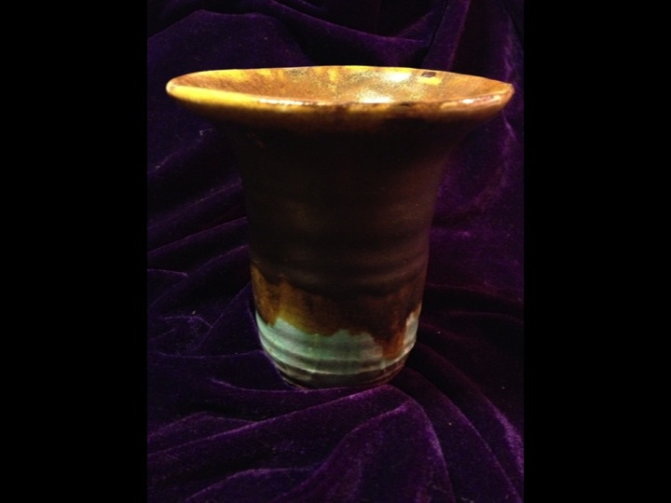

(Throughout the paper I will be including pictures of vessels I created)

Step 1: Wedging.

Similar to how Holdrege (says we begin a conversation, I model this first step with what it is like to initiate an exploration of something in nature, instead of using a member of the plant kingdom, I initiate a conversation with clay. The experience being the same, usually a sudden moment filled with a burst of interest. “…my attention has been caught.” (p. 31)

“Unity-a myriad of sensory experiences somehow cohere to give the sense that one is a single individual…” (Rose/Abi-Rached, p. 213).

Note: I use these quotes from Neuro because they sample the 7 ways a person comes to realize the self. I thought it would be interesting to pair these ways of coming to consciousness of the self, the self as part of a whole, with the 7 steps of delicate empiricism, to model the way in which these ‘7 steps’ of fluid connection with the natural world, equal a wholesome connection, just as 7 fragments of realization make up a whole and complete idea of the self, connecting the mind and body.

You begin raw, as plastic (like the brain). And from here you are molded. We each hope we are molded by someone who has an idea of what they are doing, but this is not always the case. Entering this conversation I feel as though I am a parent who has just emerged from a birthing experience holding a brand new baby with no idea how to proceed from there. This clay in my hands is foreign and unknown and I have no idea how to shape it. Most days, I feel this way in my body, I have it, I can feel it and see it but I don’t always know what to do with it or why. Words come to explain to others how I may be feeling, but it does no justice to say, maybe it would to show with a movement, a unity of fragments…I don’t know.

I watch others slap their clay into a semi-circular shape and then pound it into the canvas table, I assume this is to remove air from it. So as if kneading bread, I approach wedging the clay. At first I am gentle, and after failing at approaching the clay this way, I become fierce and stern with it. Not asking it, but telling it what to do. I must find my voice, my desires, my paths, my goals and my questions before transformation can fully occur. A transformation that can be documented in the molding of clay. It is important to mention that the clay also still has a voice in this process, it creates creases and folds, ways in which I wouldn’t prefer, and yet I appreciate this initiation style, a battling of sorts, a resistance to completely cave in. It reminds me that I am indeed coming into contact with a new form of expression, and this matter that I am working with has a life of its own and wants to say something. The following is a prose written by me, expressing the importance of entering the next stage of the conversation with seeds, seeds being vessels which hold much potential.

In this beginning stage of bonding – of wedging – I enter into the next phase of the conversation with seeds in my palms, these seeds are patiently waiting to be planted, cared for, and taken away by the winds of a great fire. These seeds are like questions, they are curious and enticing yet they hold all of the wisdom they need.

“Long before writers figured it out, seedbearing plants had found a way to convey to the next generation wisdom accumulated over millions of years.” –Books of Ice (Orion Magazine, Moore)

Here is a poem that plays with the initiation of a conversation based on the idea in Holdrege’s model of Goethean science. When we begin a conversation with something, it involves initial questions. To have any sort of foundation for a conversation you must have questions or longings-to-know, that get under your skin and drive the conversation that’s been approached. For me, this was in the form of apprehension at giving into trust. Here is a piece I wrote in which the clay asks a significant question at the end, the question of whether surrendering is okay.

Here she enters,

moving with precision in her deathly stained apron

and me, wrapped in plastic

all wet and ready to melt in her hands.

some how we'll start this damned conversation

Then comes the wire - or maybe raw hands –

both dry in a shocking way.

With no warning, or even prep-talk,

just slipping, and pulling apart my whole.

She pats me in a manner that is supposed to make me melt –

melt into a circular style,

to become whole again

her hands curse against my skin, and I can appreciate this.

She pounds me down, again and again.

Taking the air right out of me, finding success

and a smile when I no longer have pockets within me.

and I know, that when my pockets have been turned inside out,

I will become rich in a new way

maybe to hold golden tea

or fermented grapes

or those sweet beans from down south.

She does have my best interest in mind

Doesn't she?

There is a rawness when I begin, a wondering, a waiting, an excitement, a dread and an appreciation. Also there remains a huge not-knowing that we must face head on, this poem is an interpretation of this not-knowing and yet trusting with the slightest of hesitation. This is how I entered into my relationship with clay and with my own creative transformation within my body.

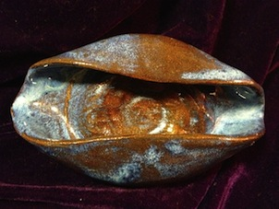

Step 2: Centering.

Holdrege defines this part of the conversation as the part in which there is a focus on the other, an intention, I use the metaphor of this part in the conversation to focus on the centering part of throwing pottery. “There will be surprises, moments of silence, tension.” (Holdrege p. 31)

“Continuity-the ability to project oneself back and forward in time with a continuing identity…” (Rose/Abi-Rached, p. 213)

When it comes to centering I find it to be the opposite of wedging, I must suggest to the clay where it should go. I must focus my hands where I’d like the clay to ideally go, and hope it does. There is high tension in this part, I Will get let down by the clay, it Will not respond, I Will come close to giving up and then I Will close my eyes and allow for a dance to occur between the clay and my fingers. For me, this is the hardest part of the conversation, the delicately, sensually-driven and incredibly focused part, where me and the clay are exposed as dynamic creatures.

With centering, a tension is born, there are points between my body and the clay that are filled with silence, with tension and with an unknown. These qualities must enter into the conversation to allow space for a shifting to occur. Metamorphosis comes when there is a release, a focus and a transformation of matter. As I focus on my experience during centering I feel a tenseness in my brain. Its as though I must freeze all of my firing neurons to allow for a calm wave to smooth over me. In Haiku form I write here of the beauty that occurs when sight falls away and other senses take over the experience.

The body tenses

Eyes drop closed and fiercely dive

Into foundation

This part of the conversation is detrimental in allowing all the other processes to occur. This is beautifully represented in a quote by M.C. Richards’ “Centering”, where she explains what it can be like to center. “The centering experience is an experience in the soul, whether we get it primarily through hands, or eyes, or imagination, and this is its compelling strategy. When we are on center, we experience reality in depth rather when in partition.” (Richards, 53) We must experience centering of the pieces, in order to come to the wholeness one longs for in life, or for in the body.

Step 3: Opening.

Holdrege recognizes this stage of the conversation with nature as the time of complete opening. During this stage our awareness opens and an awareness of other sinks in and opens us up. I loved that this stage of the conversation was about opening, I feel that the third part of working with clay and with our creative selves, is the proper time of opening. “The conversation is imbued with an atmosphere of openness.” (Holdrege p. 31)

“Embodied-the sense that one’s body, and only parts of one’s own body such as one’s limbs, belong to oneself…” (Rose/Abi-Rached, p. 213)

There is a deep sense of acceptance happening in this part of the conversation. An acceptance for what might come between me, my body and the clay. Opening is when the dance truly begins between the clay and the body, it is a dance of abstractness and yet, when the mind slips into play and asks the clay for a certain shape the dance shifts into a pattern that doesn’t seem as though it could be changed and still everytime you sit down with new clay it is a completely new dance to figure out. Opening is about setting firm foundations for transformation. In Holdrege’s case, we would see this as setting a foundation for open and fluidness to be embraced in the conversation. When the ambiance is set to be open, there is flexibility present in the conversation which transfers into the energy of each individual. When we are open to ourselves and to each other a newness can come forth. Here is a poem in which I speak of the opening that is occurs all around us, including the body energy and structure.

The mouth

The yoni

The heart

The spirit, the creation, the seed, the leaf, the blossom, the pollen, the fruit, the death

The door

The mind

The clay. Opening is all around you.

As I open the clay my body releases the tension I had become susceptible to during the stage of centering. That centering focus is draining, nature then sets the stage for space in the conversation to breath and inhale the otherness that consistently remains open. This openness flows throughout the cycle of metamorphosis, because this openness does just that, it allows the person, or matter (clay) to be open to what might happen in later parts of the conversation. Its as if you are just emerging from the cocoon, open to however the world might shape you. One must open. The cyclical reality of pottery reminds me heavily of The Vegetative Soul, where Miller speaks of the woman as a flower, a flower that goes through the stages of metamorphosis, we see that women represent this constancy of transformation, the metaphor of flowers highlights the beauty of this. I relate this stage of pottery, the Opening, to the stage of efflorescence. Miller (2002) supports this connection by referencing Iragaray’s work on efflorescence. “Efflorescence-a figure that implies metamorphosis and indefinite individuation-“ (Irigaray, unknown, in Miller 2002. p. 188). At this stage in the conversation with the vessel being creating, there is a feeling of opening, of wheels turning and not being able to stop, just as the opening allows for the constant motion, the buzzing of blooming is not stoppable, it is inevitable, we must not resist, otherwise, the early death of creativity, life and embodiment comes.

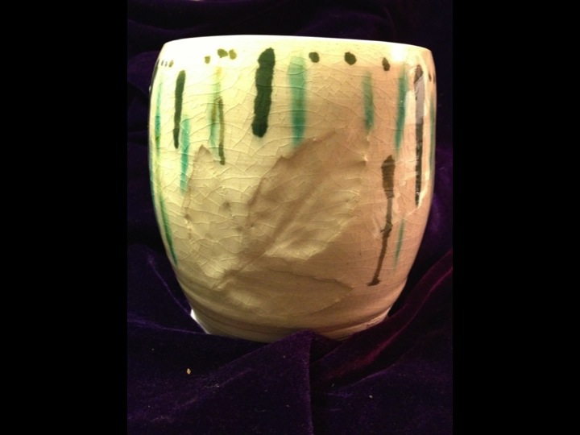

Step 4: Pulling

In this stage, Holdrege identifies that we must at this point recognize the other as its own entity outside of us. I felt this made sense with my own crafted steps because this part the clay starts to take on its own life, it becomes much harder to have control of the clay. “The recognition of the other as something in its own right is a pre-condition for any conversation.” (Holdrege p. 31-32)

“Privacy-that one’s experiece of sensations, qualia, and one’s mental life are one’s own, alone…” (Rose/Abi-Rached, p. 213)

This stage of pottery requires me to step outside of my knowing, it asks me to meet myself in my own skin and remain consistently aware of the otherness. It is where I must become friends with what the clay is doing. This is when the real reality kicks in that the clay is alive and if you don’t listen, it will not keep responding to your movements or to what you are trying to say. There is a constant swinging of motion to this stage. A forward and backward with the slipping of fingers along clay, the clay which you beg to be smooth. The clay is asking patience of you, patience of the fruit to come. It requires a slowness of you, a time for breathing and steadiness. A deep understanding of other, all while still holding your own. To me, Pulling represents a time of springing up, the time in which the plant has bloomed and is now in a stage of slow and steady movement towards a new form. Post opening, pulling advocates for movement. “Efflorescence opens up roots and routes, advocating movement over stasis...” (Miller 198). There is a time when foundations have been laid, opening has been ushered, our hearts remain at a still point, our minds are full of ideas what remain to be done, it is then we call upon the animus, the movement, the forwardness to take over. There is a deep surrendering that must happen at this stage of creating a vessel, you can either approach the clay (or body) with a willingness to let the wild of the other take over and be at will. Or, you can tense up, or step up to the higher point in the process and guide the way of the clay, of the form in a way that allows your conscious self to have control. Personally, I think its beautiful to surrender to the clay in this stage, allow what is naturally wanting to come forth to come forth and take upward motion. This is a beautiful stage in the process which allows focus on the other, as wildness ensues inside of you.

Step 5: Shaping.

Here is where we re-enter the conversation and allow newness to come forth between this newly built pulled apart and put back together relationship. In my own crafted steps this is the stage in which I put my full voice back into the conversation, there needs to be a balance between what I want and what the clay can do. Holdrege exemplifies this idea by saying that “a vibrant conversation needs the movement between receptive attentiveness and active contributing.” (Holdrege p. 32)

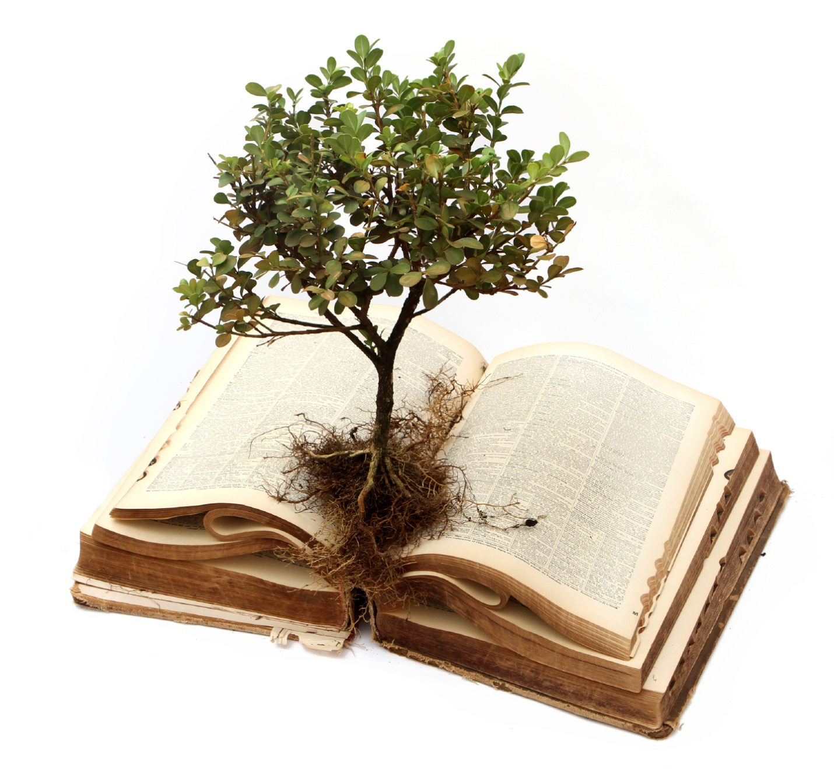
“Social embedding-that we are part of, and can interact with, a social environment…” (Rose/Abi-Rached, p. 213-214)

Here I listen to what the clay (The vessel) wants, it wants to form into its own uniqueness and I can allow this to happen but I also must bring my own self into this and create a shape that suits both me and the clays ability.

The vessel is a creative force that has been born from you, and yet is in and of itself. In Women Who Run With the Wolves by Clarissa Pinkola Estes (1992), she speaks to what the wild creative force requests and demands of us, the demand of course being vessels. It is important to remember that we do not need to fill or empty our vessels, we simply need to provide them, to show up with them always. “We don’t have to fill them, we only have to build them.” (Estes p. 299) This provides space in the conversation with the forming of vessels, to allow the clay to play its role, to listen and bring your individuality. To watch the shaping of the vessel unfold and to provide support and input where pauses occur. This is a prosed-riff that I wrote which was inspired by Women who run with the Wolves.

Here we look for the vulva in her vessel. The vulva sits between the cows skull and remains until the blue hazey sky brings the bright sea a wish of imagery. The bowl to hold her flowers is imprinted with the letters that became her death…for when she can witness what is to come, she can shift the now. This is not about avoiding, but about properly shaping ones self for the next step of metamorphosis. When one is stuck in efflorescence, the efflorescence itself dies away. Do not allow death. Allow shape to pop, to birth your own vessel. A relation of other and self, of mirroring eachother into one another. Folding and unfolding the grace of femininity, holding one another up to allow nature to uphold its gift, birth death and rebirth.

The feminine sits in this place of shaping and being shaped. My body creates vessels in itself, not for itself. I believe this is the natural way with metamorphosis, with plants and with the body. It is inside, it is depth. On how women are compared to vegetables and not to animals, Miller (2002) recycles the idea that “women remain in the plant world rather then acceding to the animal, as part of the “in itself” rather than “for itself”…” (Witford 1995, on Iragaray in Miller 2002 p. 190). This is suggesting that nature represents transformation and the ability to shift and change, morph more easily. Shaping is the ending of transformation, of metamorphosis, following shaping, you allow the newness of what was transformed to be admired and revealed.

Step 6: Glazing/Décor.

In this stage Holdrege speaks of the importance of knowing that we are all apart of this whole. We must not forget we are interwoven in the natural world. And when it comes to clay, we must not forget that we have the role of creating a piece that represents something of us, this will then represent a relationship that was symbiotically built. “Experiments don’t “prove”, they mediate a relationship. We are interwoven with nature and weaving new fabric…” (Holdrege p. 32)

“Free will-that one is able consciously to “choose between alternative courses of action with the full knowledge that you could have chosen otherwise”…” (Rose/Abi-Rached, p. 214)

This is where metamorphosis has become complete and now you build and shed. This part of the process is interesting, because you have built the vessel, and yet work still remains. The body is at ease in this stage of the process, it breathes normally and keeps the heart at ease. The mind builds up creative thoughts, wondering how to make this newly built vessel into a sturdy and creative piece to then be thrown into the fire. Glazing is an interesting conversation, for the vessel stands naked, your own vessel feeling its fragile bones, waiting for the luxurious fur, or the hard glaze of gold to coat it into the next phase. To me, this stage represents the plant beginning to go to seed, it becomes sturdy for a moment and then once going to seed, becomes fragile and sinks a little lower to the ground, asking to be taken care of. We now must pick up the seed, or glaze the vessel, and know that either way, transformation is coming constantly. Once the process has begun, just as the sun spins up and over, the metamorphosis will take place. We must choose that which will allow us to fill and also to empty, to be born, and also to die. Here is a piece or prose that I wrote that speaks of a form choosing a thing that is cyclical, birthing and dying, rather then the thing that is full of riches that end as the sun goes down.

Gold dying for brown seeds, and which is richer, which is worth more to the alchemist; Who can shift things apart, into, beneath, and from.

Am I watchful of your shifting eyes or am I deterred by your face which remains so quietly beside the stream, shifting color and motion. Here we evolve, the side of the sea, under the golden sun, tanning our hides and wishing to continuously impact ourselves. Which is death? When we can no longer transform? or when we can no longer track our transformation? Who here is the alchemist and who here is the lonely animal that speaks before the gods, wishing and hoping to be reborn as the alchemist? For they can always track the shifts. The letters held meaning in her head but that disappeared when the images burned brighter in her mind. The brown seeds showed her a continuation of wisdom, always dying, always being born, and for this, she chose the seed. The alchemist had a different thought, for he wanted to multiply, and when the sun went down and his gold no longer shown, the deal was over and his transformation remained complete. Unable to throw himself into the body of the deep fire. He wilted.

The preparation has become complete, and once her faith has been replenished she can now see forth into the shining fire with a graceful ease of acceptance. Here is metamorphosis at its best. Diving in continuation.

To become ready to the final stage of our transformation we must take the moment to breathe in what we have created, to honor its cyclical nature, to know that even if you give it all the strength you can, it will need to endure the flames.

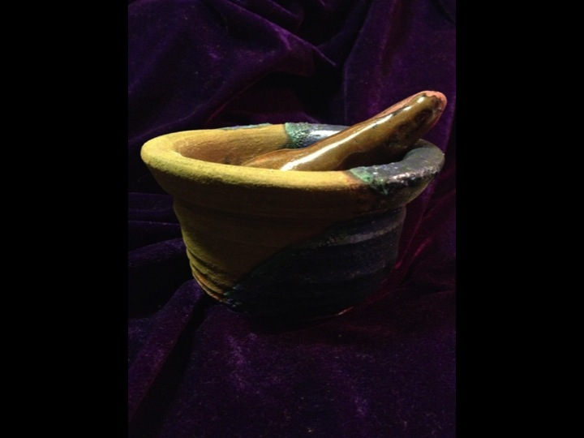

Step 7: Firing

In the last stage of Holdrege’s ideas of conversing with nature we finally realize the responsibility humans must take on. This for me is being willing to place your vessel directly into the fire, an ability to let go and let what is to come, to come forth. To know that what you contributed IS enough. “I’m engaging in the world and whatever the outcome of the conversation, it will bear in part my stamp.” (Holdrege p. 32)

“Self-awareness-an aspect of selfhood that is […] axiomatic.” (Rose/Abi-Rached, p. 214)

The fire hits and so does consciousness, this is real, I converse with clay, with my body, and created something beautiful.

We are all living seeds, seeds which must be propagated by a deep fire. Throw my body into the kiln and I will grow into the next thing. Like the ourboros, the process of creating vessels, of allowing the metamorphic process to unfold in the body, is a continuous process that has no end or beginning. This process asks the fire to act as a gateway to unfolding the creativity which allows one to continue in a freshened way. Much as life, I see creating vessels as a continuous process, it does not end at the firing but begins, it signifies a transformation which allows the vessel to be used and appreciated in a new way. In this stage of the conversation I am reminded of Coming to Writing by Helene Cixous, who speaks of her desire to write as a volcano ready to erupt without any lava, we must be whole in order to properly unload. For those who can not go through metamorphosis, I believe they have forgotten to throw themselves into the fire, to continue on with that which is incompleteable. We must constantly give into the surrender that comes with entering the fire. Richards says “it is the fire that gives us our shape” (p. 141) Which is to say it is a piece of a whole, in order to serve this world we begin by being in the form of raw clay, and then we move into becoming shaped in order to serve a larger purpose. The vessel cannot be complete without its firing, for then the vessel holds no strength, and in turn, no purpose.

When a new vessel is being formed it can seem staccato like, pieces and hard movements which seem awkward, take time to come together. This is very much like poetry and the forming of new neuronal patterns. When a person alters they’re vessel’s patterns they must go through steps to get sunk into a new pattern, this is similar to poetry. Pieces form to make up the whole, suddenly, a consciousness hits. You gather and gather and then bam! A whole, a new fire created by the forming together of pieces.

“It has an element of unexpectedness at the same time that it seems convincing. It alters our consciousness.”(Richards, 71) This is poetry. A forming of various words, coming to a new whole, allowing for ones mind to bend and twist in a new way.

Medicines of the ancestors.

A Rose

Arose

A Rows

Arrows

Arouse

For me, vessel's hold the representation of transformation. The vessels that I inhabit, create, live inside and alongside, act as a physical form of transformation, tracking metamorphosis. The body is a living, breathing consistently recycled vessel. I can watch it grow and although it does not always seep into my conscious awareness, it is always happening. The brain is a vessel, and this vessel is constantly realigning and updating who you are. I can know this by looking at the field of neuroscience. In Neuro, I see that the brain is firing synaptic updates by simply being in the world and interacting. As a whole, we are not aware of this, but it is happening. The same goes for plants. They are constantly monitoring and adapting to their surroundings, realigning themselves and how they are in the world. I would think when one harvests plants, that their magic, their energy would die away, but in fact, picking the plant is just another step in the evolution of its medicine, of its metamorphosis. The drying plants bring out a new form, it acts as the fire to the clay. The plant is now stronger and richer with more to give. Vessels have birthed the idea of recycling, acceptance of death, rebirth and cyclical living for me. Beautiful and unexpected. When I tap into art that is sensual a piece of my brain gets turned off and I see things in a less objective and more subjective way. I have become opened by the forming and creating of vessels, by perceiving the world as a vessel, for which all passes through and transforms.

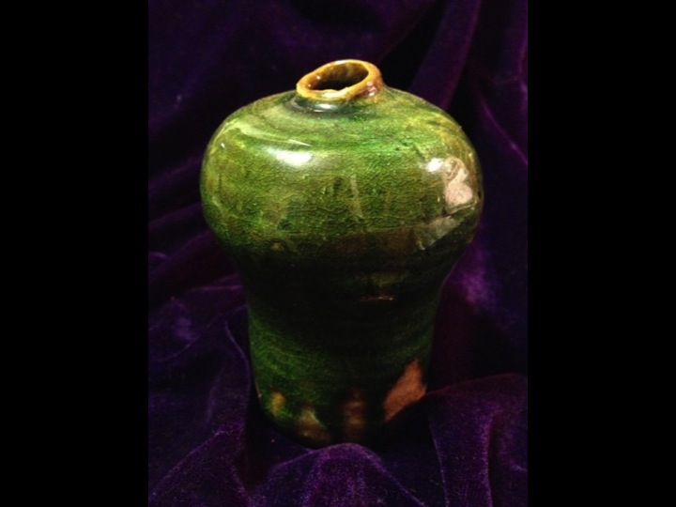

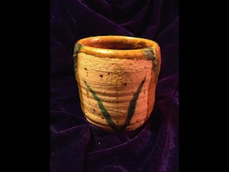

Bibliography:

- Cixous, Helene. (Edited by Marta Segarra) “The Portable Cixous” New York: Columbia University Press 2010. Print

- Dean Moore, Kathleen. “Books of Ice” Orion Magazine March/April 2013: 54. Print.

- Miller, Elaine. “The Vegetative Soul: from philosophy of nature to subjectivity in the feminine” Suny Press 2002. Print.

- Pinkola Estes, Clarissa. “Women Who Run With the Wolves” Toronto: Ballantine Books 1992. Print.

- Richards, M.C. “Centering: In pottery, poetry and the person” Middletown: Wesleyan University Press 1989. Print.

- Rose, Nikolas, and Joelle M. Abi-Rached. “Neuro: The New Brain Sciences and the Management of the Mind” New Jersey: Princeton University Press 2013. Print.

- Shlain, Leonard. “The Alphabet Versus The Goddess: The Conflict Between Word and Image” New York: Penguin Compass 1998. Print.

