The Analysis of Financial Statements

- The objective of the financial analysis imbedded in the quarter project is to evaluate a company as an investment opportunity
  - Past performance record and future expectations
  - How much risk is inherent in the current capital structure
  - What is the performance of the firm compared to the industry and/or specific competitors
- Why is management concerned with financial analysis – they must understand the picture that external parties will get from analysis
  - What operating areas are strong/weak
  - What are overall financial strengths/weaknesses
    - Operating results
    - Balance sheet position
    - Cash position
- Approaches to analysis
  - Common-size financial statements
    - Same company over time – trend analysis
    - Compared to industry and/or specific competitors
    - Balance sheet items as % of total assets
    - Income statement items as % of net revenue
  - financial ratios
  - structural analysis – capital structure
- Key financial ratios – NOTE: Figure 6.1, pg. 210 (graph of financial ratios by type) and Appendix A, pgs. 256-259 (formulas and interpretations) are excellent quick reference guides for ratio analysis
  - Liquidity – ability to meet cash needs as they arise
  - Activity – liquidity of specific assets (other than cash) and the efficiency of managing assets
  - Leverage – extent of financing with debt relative to equity (capital structure) and ability to cover interest and other fixed charges
  - Profitability – overall performance and efficiency in managing assets, liabilities, and equity
  - Cautions of ratio analysis
    - They are indicative, not definitive
    - No single set of ratios – there are many – and variations in calculations exist
    - There ARE ‘rules of thumb’ for many of them (contrary to what the text states on pg. 198); but these ‘rules’ are relative to industries, particular economic climate, etc. Therefore, ratio analysis is a DYNAMIC practice rather than a STATIC one
- Liquidity ratios
  - Current
    - Current assets / current liabilities
    - Short run solvency or ability to pay bills as they come due
    - Remember that the balance sheet is as of a particular date, and the actual amount of current assets OR current liabilities change vary considerably from the date of the balance sheet
    - A/R and inventory are not nearly as ‘liquid’ as cash when it comes to the ability to pay the bills
  - Quick, or acid-test
    - Current assets – inventory / current liabilities
    - A more conservative version of ability to pay bills as they are due
  - Cash flow
    - Cash + marketable securities + cash flow from operations / current liabilities
    - A cash flow version of liquidity
    - Remember that cash flow from operations IS NOT the same as the amount of cash IN THE BANK on the day of the balance sheet
  - Average collection period
    - Net A/R / average daily sales
    - Measures ability of to collect from customers, and possibly indicates rigor or laxity of credit-granting policies which are part of the marketing strategy of a firm
    - If you know what credit sales are, use that in the denominator; if not, use total sales recognizing that is a cruder estimate
  - Days inventory held
    - Inventory / average daily cost of sales
    - Average number of days it takes to sell inventory to customers
    - Both too high or too low a value can be a concern
      - too high – inventory obsolescence
      - too low – stock-out results in lost sales opportunities
  - Days payable outstanding
    - A/P / average daily cost of sales
    - Average number of days it takes to pay off accounts payable
  - Cash conversion cycle, or net trade cycle
    - Average collection period + days inventory – days payable outstanding = number of days in cash conversion cycle
    - The normal operating cycle consists of
      - buying and/or manufacturing inventory, with some purchases on credit that create accounts payable
      - selling inventory, with some sales on credit that create accounts receivable
      - collecting cash from customers and paying cash to suppliers
    - This ratio help understand why cash flow has improved or deteriorated
- Activity Ratios
  - A/R turnover
    - Net sales / net accounts receivable
  - Inventory turnover
    - Cost of goods sold / inventory
  - A/P turnover
    - Cost of goods sold / accounts payable
  - These first 3 measure how many times, on average, A/R are collected in cash, inventory is sold, and a/p is paid during the year. Notice that they are the complement of the 3 ratios used to calculate cash conversion cycle – the numerator and denominator are switched
  - Fixed asset turnover
    - Net sales / net property, plant & equipment
  - Total asset turnover
    - Net sales / total assets
  - These last 2 are GENERAL measures of how effective the firm is in generating sales from asset investments. The higher the ratio the smaller the required investment to generate sales.
- Leverage
  - Debt
    - Total liabilities / total assets
  - Long-term debt to total capitalization
    - Long-term debt / long-term debt + stockholders’ equity
  - Debt to equity
    - Total liabilities / total equity
  - Each of these is a measure of the extent of debt relative to equity financing
    - Debt involves risk to the firm because it carries both an interest cost and a commitment to repayment. Failing to meet these obligations results in bankruptcy!
    - Higher debt loads make additional debt financing more difficult and more expensive to obtain
    - There are other obligations that may not show up as ‘liabilities’ on the balance sheet
      - lease payments that don’t get classified as capital leases
      - off balance sheet financing
  - Times interest earned
    - Operating profit / interest expense
  - Cash interest coverage
    - Cash flow from operations + interest paid + taxes paid / interest paid (notice that interest and taxes REDUCED cash flow from operations, and so this measures how many times interest payments are earned from operations BEFORE interest and taxes reduced operating cash flow)
  - These 2 measures indicate how many times operations ‘earned’ the cost of debt financing – the higher the value the better.
    - Cash interest coverage recognizes that operating profit is not the same as cash flow, and interest payments require cash.
  - Fixed charge coverage
    - Operating profit + rent expense (from operating leases) / interest expense + rent expense
      - this is a VERY CRUDE measure of how many times the ‘fixed’ costs of operations – the costs that do NOT vary with levels of production and MUST be paid regardless of levels of production
  - Cash flow adequacy
    - Cash flow from ops / capital expenditures + debt repayments + dividend payments
    - Measures how adequate operating CASH FLOW is as a source of asset expansion, debt repayment and return to stockholders.
- Profitability
  - Gross profit
    - Gross profit / net sales
  - Operating profit
    - Operating profit / net sales
  - Net profit
    - Net earnings / net sales
  - Cash flow margin
    - Cash flow from ops / net sales
  - Each of the above 4 measures ‘ for every dollar of sales, how much profit was earned’ at the gross, operating, net and cash flow line
  - ROA or ROI
    - Net earnings / total assets
  - ROE
    - Net earnings / stockholders’ equity
  - Cash return on assets
    - Cash flow from ops / total assets
  - Each of the above 3 measures ‘for every dollar of investment, how much return was earned’ . Sometimes ‘investment’ means total investment (total assets) and sometimes it refers only to the investment of owners.
  - Each of these profitability measures shows the ‘bang for the buck’ by a somewhat different slice of the firm.
- Market ratios
  - EPS
    - Net earnings / average shares of common stock outstanding
  - P/E ratio – the ‘multiple’ that the stock market ‘pays’ for the firm’s earnings. The higher this multiple, the more ‘in favor’ the stock is.
    - Market price of common stock / earnings per share
  - Dividend payout ratio
    - Dividends per share / earnings per share
  - Dividend yield
    - Dividends per share / market price of common stock
    - Shows the ‘percentage return’ earned by an investor in the form of dividends on the price paid for the stock.
AN OVERVIEW OF COST TERMS IN CHAPTER 2
Purpose of classification | Cost classifications
Preparing an income statement and balance sheet | • Product costs  • Direct materials  • Direct labor  • Manufacturing overhead  • Period costs (nonmanufacturing costs)  • Marketing and selling costs  • Administrative costs
Predicting changes in cost due to changes in activity | • Variable costs  • Fixed costs
Assigning costs | • Direct costs  • Indirect costs
Making decisions | • Differential costs  • Sunk costs  • Opportunity costs

COST CLASSIFICATIONS IN MANUFACTURING COMPANIES
(Exhibit 2-1)

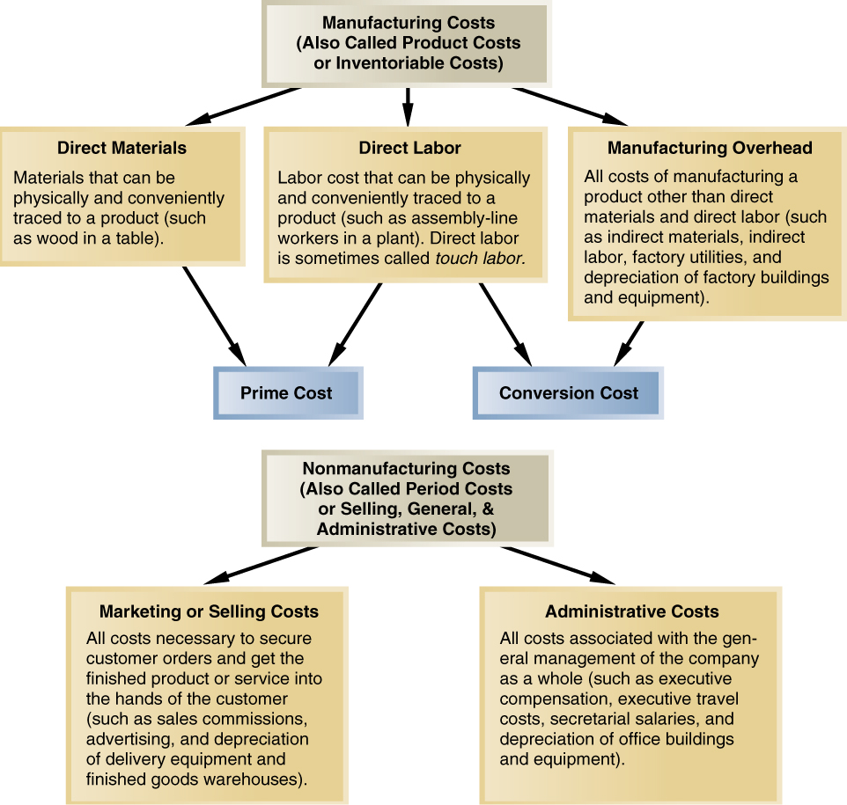
COST FLOWS IN A MANUFACTURING COMPANY
(Exhibit 2-6)

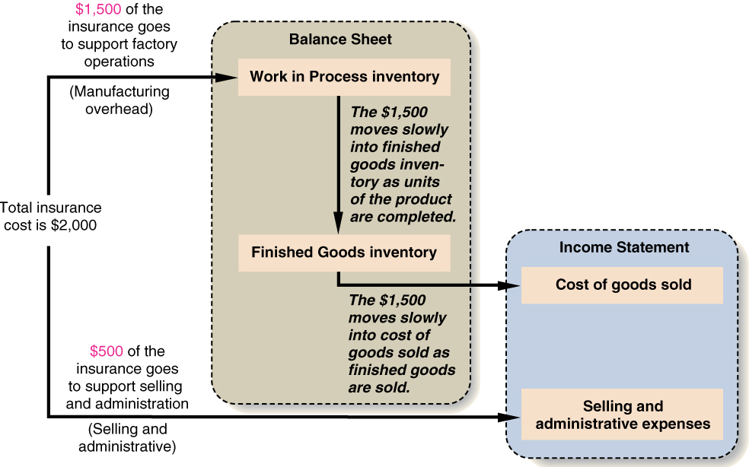
COST FLOWS EXAMPLE
EXAMPLE: Ryarder Company incurred the following costs last month:

Purchases of raw materials | $200,000
Direct labor | $270,000
Manufacturing overhead:
Indirect materials | $ 5,000
Indirect labor | 100,000
Utilities, factory | 80,000
Property taxes, factory | 36,000
Insurance, factory | 9,000
Equipment rental | 70,000
Depreciation, factory | 120,000
Total manufacturing overhead | $420,000

But:
• Some of the goods sold this month were produced in previous months.
• Some of the costs listed above were incurred to make goods that were not sold this month.
Therefore:
• Cost of goods sold does not equal the sum of the above costs.
• We need to determine the values of the various inventories.
COST FLOWS EXAMPLE (cont’d)
Additional data for Ryarder Company:
Raw materials inventory:
Beginning raw materials inventory | $10,000
Purchases of raw materials | $200,000
Ending raw materials inventory | $30,000
Raw materials used in production | ?
Work in process inventory:
Beginning work in process inventory | $40,000
Total manufacturing costs | ?
Ending work in process inventory | $60,000
Cost of goods manufactured (i.e., finished) | ?
Finished goods inventory:
Beginning finished goods inventory | $130,000
Cost of goods manufactured (i.e., finished) | ?
Ending finished goods inventory | $80,000
Cost of goods sold | ?
COST FLOWS EXAMPLE (cont’d)

Computation of raw materials used in production
 |  | Beginning raw materials inventory | $ 10,000
 | + | Purchases of raw materials | 200,000
 | – | Ending raw materials inventory | 30,000
 | = | Raw materials used in production | $180,000

Computation of total manufacturing cost
 |  | Raw materials used in production | $180,000
 | + | Direct labor | 270,000
 | + | Manufacturing overhead | 420,000
 | = | Total manufacturing costs | $870,000

Computation of cost of goods manufactured
 |  | Beginning work in process inventory | $ 40,000
 | + | Total manufacturing costs | 870,000
 | – | Ending work in process inventory | 60,000
 | = | Cost of goods manufactured (i.e., finished) | $850,000

Computation of cost of goods sold
 |  | Beginning finished goods inventory | $130,000
 | + | Cost of goods manufactured (i.e., finished) | 850,000
 | – | Ending finished goods inventory | 80,000
 | = | Cost of goods sold | $900,000

SCHEDULE OF COST OF GOODS MANUFACTURED

Ryarder Company
Schedule of Cost of Goods Manufactured

 | Direct materials:
 | Beginning raw materials inventory | $ 10,000
 | Add: Purchases of raw materials | 200,000
 | Raw materials available for use | 210,000
 | Deduct: Ending raw materials inventory | 30,000
 | Raw materials used in production |  | $180,000
 | Direct labor |  | 270,000
 | Manufacturing overhead:
 | Indirect materials | 5,000
 | Indirect labor | 100,000
 | Utilities, factory | 80,000
 | Property taxes, factory | 36,000
 | Insurance, factory | 9,000
 | Equipment rental | 70,000
 | Depreciation, factory | 120,000
 | Total overhead costs |  | 420,000
 | Total manufacturing costs |  | 870,000
 | Add: Beginning work in process inventory |  | 40,000
 |  |  | 910,000
 | Deduct: Ending work in process inventory |  | 60,000
 | Cost of goods manufactured |  | $850,000

Cost of Goods Sold
 | Beginning finished goods inventory |  | $130,000
 | Add: Cost of goods manufactured |  | 850,000
 | Goods available for sale |  | 980,000
 | Deduct: Ending finished goods inventory |  | 80,000
 | Cost of goods sold |  | $900,000
COST CLASSIFICATIONS TO DESCRIBE COST BEHAVIOR
To describe how costs react to changes in activity, costs are often classified as variable or fixed.

VARIABLE COSTS
Variable cost behavior can be summarized as follows:

Variable Cost Behavior
In Total | Per Unit
Total variable cost increases  and decreases in proportion  to changes in activity. | Variable cost per  unit is constant.

EXAMPLE: A company manufactures microwave ovens. Each oven requires a timing device that costs $30. The per unit and total cost of the timing device at various levels of activity (i.e., number of ovens produced) would be:

Cost per | Number of | Total Variable
Timing | Ovens | Cost—Timing
Device | Produced | Devices
$30 | 1 | $30
$30 | 10 | $300
$30 | 100 | $3,000
$30 | 200 | $6,000
FIXED COSTS
Fixed cost behavior can be summarized as follows:

Fixed Cost Behavior
In Total | Per Unit
Total fixed cost is not affected by changes in activity (i.e., total fixed cost remains constant even if activity changes). | Fixed cost per unit decreases as the activity level rises and increases as the activity level falls.

EXAMPLE: Assume again that a company manufactures microwave ovens. The company pays $9,000 per month to rent its factory building. The total and per unit cost of rent at various levels of activity would be:

 | Number of
Rent Cost | Ovens | Rent Cost
per Month | Produced | per Oven
$9,000 | 1 | $9,000
$9,000 | 10 | $900
$9,000 | 100 | $90
$9,000 | 200 | $45
A GRAPHIC VIEW OF COST BEHAVIOR

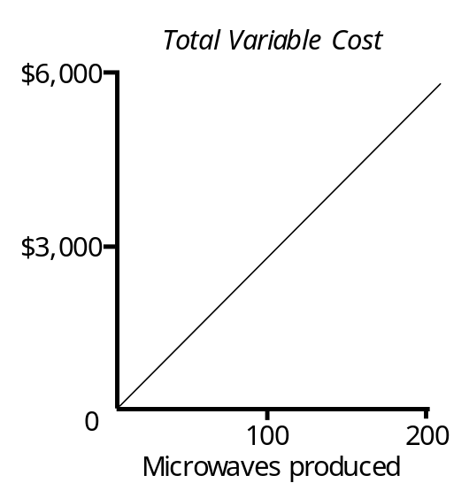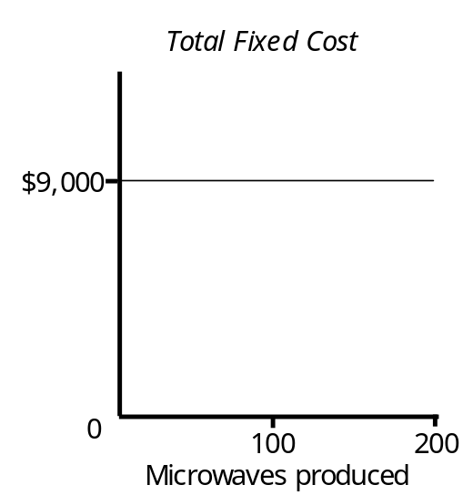

RELEVANT RANGE
If activity changes enough, fixed costs may change. For example, if microwave production were doubled, another factory building might have to be rented.
The relevant range is the range of activity within which the assumptions that have been made about variable and fixed costs are valid. For example, the relevant range within which total fixed factory rent is $9,000 per month might be 1 to 200 microwaves produced per month.

