ARCTIC DUO
The first descent of the Kongakut River, 1980
John Kramer, Sobek Expeditions

In mid-September the blueberries on the north slope of the Brooks Range are bitten by frost; snow falls. The tundra, just a few months ago bursting with the green softness of spring growth, is shutting down for another long darkness. The small rodents have cached their winter food; the bears have dug their dens. Life in the Brooks Range is poised for another big sleep, for six to eight months of refrigeration.

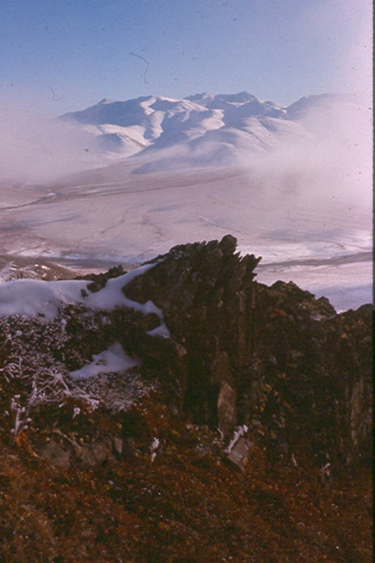
Is this any time to run a river? When the permafrost stops melting, and water trickles in smaller and smaller teardrops from the miserly tundra sponge, intent on keeping a little of the twelve inches of annual precipitation it gets? When the probability of snow is as high as the rivers are low? When foul weather could trap you in a tent in the arctic wilds, or worse still, at the end of a runway waiting for an oft-cancelled flight? Sure it is! When it’s the only time you’ve got and you're eager for your first venture north of Fairbanks; it’s a fine time for arctic boating. My partner, John Yost, and I were more than ready to head north with a raft and our gear to Barter Island on the Arctic Ocean, known locally as Kaktovik. There we planned to charter a flight with Walt Audi, the only bush pilot within 200 miles of the rivers we were eyeing.

Walt, we quickly learned, is hard to contact. Our only way to get in touch is by sat phone, and he doesn’t own one. He has radios in both of his planes and on the kitchen table, but no phone. John tried writing him letters asking him to call us at specific times from a phone at the airport. We waited for a call at those times, but none ever came. I still don’t know how John finally reached Walt. That wasn’t my department. I just knew that Walt agreed to fly us in the next week, on September 13th.

The arctic! “North to the Arctic”, sung to the tune of “North to Alaska”, was my theme song as we rushed to prepare for the trip, which took us two hours at the Army-Navy Store and the health food center in Anchorage. Fortunately we are old hands at this because two hours is all we had. We had spent the intervening week running rivers in another part of Alaska, but that’s another story (“Kennicott to Cordova,” Alaska Magazine, October 1979).

There was a bit of confusion at the check-in at Anchorage airport, but Wein Air, apparently used to bulky baggage, processed our ten-foot oars and 100+ pound boat with a minimum of hassle. What wasn’t minimum was the charge for excess baggage, $165 one way. Our bulky possessions, 8 passengers and a hell of a lot of soda pop bound for the Kaktovik store were crammed into the big Fokker F-27. The flight to Fairbanks went without a hitch, but when we alighted there we stayed, for eight full hours. Apparently the subcontractor to Wein that operates the Fairbanks-Barter Island run had worked all available personnel beyond their FAA limits, so it was illegal for them to take off before the long wait. Here was a sure sign of the approach of the frontier of civilization, when that Talmud of modern America, that unshakeable timetable of technology, the airline schedule, yielded to the pressures of limited supply. And why were there no pilots to fly us anyway, in a state where there are nearly as many pilots as drivers? We landed late that night at chilly Barter Island airport. Crisp, clean salty air reverberated with the crashing of the arctic surf. I craned my neck to see Polaris high above me. It was the arctic, exhilarating in spite of the full day’s delay.

Walt Audi, looking a bit pale and weary, was there to meet us. The pallor is a common affliction among all but the Eskimos here because the sun rarely shines. When it isn’t below the horizon for months at a time, the same fog and clouds that cause regular postponements of scheduled flights obscure it. The impression of weariness was partly due to Walt’s quiet nature and partly to his state of mind. He was boarding the same plane we just emerged from. While we were eager to get to the river early the next morning, Walt had ahead of him a late night flight back to Fairbanks to repair his plane and do the month’s grocery shopping before flying back here again to take care of us. All this after who knows what kind of day.

John and I got a good look at Kaktovik the next day before Walt returned in the late afternoon. The community is a small ramshackle collection of tin roofs, trailers, modulars, and a nice new high school complex, most of which is a gymnasium. The most striking feature of the village is the amount of refuse lying around. Old boards, barrels, snow machines, trucks, tin cans, rags, tarpaper, and rusty what–not line the streets. What else can one do with the stuff when below a few feet of vegetable mat is frozen ground? Besides, it all had to be flown in, and who knew when some castaway bit of junk would be resurrected for some useful purpose? Barter Islanders pack their sewage in barrels on big sleds that they drive out onto the ice in winter and unload. When the break-up comes the sewage goes, though not too far. On our flight along the coast we saw thousands of barrels washed up along the arctic beaches.

Walt’s plane was a sturdy Cessna 185. In the air John and I discussed our pick-up arrangements, assuming that we were headed for the Hulahula River. The Hulahula is a promising stretch of river about 100 miles long with a nice 25 foot per mile gradient. From its mouth we could row back to Barter Island if we had time to do that before the flight the following week to Fairbanks. If we were late, Walt could come and fly us out.
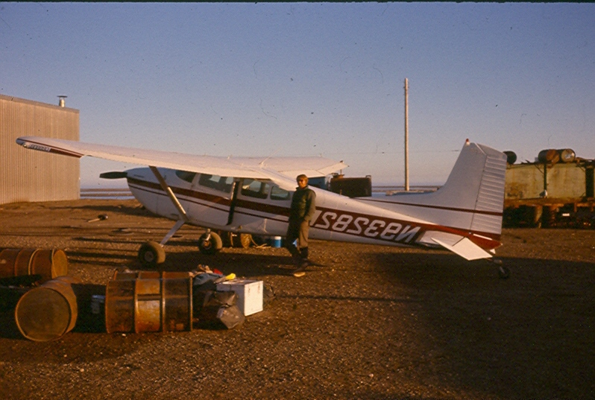

We also thought that the arctic musk ox herd might by in the Hulahula delta this time of year. If you don’t know what a musk ox looks like, find a picture. They’re beyond words. All this had captured our fancy and ruled out another option, the larger Kongakut River. Silent Walt kept flying east, though the Hulahula lay to the west. John and I exchanged questioning glances, but soon the mystery was cleared up. After a swing west it was clear that the Hulahula was dry, the musk oxen were inland and our only hope for a river trip was the Kongakut, to the east. Walt knew his stuff.

Our remaining hope dimmed with each minute of the flight. From the air the Kongakut looked like little more than a braided rock bar with water trickling between the stones. An expedition had taken a look at the river earlier in the year and had deemed it too low to run even then. Thanking Walt for the expensive scenic flight, they continued over the Brooks Range to the Chandalar River, a better-known run on the south slope. Here we were almost two months later looking at the same stretch, and it looked almost dry. “Well, we’ll have a week camping in the Brooks Range anyway,” I consoled myself. We decided to give it the old college try. “Hell, we can drag the stuff 50 miles in five days if we have to.”

Walt didn’t like the put-in at the Kongakut for good reasons. He had lost a plane there the year before. Not just crashed, lost. It was washed away after the crash. Our approach involved a steep turn and rapid loss of elevation, then a slow glide to the crest of a small knoll buffeted by gusty winds, followed quickly by a semi-stall that drops the plane 25 vertical feet, then acceleration that gives enough airspeed for a “safe,” insane landing. Bam! Bam! Bam! Head-sized boulders bounced the struts that bent like little wiffle ball bats, but the landing gear performed its miracle. My head hit the roof repeatedly as we careened down a dry river bar. Body odor wafted back to me from John in the front seat.

The put-in was serene once Walt buzzed away into the dusk. Barren, brown, rolling mountains surrounded us. The river was shallow and clear. We got to work on our boat. Experienced river runners know that things tend to be forgotten despite checklists and self-inflicted third degree cross-checks.
“You got the salt?”
“Yeah, you got the matches?”
“No, but I’ve got two lighters.”
Unfortunately John never asked me if I had an Allen wrench to assemble our break-down aluminum rowing frame, and I forgot to ask him if he had the oarlocks. Since I didn’t have the locks and he didn’t have the wrench, we had neither. Great! Here we were at the top of a seemingly unrunnable arctic trickle with no oarlocks and five unassembled frame pieces. What to do? We went to bed.

The morning brought clear air and clear heads that we used to improvise. We lashed the oars to forked sticks and jammed them into the holders designed for the missing locks, and lashed the frames together with the remainder of our rigging rope. We loaded our gear, donned our rubber boots, and pushed off to begin our arctic river trip at last.

Morale hit (pardon the expression) rock bottom as, after hanging up, pushing, shoving, breaking the forked stick on the left oar twice and the one on the right once, and scraping rocks for half an hour we had traveled only a quarter-mile. We were committed, downstream from one landing area and upstream from the next one, so we braced ourselves for a long and grueling trip. I quickly calculated to myself the river hours need to get to the next landing spot at our current rate of progress. “Hmm, twenty hours a day.” Things had to get better, I thought, and they did. The river deepened enough to float our raft, though no tributaries joined the Kongakut. Our rocky first quarter mile seemed to have been due to percolation of much of the water under the riverbed gravel.

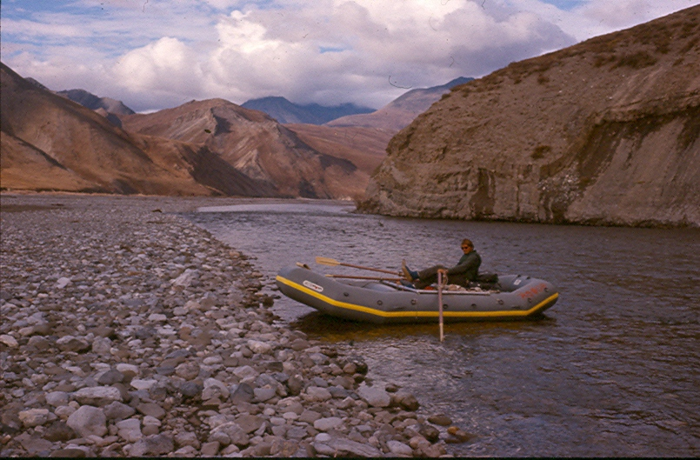

The water was crystal clear as we floated through deep pools near small cliffs and outcroppings. I noticed red dots and shadows darting beneath us. Fish! Hundreds of huge fish! The arctic char is a beautiful, large fish. We were looking at dozens over 24 inches long in a 15-yard pool. There were thousands of them swimming beneath us as we drifted through pool after pool. Their red markings and large white lips accented their furtive motions as I, in clumsy waders and bare handed, or armed with a stick, tried to approach them. Char are not to be had so easily. Lacking the swiftness and claws of a bear and the patience of an Eskimo, I didn’t have a chance.
“It’s just as well,” I rationalized. “We brought our own food and the natural balance is best left to itself.”

Fifteen miles from the put-in we found what appeared from the raft to be a level bank on the right side of the river. It was in fact hummocky, rocky, wet tundra with knee-high brush and shin deep holes. Poor tenting by any standard, but for us it was the best-looking campsite around. We set up the tent, cooked in the dusk light, and went to sleep.
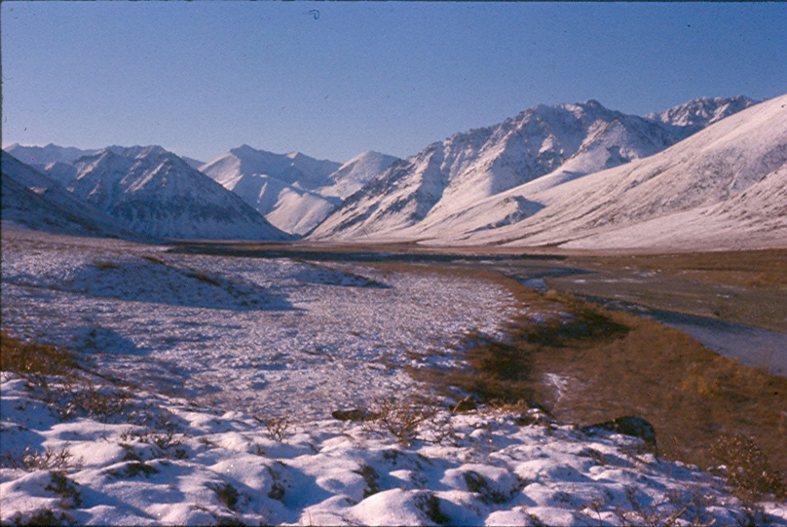
The next morning brought a white surprise. The first snow of the arctic winter had fallen that night, snow that would pro bably not melt until the following April or May. Not wanting to face the damp chill of a snowy river trip, we stayed in our bags until we couldn’t justify waiting any longer. We weren’t getting any closer to our take-out at Caribou Pass, and the weather wasn’t getting any better. There was an eerie frosty fog hiding the tops of the hills.

We got on the river late in the morning, and what an interesting river it had become. The Kongakut entered a steep valley or gorge where the rocks were plentiful and the maneuvering fun. I look forward to doing this stretch again in higher water when the rocks will be buried in turbulence and the current swift. The warmth of the day turned the snow to chilling drizzle and I walked along the bank to keep warm while John rowed. The river was braided here and I 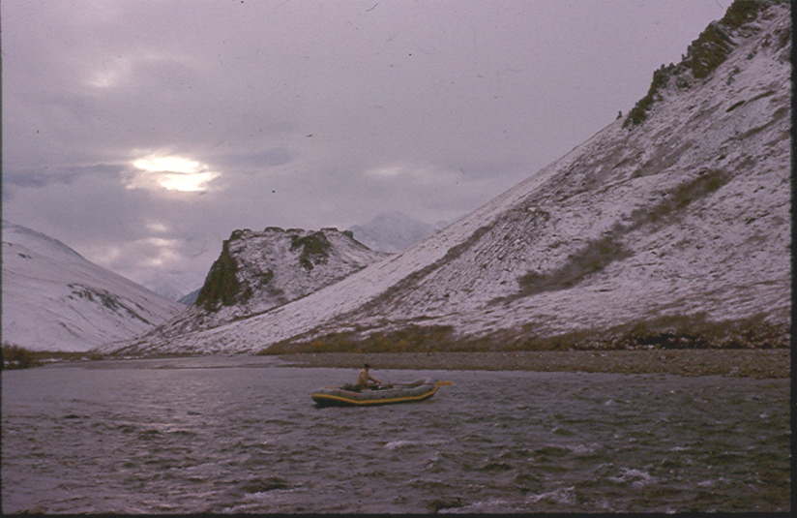 forded it in my hip waders several times. John made good progress in the shallow places without my weight in the boat. By lunchtime it had really started to rain hard. We found a small boulder to sit under during the worst of it and ate lunch. Our lunch boulder was a bit of an oddity, for the valley had opened up with the rockiest places up the hillside away from the river. The atmosphere was sullen and quiet, imparting an awesome sense of aloneness. This was the mystique of the Brooks Range that I had felt that first day. It is chill, quiet, eerie, barren. Life clings here, on the edge of survival, and at peace. Despite the late start and long lunch, we had covered twenty miles by the time the light started to fade. A sandy, dry slough on the right made camp three near perfect. Tall willows protected us from snowy winds that night.

Out early the next day we spotted Dall sheep. Two pure white yearlings clattered nimbly up a loose, gray talus slope. They paused obligingly for my camera and to satisfy their curiosity. The Kongakut is a Dall sheep hunting area in the summer, one of the remotest in Alaska. A few tributaries had joined the river by now and we floated through almost everything without trouble. We were packed extremely lightly, and by distributing our weight evenly around the raft, we drew only a few inches of water. What had looked impassable from the air was, with a few shoves, quite manageable. The trick to running a braided river such as this is to choose the proper channel. When given a choice, we always made for the first channel to drop off, even if more water seemed to be flowing by it. The lower channel will gain water further downstream; the upper channels will only lose it. Oftentimes they lose it in small increments and through percolation, so that what had been the main channel dwindles to nothing and the first small braid swells into a river.

Shortly after lunch we spied the bluff that marks Caribou Pass and our take-out. Thanks to the 20 feet per mile gradient and swift water we had taken only three days to cover our fifty miles. It was mid-afternoon on Sunday. Walt was due to pick us up Tuesday evening. We had two full days to explore the area. Our spirits soared that afternoon as the sun came out and we went about the work of setting up camp and disassembling the rafts in shirtsleeves. Our sweaters were never out of reach though because the slightest breeze or the smallest cloud reminded us of where we were. As clouds rolled in later, we retired to the tent for warm drinks. We proceeded to tear my book into sections so that we could both read it simultaneously, and enjoyed a leisurely evening. 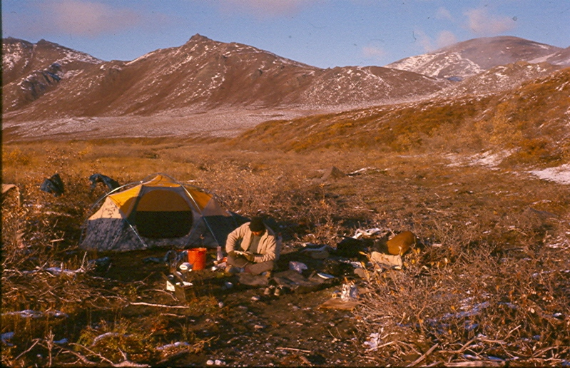
Day 4 was a hiking day. I took off early over freshly fallen snow among the crisscrossed tracks of moose, caribou, bear, small rodents, hares, and fox. We had seen fox the day before, and assumed that they must live near our camp. They obviously had been very active during the night and after dawn. How remarkable that so many species and so many individuals live in this barren cold land. Its riches were hidden from my civilized vision until that moment, when I began to realize how productive this seemingly dormant ecosystem is. I crossed the tracks of dozens of animals that day, but saw nary a one. I was especially interested in two sets of bear tracks (mother and cub) that I followed along a hill slope and down into a draw. The tracks led down into a creek bed out of sight but didn’t continue up the other side. When hiking in the McKinley backcountry (“Tundra Solo,” Alaska Magazine, August 1978), I had run across a bear den dug into a southwest slope. Noting the orientation of the creek I wondered if I hadn’t stumbled upon another. This and the fact that bits of snow were still falling from the edges into the freshly made tracks caused my heart to skip a beat. “My God,” I thought, “I’m only 100 yards from an animal that can run 30 mph and snap a 4x4 with a casual swat.” I looked around. Not a tree in sight. “Of course, they don’t grow here, stupid,” I thought as I silently crept away up the creek and circled around along the ridge top.

From a quarter of a mile away, I glassed the creek bed and saw neither bear nor den. All men have a streak of Evel Knievel’s mania in them, the need to test reality with risk. So, unarmed and humming in a loud nervous tone I clattered down the streambed, rattling stones and making every effort to give plenty of warning of my approach. Grizz in this country probably aren’t used to the sight of man and would (I hoped) beat a hasty retreat when I approached. Shortly before I reached the mysterious stream bank I found the retreating tracks going up the other side, in the direction from which I had just come. Yikes!

The day was sun bright and clear with hoar frost clinging to every leaf and twig. The whole world sparkled like a sugar coated fairyland. The northernmost mountain in that part of the Brooks offers a spectacular view over thirty miles of flat tundra to the Arctic Ocean 2500 feet below. I had been hiking for several hours to get there but could only stay a short while to admire the wild expanse around me. The wind was positively bone chilling. All around me, from the gently sloping crest of the Brooks southward to the indistinct ice blue oceanic horizon northward I saw a delicate land which conflicted with the flapping roar and cold I heard and felt. I charged down the snow slopes towards camp, leaping over snow covered boulders and low shrubs, laughing when I tumbled and fell or when my leg plunged deep into a drift. The laughter leapt up clean and free like the land around it. 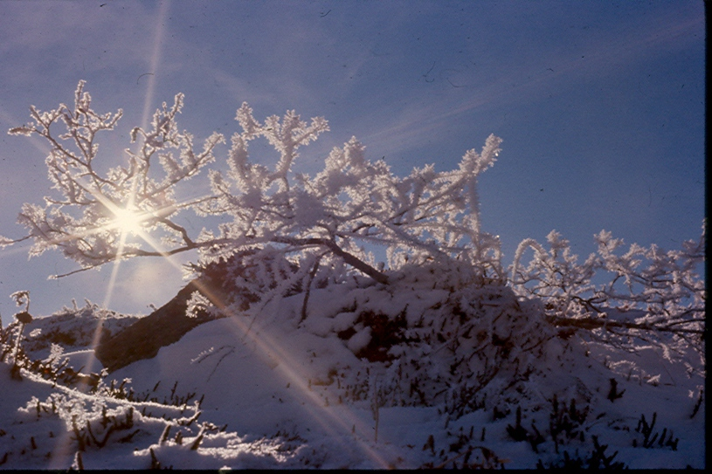

As a geologist, I have a peculiar inclination to look at rocks. Those on this mountain had been folded and bent, the more ductile shales formed striped arcs adjacent to the broken pieces of more brittle sandstone, a classic example of the relative competency of sedimentary rocks. Things are so clear here in the arctic. The relationships between the elements of this reality, the animals, plants, earth, and air are not clouded with the ambiguous and contradictory values of man. I passed the afternoon wandering back towards camp amid the hoar-frosted branches of blueberry, pondering my isolation and the simple, brutal laws of arctic survival.

Tuesday, the day we’d designated for our pick-up, dawned clear and cold. We lay around reading most of the morning in the familiar comfort of a warm bag and good book. Although I appreciated the isolation of my mountain hike the day before, still I am a social animal accustomed to my creature comforts and civilized amusements. I felt guilty enough about burying myself in nylon and down to take a last hike along the arctic waterway for several hours in the afternoon. The bleak simplicity of the place once again impressed itself upon me. By late afternoon all the food was put away, the sleeping bags stuffed (reluctantly, as it was quite cold), and the rest of our gear stacked neatly by the rock garden we took to be the airstrip. We read, and read. My once whole copy of Shogun was now in seven 100 to 250-page pieces. When the light started to dim, our comments about silent Walt’s tardiness increased.

By the last light we dug out our stove and dwindling food supply, re-ensconced ourselves in the bags and tent, and began to speculate about what was happening to us. First, we counted and recounted the days of our trip. Yes, this had to be Tuesday, and since the Wein Air flight leaves Barter Island every week on Wednesday morning we were sure that Walt knew we had to get out. So where was he? Did he forget us? Bad weather? No, it was clear and sunny all day. Well, he had crashed in the past, and we also knew that the plane had been to Fairbanks for repairs the week before. Hmmm. On we went, through our second helpings of stew and cocoa, speculating uselessly about why he hadn’t arrived when all that was important was that he hadn’t.

We were eating profusely as is the habit of nervous men. “But why are we eating all this? This could be all we have left for another week!’ Saying this and indicating our sparsely packed food box was all we needed to formulate some realistic plans. Rationing was instituted immediately and we got out the maps and considered the week of rowing ahead of us, much of it on the Arctic Ocean, to reach barter Island on our own. So much for Walt. At least we’d save a bunch of money while having a backbreaking, hungry, unforgettable time. By 11 AM the flight to Fairbanks for that week would have departed. If Walt hadn’t shown by then we were going to start down the river to the ocean and row the boat home!

Wednesday morning we were socked in with a 250-foot ceiling. We had a leisurely and sparse breakfast until 10:30, then started to pack up the tent. I was carrying a food box over to the lump of boat rubber we were planning to re-inflate when I heard a faint buzz. “A plane? A plane! John, a plane!” My shouts weren’t necessary. He was already looking down the river, when out of the clouds appeared Walt’s 185 about 200 feet off the ground. He buzzed us once and landed. Barter Island had been clear when he took off that morning; we had been totally socked in. The opposite had been true the day before: While we had clear skies he had been totally socked in by ground fog.

So our arctic adventure ended on a typical Alaskan note. Nature is King in this country. Men adjust to it as they can but they never forget it.

